Geog 3 Summative Assessment 3 Worksheet

Instructions
First, go to Food Access Research Atlas for the description of the food atlas, including the definition of a "food desert".
Please read these first few short sections in this description regarding the food atlas and pay attention to how a food desert is defined:
- Measures of food access
- Additional indicators of food access
- Data availability and updates
- Component layers for mapping tool
Go to the Food Access Research Atlas. Read the brief overview points on the page and then click on "Enter the Map.”
- What is the definition of a food desert that is used by the map (the original definition, before changes made more recently)? That is, what does the phrase “LI and LA at 1 and 10” mean?

- Before zooming in on the atlas (link above), make sure you have the background set to ‘topo’ (not satellite imagery), and the food desert criteria set to “LI and LA at 1 and 10 (original food desert measure)” – these should be the default settings. Now, look at the food desert map of the whole U.S.
Name three regions (Which can include parts or all of the multiple states) that seem to have a disproportionately high incidence of food deserts.

- Zoom in on the Philadelphia, PA metropolitan area (if needed you can use the "find a place" search box). Roughly centering Philadelphia in the view and with Woodbury heights, NJ in the south and Elkin Park, Pa in the north—it’s ok that some areas are in New Jersey since we are thinking about a metro area and not just Philadelphia proper (see guide image below). Estimate the percentage of neighborhoods in this area with food deserts and note it below.
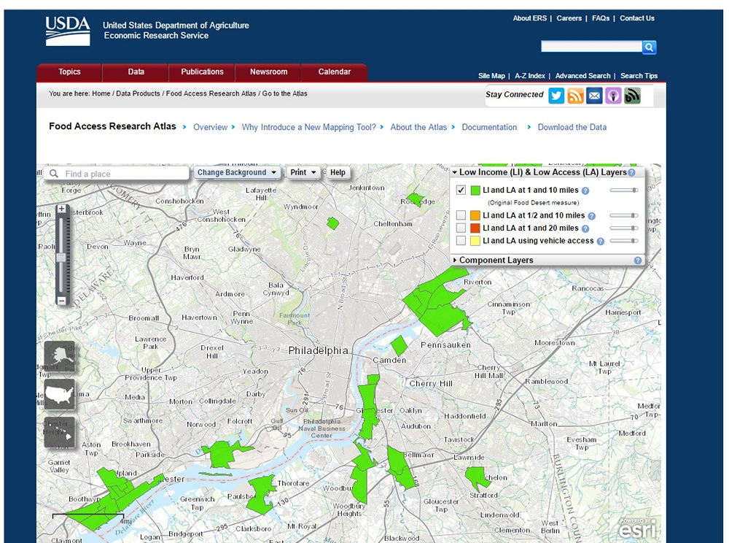
Figure 3. Map of food desert areas in Philadelphia, Pennsylvania. Note that the green layer (original food desert definition) is checked.

- Now zoom in on the Houston, Texas area in the mapping tool. (hint: it's on the gulf coast, west of New Orleans). Place the view with Houston centered and Spring in the North and Friendswood in the South. Consider the Houston city area at about this diameter (Spring to Friendswood) and estimate the proportion of neighborhoods with food desert status and limited food access and note it below. You should also use the slider next to the green checkbox to increase the transparency of the green layer, and then expand the section on "component layers" under the different check boxes, so that you can turn on, one by one, the layers for low access at 1 and 10 miles, and low income. Notice that each of these conditions (LI and LA at 1 and 10) is far more widespread than the green food desert layer, and it is the combination of the two that are needed to create the worst level of food access.
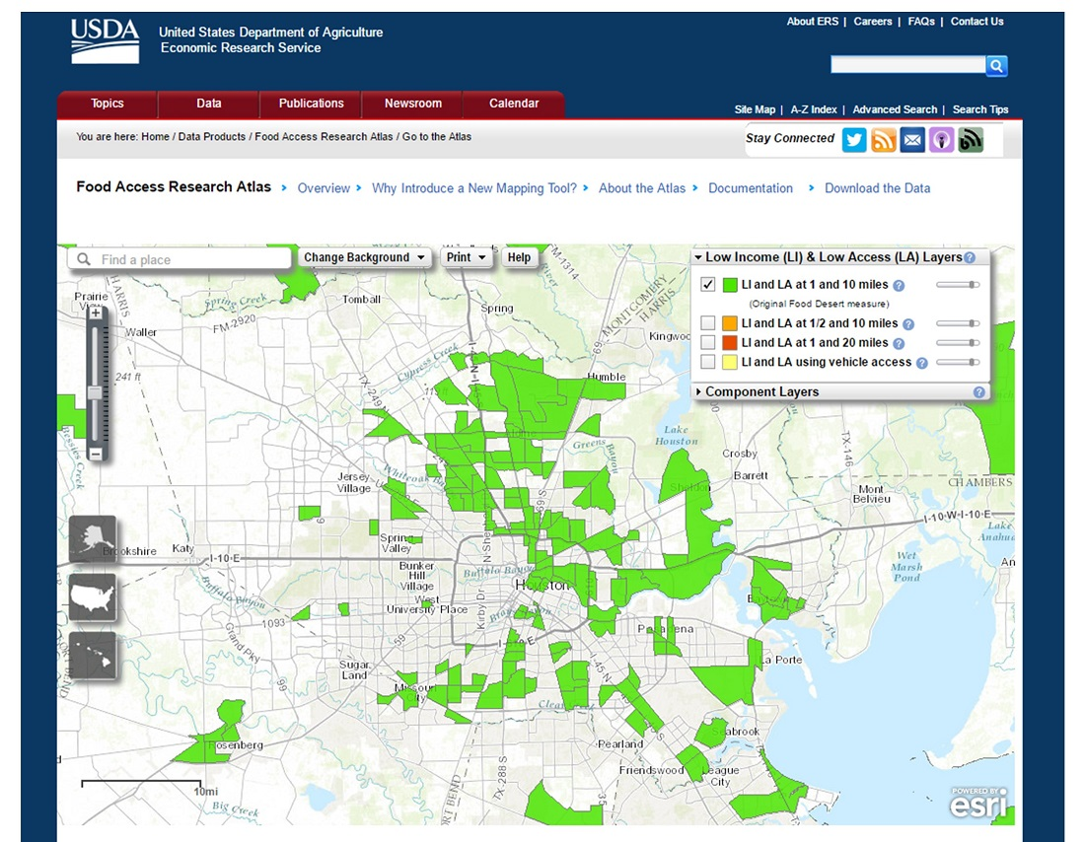
Figure 3. Map of food desert areas in Houston, Texas, for use in checking the view in the summative assessment.

- Which city has the higher percentage of food deserts? Can you think of some reasons why this would be the case?

Now read the short excerpt from pp. 104-106 in “Re-storing America’s food deserts”, chapter 8 in Winne, M. (2008). Closing the food gap: Resetting the table in the land of plenty, about efforts to “re-store” food deserts in Philadelphia. Note this book chapter is an excellent source for information and case studies of other efforts to fight food deserts, and some reflections about what works and doesn’t work in improving food access in the United States. Answer the rest of the questions below.

- Now pretend you are on a food access advisory panel that is supposed to help develop a policy to improve food deserts in Houston. You are supposed to organize your advice in three to four main points on the problem and some steps to solve it. Your first point can be what you found from the food access atlas above, pretending that you are writing to an audience that knows little about the problem and its effects on diet and nutrition. Then suggest some solutions, based on the example of Philadelphia and the Paul Winne reading.
Listen to the first ten minutes of the following 21-minute radio clip below. Look for additional solution ideas for food deserts in the interview since you will be asked about new strategies additional to those from Philadelphia. "Houston Matters Radio Program: Food Deserts in Houston"
- Did you learn anything more from this radio interview? Note additional strategies and ideas that came from the interview below.

- Now consider your focus region for the capstone project and answer below. You can use these responses to fill in the table for your capstone project on food access.
  - For U.S.-based capstone regions: Look at this region in the food access atlas mapping tool, and make notes about whether there are food deserts (e.g. the rough percentage, as above), whether these are in urban or rural areas, and ideas about why these deserts might exist.
  - For Northern Thailand: Go to the FAO's "Food Security and Nutrition Status in Thailand 2005-2011." Read the forward and introduction and then take a look at Chapter Three. Briefly describe two or three factors influencing food access or food security in the systems of this region. How do challenges to food access differ between the United States and these systems?
  - For other global capstone regions (e.g. Peru): read the World Food Program (WFP), briefly describe two or three factors influencing limiting food access in the smallholder systems of your region if listed. How do challenges to food access differ between the United States and these systems where local on-farm production is so important?
  - For other regions not listed or adequately addressed on the WFP site: find one resource that speaks to food access in your region and describe their findings and how you think they come to these conclusions via a methodology.

- If you do a Google (or other web search), can you find another example of efforts to address food deserts or improve food access in your capstone region? Name one and describe it in a few sentences below.

