Timothy J. Bralower The Pennsylvania State University 814-863-1240
Professor 535 Deike Building bralower@psu.edu
Department of Geosciences University Park, PA 16802-2714 www.geosc.psu.edu
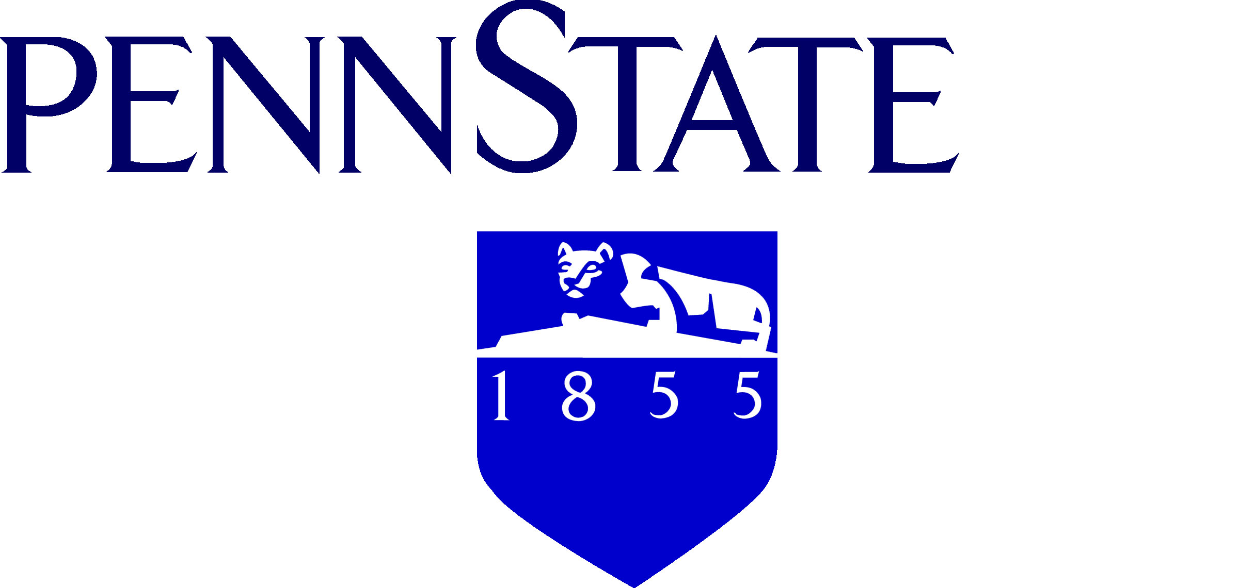

May 11th, 2013

Student:

Penn State is partnering with Carleton College, the University of Akron, Central Washington University, NC State, Nebraska, Stanford University, and UTEP in a national study designed to improve student understanding in the Earth, Ocean and Atmospheric Sciences. You are enrolled in a course that is central to all three of these areas and we are dedicated to continually improving the course and taking what we learn about effective teaching and incorporating it across our curriculum. This is part of a large national effort by geoscientists to prepare students for their future careers as best we can.

To help us improve the effectiveness of our teaching, we ask you to become part of a survey that will be conducted at three stages during the semester. The first part will be during the course orientation, the second part will be part of the first midterm and the third part will be right after the final. We stress that becoming part of the survey is entirely your decision and your choice to participate or not to participate will not impact your grade. Moreover, the results of the survey will be 100% confidential, randomly generated records will be substituted for your PSU IDs and all records will be destroyed at the end of the semester.

Please let us know if you have any questions. If you decide to participate, the first step is to sign an e-consent form with your Penn State Access User ID (ie xyz1234@psu.edu).

Please do not hesitate to let us know if you have any questions and we thank you in advance for considering participating in this important study.

Best wishes,

Timothy J. Bralower
Professor

An Equal Opportunity University

