Earth 103 Module 3 Practice Lab

Once you are done answering the questions below, log into Canvas and enter your answers into the Module 3 Lab Practice Submission (Practice) to check your answers. If you didn’t do as well as you thought you should, review the materials in the course website including the instructional videos or post a question to the Yammer group to ask for clarification of a particular topic or concept. After that, open the Module 3 Lab Submission (Graded) and complete the graded version of the lab.

Changing Initial Temperature

Model url: https://forio.com/simulate/dmb53/planetary-climate1/simulation/

1 How will changing the initial temperature affect the model? We saw that when we started with an initial temperature (remember that this is the global average temp.) of 0°, the model ended up with a temperature of about -18°C. What will happen if we start with a different initial temperature? Change the initial temperature to 1, then run the model and take note of the ending temperature by placing your cursor over the curve at the right hand side (where the time is 30 years) and then click and you should see the little box that tells you the position of your cursor. You should round this temperature to the nearest whole number. Select your answer from the following:

A. 10°
B. -8°C
C. -18°C
D. -33°C

Click on the Restore All Devices button when you are done, before going on to the next question.

Changing the Albedo

2. What will happen to our climate model if we change the albedo? Recall that a low albedo represents a dark colored planet that absorbs lots of solar energy, while a higher albedo (it can only go up to 1.0) represents a light-colored planet that reflects lots of solar energy. Change the albedo to 0.5, then run the model and find the ending temperature, and select your answer from the following:

A. about -35 (plus or minus 1)
B. about 2 (plus or minus 1)
C. about -1 (plus or minus 1)
D. about -16 (plus or minus 1)

Click on the Restore All Devices button when you are done, before going on to the next question.

Changing the Emissivity

3 Next, we will see what happens when we change the emissivity. Recall that if the emissivity is 1.0, the planet has no greenhouse effect and as the emissivity gets smaller, it represents a stronger greenhouse effect — so how will this change our climate model? Change the emissivity to 0.3, then run the model and find the ending temperature, and select your answer from the following:

A. about -18 (plus or minus 1)
B. about 47 (plus or minus 1)
C. about 16 (plus or minus 1)
D. about 71 (plus or minus 1)

Click on the Restore All Devices button when you are done, before going on to the next question.

Changing the Solar Constant

Refer to Mod 3 SA 4 video

The solar constant is not really constant over any length of time. For instance, it was only 70% as bright early in Earth’s history, and it undergoes smaller, more rapid fluctuations (and much smaller) in association with the 11 year sunspot cycle. Let’s see how the temperature of the planet reacts to changes in the solar constant. First, we need to run a “control” version of our model, as is shown in the video above. Set the model up with the following parameters:
Initial Temp = 15°C
Albedo = 0.3
Emissivity = 0.6147
Ocean Depth = 100 m
Solar Constant — alter graph as shown in the video

Record the peak temperature (should be about 15.05°) and the time lag (about 1.7 years)

4 What we are going to look at now is how the ocean depth affects the way the model responds to this spike in the solar constant. In our control, the ocean depth is 100 m — this means that only the upper 100 m of the oceans are involved in exchanging heat with the atmosphere on a timescale of a few decades. If the oceans were mixing faster, this depth would be greater, and if they were mixing more slowly, the depth would be less. Change the ocean depth to 50 m. Then run the model and note the peak value of the temperature and estimate the lag time, for comparison with the control version. Select your answer from the following.

A. Peak temp > control; lag time > control
B. Peak temp < control; lag time > control
C. Peak temp > control; lag time < control
D. Peak temp < control; lag time < control

Adding a Feedback
Model url: https://forio.com/simulate/dmb53/planetary-climate-fdbk2/simulation/

Now we’re ready to try something more challenging and more realistic. In the real world, the surface temperature has a big impact on the albedo — when it gets very cold, snow and ice will form and increase the albedo. So there is a feedback in the system — a temperature change will cause an albedo change, which will cause a temperature change and so forth. To explore this feedback, we need to work with an altered version of the model (click here), where we have defined the relationship between albedo and temperature as follows:

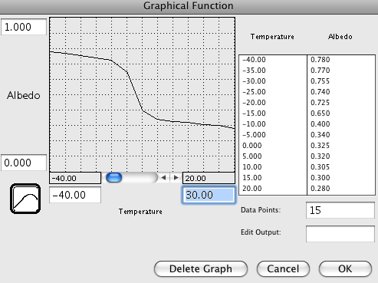

This graph implies that there is a kind of threshold temperature of about -10 to -15°C at which point the whole planet becomes frozen. The suggestion is that even with a very cold global temperature of 0 °C, the equatorial region might be relatively ice-free and would thus have a low albedo, but as the temperature gets colder, even the tropics become covered by snow and ice. Once that happens, the planetary albedo changes only slightly. Likewise, at higher temperatures, the albedo decreases only slightly since there is so little snow and ice to remove.

It is important to understand what this model includes — a link between planetary temperature and planetary albedo. As the temperature changes, so the albedo changes, and as the albedo changes, so the insolation changes, and as the insolation changes, so the temperature changes — this is a feedback mechanism. Feedback mechanisms are very important components of many systems, and our climate system is full of them.

Refer to Mod3 SA 5 video

By definition, feedback mechanisms are triggered by a change in a system — if it is in steady state, the feedbacks may not do much. In the above graph, you may notice that at a temperature of 15°C (our steady state temperature), the albedo is 0.3, which is the albedo of our steady state model. So, if we run the model with an initial temperature of 15 °C, and an unchanging solar constant of 1370, our system will be in a steady state and we will not see the consequences of this feedback. But, if we impose a change on the system, things will happen.

The change we will impose involves the greenhouse effect. The model includes something called the CO2 Multiplier. When this has a value of 1, it gives us a CO2 concentration of 380 ppm, which is the default value that gives us a temperature of 15°C. If we change it to 2, we then have 760 ppm and a stronger greenhouse, which leads to warming. If we change it to 0.5, we then have 190 ppm and a weaker greenhouse, thus cooling.

You will be give a value for the CO2 Multiplier; enter that into the model and run it with the Albedo Switch in the off position (see the video) and note the ending temperature. Then turn the Albedo Switch on, which activates the feedback mechanism, and run the model again, noting the ending temperature. The difference between these two temperatures is what you need for your answer. For example, if you set the CO2 Multiplier to 3 and run the model with the Albedo Switch turned off, you see an ending temperature of 18.17°C, and then with the switch turned on, the ending temperature is 24.86°C, so the temperature difference due to the albedo feedback is +6.69°C — this is the answer you would select.

Set the CO2 Multiplier to 6.0

5 What is the temperature difference due to the albedo feedback? Choose the answer that most closely matches your result. Be sure to study page 3 of the graph pad to get your results.

A. about -5°C
B. about +31°C
C. about +18°C
D. about -20°C

Causes of Climate Change
Model url: https://forio.com/simulate/dmb53/climate-forcing/simulation/

Things that can cause the climate to change are sometimes called climate forcings. It is generally agreed upon that on relatively short timescales like the last 1000 years, there are 4 main forcings — solar variability, volcanic eruptions (whose erupted particles and gases block sunlight), aerosols (tiny particles suspended in the air) from pollution, and greenhouse gases (CO₂ is the main one). Solar variability and volcanic eruptions are obviously natural climate forcings, while aerosols and greenhouse gases are anthropogenic, meaning they are related to human activities. The history of these forcings is shown in the figure below.

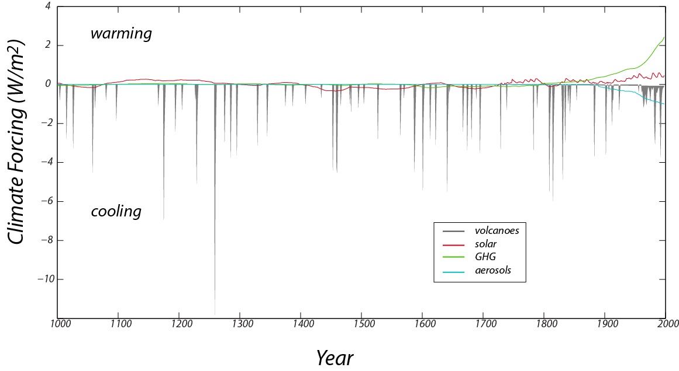
Figure 3. The reconstructed record of important climate forcings over the past 1000 years (data from Crowley, 2000). Positive values lead to warming, while negative values lead to cooling. Note that although volcanoes have very strong cooling effects, these effects are very short-lived.
Credit: David Bice

Volcanoes, by spewing ash and sulfate gases into the atmosphere block sunlight and thus have a cooling effect. This history is based on the human records of eruptions in recent times and ash deposits preserved in ice cores (which we can date because they have annual layers — we count backwards from the present) and sediment cores for older times. Note that although the volcanoes have a strong cooling effect, the history consists of very brief events. The solar variability comes from actual measurements in recent times and further back in time, on the abundance of an isotope of Beryllium, whose production in the atmosphere is a function of solar intensity — this isotope falls to the ground and is preserved in ice cores. The greenhouse gas forcing record is based on actual measurements in recent times and ice core records further in the past (the ice contains tiny bubbles that trap samples of the atmosphere from the time the snow fell). The aerosol record is based entirely on historical observations and is 0 earlier in times, before we began to burn wood and coal on a large scale.

In this experiment, we will add the history of these forcings over the last 1000 years and see how our climate system responds, comparing the model temperature with the best estimates for what the temperature actually was over that time period. Solar variability, volcanic eruptions, and aerosols all change the E_{in} or Insolation part of the model, while the greenhouse gas forcing change the E_{out} part of the model. We can turn the forcings on and off by flicking some switches, and thus get a clear sense of what each of them does and which of them is the most important at various points in time.

We can compare the model temperature history with the reconstructed (also referred to in the model as “observed”) temperature history for this time period, which comes from a combination of thermometer measurements in recent times and temperature proxy data for the earlier part of the history (these are data from tree rings, corals, stalactites, and ice cores, all of which provide an indirect measure of temperature). This observed temperature record, shown in graph #1 on the model, is often referred to as the “hockey stick” because it resembles (to some) a hockey stick with the upward-pointing blade on the right side of the graph.

First, open the model with the forcings built in, and study the Model Diagram to get a sense of how the forcings are applied to the model. If you run the model with all of the switches in the off position, you will see our familiar steady state model temperature of 15°C over the whole length of time. The model time goes from the year 1000 to 1998 because the forcings are from a paper published in 2000.

Graph #1 plots the model temperature and the observed temperature in °C, graph #2 plots the 4 forcings in terms of W/m², graph #5 plots the cumulative temperature difference between the model and the observed temperature (it takes the absolute value of the temperature difference at each time step and then adds them up — the lower this number at the end of time, the closer the match between the model and the observed temperatures), and graph #6 shows the same thing, but it begins keeping track of these differences in 1850, so it focuses on the more recent part of the history. Graph #1 gives you a visual comparison of the model and the observed temperatures, while graphs #5 and 6 give you a more quantitative sense of how the model compares with reality.

Refer to Mod3 SA6 video

6. Before running the model, set the ocean depth to 50 m. Run the model 4 times with each of the forcing switches turned on separately (i.e., only one forcing switch turned on for each model run) and evaluate which of the forcings does the best job of matching the shape of the observed temperature curve from 1800 to 1998. Which one provides the best match?

A. GHG
B. Aerosols
C. Volcanoes
D. Solar

7. Before running the model, set the ocean depth to 150 m. Run the model 3 times — once with only the natural forcing switches turned, once with only the anthropogenic forcings turned on, and once with all of them turned on. Which combination does the best job of matching the shape of the observed temperature curve from 1800 to 1998?

A. natural forcings
B. anthropogenic forcings
C. all forcings
D. natural and anthropogenic forcings are about the same.

Once you are done answering the questions, go into Canvas and enter your answers into the Module 3 Lab Practice Submission (Practice) to check your answers. If you didn’t do as well as you thought you should, review the materials in the course website including the instructional videos or post a question to the Yammer group to ask for clarification of a particular topic or concept. After that, open the Module 3 Lab Submission (Graded) and complete the grade for the lab.

