Earth 104 Activity: Global Energy Consumption, Carbon Emissions, and Climate

In this activity, we will explore the relationships between global population, energy consumption, carbon emissions, and the future of climate. The primary goal is to understand what it will take to get us to a sustainable future. We will see that there is a chain of causality here — the future of climate depends on the future of carbon emissions, which depends on the global demand for energy, which in turn depends on the global population. Obviously, controlling global population is one way to limit carbon emissions and thus avoid dangerous climate change, but there are other options too — we can affect the carbon emissions by limiting the per capita (per person) demand for energy through improved efficiencies and by producing more of our energy from “greener” sources. By exploring these relationships in a computer model, we can learn what kinds of changes are needed to limit the amount of global warming in the next few centuries.

Review of Energy Units

Before going ahead, we need to make sure we all have a clear picture of the various units we use to measure energy.

Joule — the joule (J) is the basic unit of energy, work done, or heat in the SI system of units; it is defined as the amount of energy, or work done, in applying a force of one Newton over a distance of one meter. One way to think of this is as the energy needed to lift a small apple (about 100 g) one meter. An average person gives off about 60 J per second in the form of heat. We are going to be talking about very large amounts of energy, so we need to know about some terms that are used to describe larger sums of energy:

10³ J | 1e3 J | kJ | kilojoule
10⁶ J | 1e6 J | MJ | megajoule
10⁹ J | 1e9 J | GJ | gigajoule
10¹² J | 1e12 J | TJ | terajoule
10¹⁵ J | 1e15 J | PJ | petajoule
10¹⁸ J | 1e18 J | EJ | exajoule
10²¹ J | 1e21 J | ZJ | zettajoule
10²⁴ J | 1e24 J | YJ | yottajoule

In recent years, we humans have consumed about 600 EJ of energy per year, which is something like 78 GJ per person per year.

British Thermal Unit — the btu is another unit of energy that you might run into. One btu is the amount of energy needed to warm one pound of water one °F. One btu is equal to about 1055 joules of energy. Oddly, some branches of our government still use the btu as a measure of energy.

Watt — the watt (W) is a measure of power and is closely related to the Joule; it is the rate of energy flow, or joules/second. For instance, a 40 W light bulb uses 40 joules of energy per second, and the average sunlight on the surface of Earth delivers 343 W over every square meter of the surface.

Kilowatthours — when you (or you parents maybe for now) pay the electric bill each month, you get charged according to how much energy you used, and they express this in the form of kilowatthours — kWh. This is really a unit of energy, not power:
$$1\left[kWh\right]=1000\left[W\right]×1\left[hr\right]=1000\left[\frac{J}{s}\right]×3600\left[s\right]=3,600,000\left[J\right]$$

In other words, one kilowatthour is 1000 joules per second (kW) summed up over one hour (3600 seconds), which is the same as 3.6 MJ or 3.6 x 10⁶ J or 3.6e6 J.

Creating an Emissions Scenario

There are many ways to meet our energy demands for the future, and each way could include different choices about how much of each energy source we will need. We’re going to refer to these “ways” as scenarios — hypothetical descriptions of our energy future. Each scenario could also include assumptions about how the population will change, how the economy will grow, how much effort we put into developing new technologies and conservation strategies. Each scenario can be used to generate a history of emissions of CO₂, and then we can plug that into a climate model to see the consequences of each scenario.

Emissions per unit energy for different sources

The global emission of carbon into the atmosphere due to human activities is dominated by the combustion of fossil fuels in the generation of energy, but the various energy sources — coal, oil, and gas — emit different amounts of CO₂ per unit of energy generated. Coal releases the most CO₂ per unit of energy generated during combustion — about 103.7 g CO₂ per MJ (10⁶ J) of energy. Oil follows with 65.7 g CO₂/MJ, and gas is the “cleanest” or most efficient of these, releasing about 62.2 g CO₂/MJ.

At first, you might think that renewable or non-fossil fuel sources of energy will not generate any carbon emissions, but in reality, there are some emissions related to obtaining our energy from these means. For example, a nuclear power plant requires huge quantities of cement, the production of which releases CO₂ into the atmosphere. The manufacture of solar panels requires energy as well and so there are emissions related to that process, because our current industrial world gets most of its energy from fossil fuels. For these energy sources, the emissions per unit of energy are generally estimated using a lifetime approach — if you emitted 1000 g of CO₂ to make a solar panel and over its lifetime, it generated 500 MJ, then it’s emission rate is 2 g CO₂/MJ. If we average these non-fossil fuel sources together, they release about 5 g CO₂/MJ — far cleaner than the other energy sources, but not perfectly clean.

So, to sum it up, here is a ranking of the emissions related to different energy sources:

Energy Source | g CO₂ per MJ
Coal | 103.7
Oil | 65.7
Gas | 62.2
Non-Fossil Fuel‡ | 6.2*
‡: Hydro, Nuclear, Wind, Solar
*: this will decrease as the non-fossil fuel fraction increases

Calculating global emissions of carbon

Our recent energy consumption is about 518 EJ (10¹⁸ J). Let’s calculate the emissions of CO₂ caused by this energy consumption, given the values for CO₂/MJ given above and the current proportions of energy sources — 33% oil, 27% coal, 21% gas, and 19% other non-fossil fuel sources. The way to do this is to first figure out how many grams of CO₂ are emitted per MJ given this mix of fuel sources and then scale up from 1 MJ to 518 EJ. Let’s look at an example of how to do the math here — let r₁₋₄ in the equation below be the rates of CO₂ emission per MJ given above, and let f₁₋₄ be the fractions of different fuels given above. So r₁ could be the rate for oil (65.7) and f₁ would be the fraction of oil (.33). You can get the composite rate from:

$${r_{c}=r}_{1}f_{1}+r_{2}f_{2}+r_{3}f_{3}+r_{4}f_{4}$$

Plugging in the numbers, we get:

$$65.7×.33+62.2×.27+103.7×.21+6.2×.19=61.4 [gCO2/MJ]$$

What is the total amount of CO₂ emitted? We want the answer to be in Gigatons — that’s a billion tons, and in the metric system, one ton is 1000 kg (1e6 g or 10⁶ g), which means that 1Gt = 10¹⁵ g (1e15 g).

$$1\left[EJ\right]=1e12\left[MJ\right], so, 580 \left[EJ\right]= 580e12 [MJ]$$

$$580e12 \left[MJ\right]× 61.4 \left[\frac{gCO2}{MJ}\right]=35.6e15 \left[g CO2\right]=35.6 [Gt CO2]$$

So, the result is 35.6 Gt of CO₂, which is very close to recent estimates for global emissions for the last few years.

It is more common to see the emissions expressed as Gt of just C, not CO₂, and we can easily convert the above by multiplying it by the atomic weight of carbon divided by the molecular weight of CO₂, as follows:

$35.6 \left[Gt CO2\right]× \frac{12 [gC]}{44 [gCO2]}=9.7 [Gt C]$

And remember that this is the annual rate of emission.

Let’s quickly review what went into this calculation. We started with the annual global energy consumption at the present, which we can think of as being the product of the global population times the per capita energy consumption. Then we calculated the amount of CO₂ emitted per MJ of energy, based on different fractions of coal, oil, gas, and non-fossil energy sources — this is the emissions rate. Multiplying the emissions rate times the total energy consumed then gives us the global emissions of either CO₂ or just C.

We now see what is required to create an emissions scenario:
- A projection of global population
- A projection of the per capita energy demand
- A projection of the fractions of our energy provided by different sources
- Emissions rates for the various energy sources

In this list, the first three are variables — the 4th is just a matter of chemistry. So, the first three constitute the three principal controls on carbon emissions.

Here is a diagram of a simple model that will allow us to set up emissions scenarios for the future:

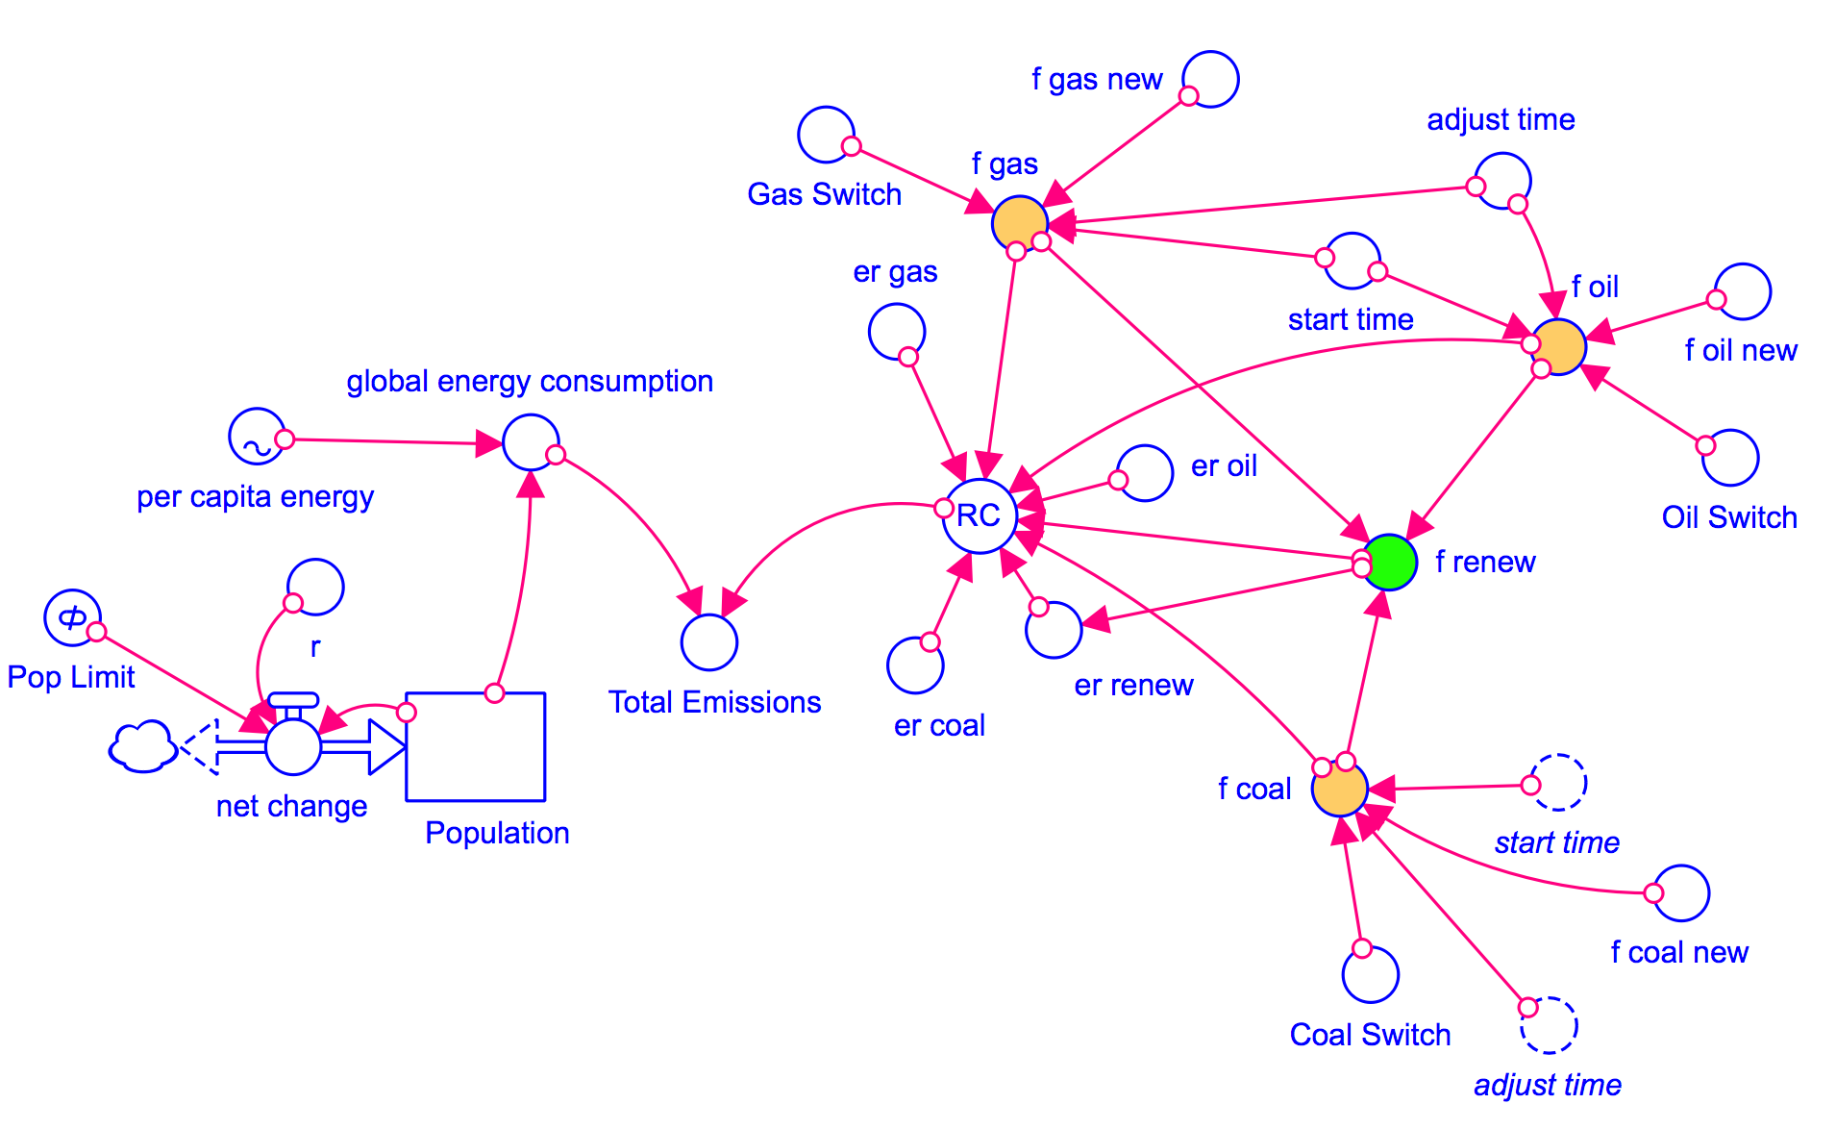
Figure 8. Stella model of the emissions calculation part of the model. This looks more complex than it really is due to the converters that enable the user to change the fraction of energy coming from different sources. The key result from this model is Total Emissions, in Gt C per year, which then controls the flow of carbon into the atmosphere of the global carbon cycle part of the model (see Figure 9).
Credit: David Bice

In this model, the per capita energy (a graph that you can change) is multiplied by the Population to give the global energy consumption, which is then multiplied by RC (the composite emissions rate — r_{c} in the equation above) to give Total Emissions. Just as we saw in the sample calculation above, RC is a function of the fractions and emissions rates for the various sources. Note that the non-fossil fuel energy sources (nuclear, solar, wind, hydro, geothermal, etc.) are all lumped into a category called renew, because they are mostly renewable (nuclear is not technically renewable, but we have a such a vast amount of uranium ore that we can lump it with the renewable energy sources). The model includes a set of additional converters (circles) that allow you to change the proportional contributions from the different energy sources during the model run.

This emissions model shown above is actually part of a much larger model that includes a global carbon cycle model and a climate model. Here is how it works — the Total Emissions transfers carbon from a reservoir called Fossil Fuels that represents all the Gigatons of carbon stored in oil, gas, and coal (they add up to 5000 Gt) into the atmosphere. Some of the carbon stays in the atmosphere, but the majority of it goes into plants, soil, and the oceans, cycling around between the reservoirs indicated below. The amount of carbon that stays in the atmosphere then determines the greenhouse forcing that affects the global temperature — you’ve already seen the climate model part of this. The carbon cycle part of the model is complicated, but it is a good one in the sense that if we plug in the known historical record of carbon emissions, it gives us the known historical CO₂ concentrations of the atmosphere. Here is a highly schematic version of the model:

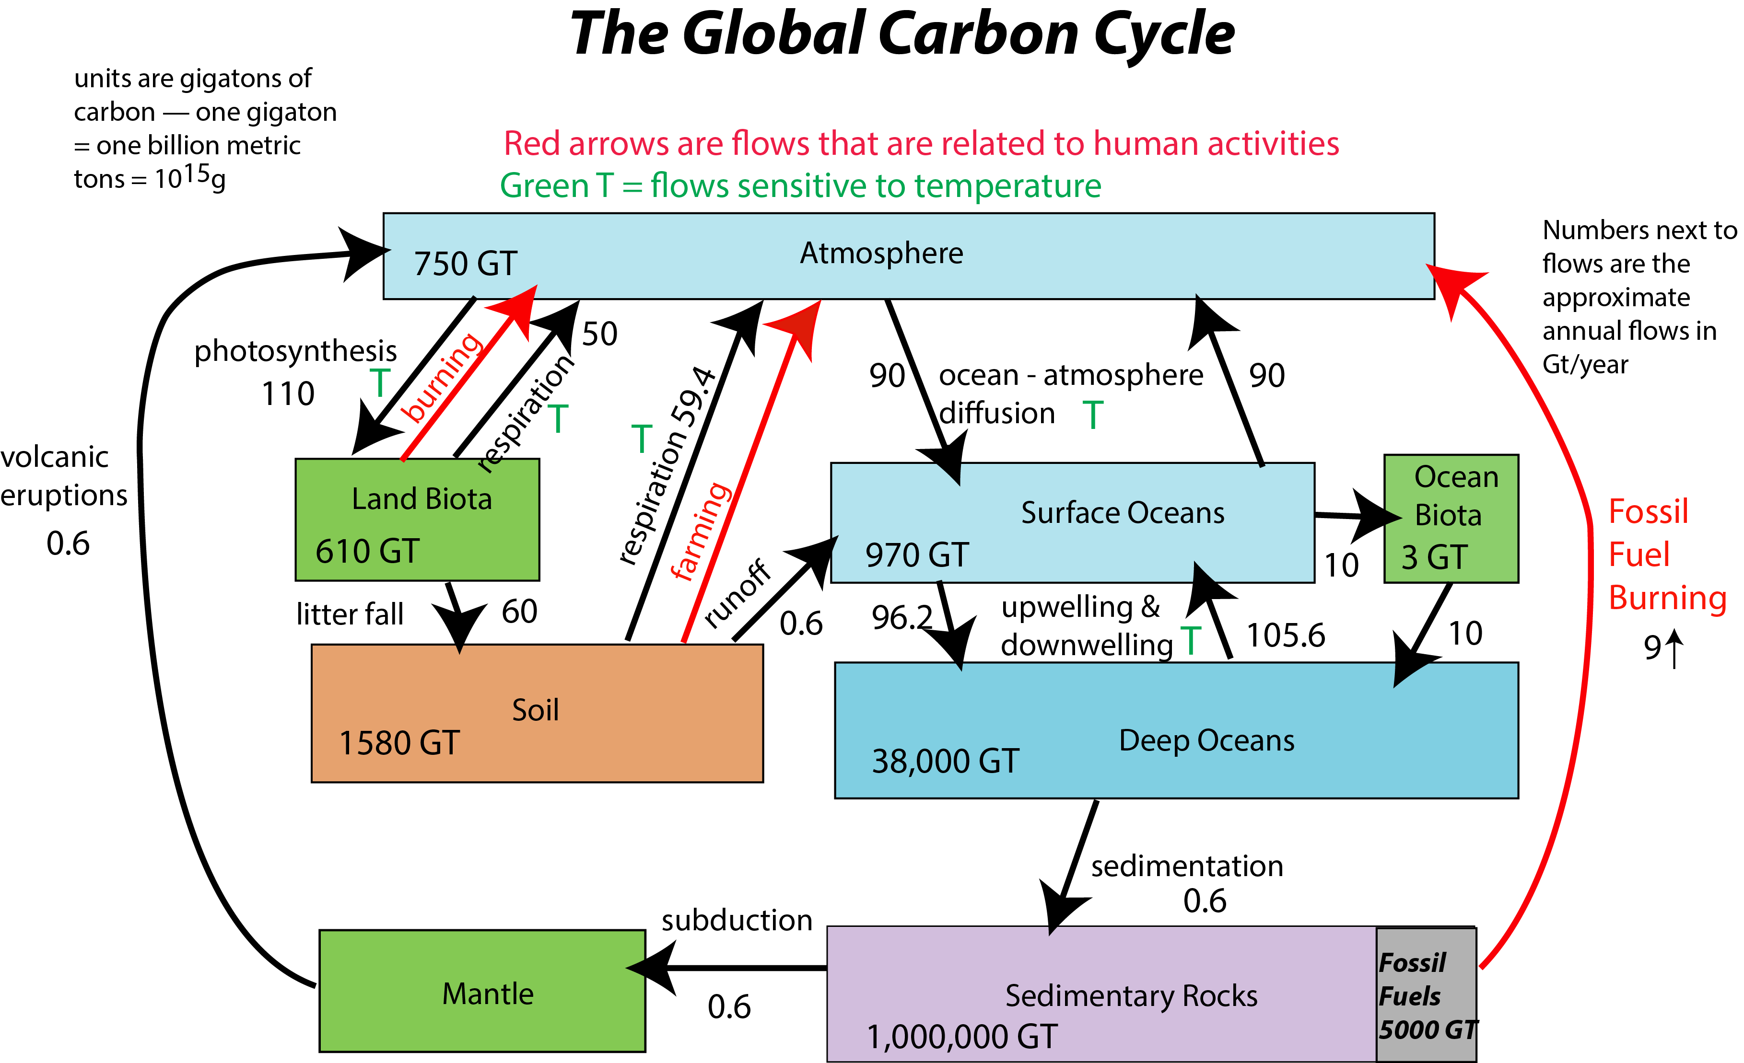
Figure 9. Highly simplified sketch of the global carbon cycle part of the model. The global carbon cycle is essentially a set of interconnected reservoirs. Humans are affecting this cycle (red arrows), preventing it from finding a steady state. The fossil fuel burning flow (on right side above) is controlled by the part of the model that calculates the emissions.
Credit: David Bice

When you open the model, you see an interface page that contains a graph and a variety of controls — things you can change. Be sure to look at the video that introduces you to the model and explains how some of the controls work.

Experiments with the Model

The first thing to do is run the model without making any changes to establish what we will call the “control” case for these experiments. In this version, population grows to 12 billion, energy demand per capita goes up and each of the energy sources (coal, oil, gas, and renewables) continues at their present percentages of total energy. You can return to this control case by hitting the Restore All Devices button. Write down the Total Emissions at the year 2100 — this will be our comparison point in time for later experiments (it should be 29.57). Check out the temperature change— it is about 6.7°C, which would be a disaster!

1. How much does switching from one of the fossil fuel sources to renewables decrease the emissions in the year 2100? First, run the model as is when you open it (all switches are in the off position) and take note of the total emissions for the year 2100 on graph #1 (this is our control case), then make the changes prescribed below and find the new emissions in the year 2100 and then calculate the difference from the control case.
Practice Version:
Oil Switch in the on position (turns green, circle moves to right)
f oil new: 0.0 (slide to the left)
Other switches off
Start time: 2020
Adjust time: 2
Per capita energy: unchanged
Pop limit: 12

Graded Version
Coal Switch in the on position (turns green, circle moves to right)
f coal new: 0.0 (slide to the left)
Other switches off
Start time: 2020
Adjust time: 2
Per capita energy: unchanged
Pop limit: 12

Difference = (±2 Gt)

Practice Answer = 29.57-19.78=9.79 [see video on how to solve this one]

2. Does this change lead to a leveling off of carbon emissions, or do they continue to climb, or do they decline?

- Levels off
- Decline
- Continues to climb [correct answer for practice version]

Why does it continue to climb? Because: 1) population continues to grow; 2) the per capita energy demand continues to grow; and 3) we do not run out of fossil fuels in this scenario.

Don’t clear the graphs at this point, because we will compare our last result with the next one.

3. Which has a bigger impact in reducing emissions by the year 2100 — limiting population growth to 10 billion, or reducing your fossil fuel fractions as prescribed? Here, make sure all the switches are turned off, and then set the Pop Limit to 10.
Practice Version:
Oil Switch in the off position (turns white, circle moves to left)
f oil new: 0.20 (or hit the reset button )
Other switches off
Start time: 2020
Adjust time: 2
Per capita energy: unchanged
Pop limit: 10

Graded Version
Coal Switch in the off position (turns white, circle moves to left)
f coal new: 0.20 (or hit the reset button )
Other switches off
Start time: 2020
Adjust time: 2
Per capita energy: unchanged
Pop limit: 10

Graded Version: same set up as before, but set Pop Limit to 10

- Population limitation
- Fossil fuel reduction [correct answer for practice version]

Reset the Pop Limit to 12 when you are done with this one.

4. How much does drastically reducing all of the fossil fuel sources decrease the emissions in the year 2100 compared to the control case? (set all switches to the off position for the control)
For the graded version, lower the fossil fuel sources to a fraction of 0.1; leave everything else the same as the practice version.
Practice Version:
All Switches in the on position (turns green, circle moves to right)
f oil new, f coal new, and f gas new: 0.05
Start time: 2020
Adjust time: 2
Per capita energy: unchanged
Pop limit: 12

Graded Version
Coal Switch in the off position (turns white, circle moves to left)
f oil new, f coal new, and f gas new: 0.1
Other switches off
Start time: 2020
Adjust time: 2
Per capita energy: unchanged
Pop limit: 12

Difference = (±2 Gt)

Practice Answer = 23.8
Follow these steps:
1. Run the control case (first click on the Restore All Devices button); look at graph page 2 (see video for how to go back and forth between pages by clicking in upper right of the graph diagram)
2. Set the model up as prescribed
3. Run the model again — you should now see a blue curve from the control run and a dashed red curve from the modified run (looking at graph #1)
6. Run the cursor along the control case curve until you get to the year 2100 and write down the total emissions at that point — it should be 29.57 (the units are Gt C/yr).
7. Run the cursor along the modified case curve (red one) until you get to the year 2100 and write down the total emissions at that point — it should be 5.74.
8. The question is asking for the difference in emissions, so subtract 5.74 from 29.57 and you get 23.83 Gt C/yr — this is the reduction in emissions we would achieve if we lowered all of the fossil fuels to just 5% of our total energy consumption.

5. Which has the bigger impact in reducing emissions — halting the rise in per capita energy use, or reducing our fossil fuel fractions? For this one, you’ll use your answer to the above question (#4) and compare to one in which you turn off all the switches, and then change the per capita energy graph so that it is more or less a straight line all the way across. You can check to see how well you’ve done this by looking at page 8 of the graph pad after you run the model. So, which has a bigger impact in reducing emissions?

- Fossil fuel reduction [correct answer for practice version]
- Per capita energy change (i.e., conservation + efficiency)

6. Now, let’s see what happens to the global temperature when we stabilize (hold constant) the carbon emissions. Modify the original model as described below — this should result in an emissions history that more or less stabilizes. Then find the emissions at the year 2100.
Practice Version:
All Switches in the on position (turns green, circle moves to right)
f oil new, f coal new, and f gas new: 0.15
Start time: 2020
Adjust time: 10
Per capita energy: 2010 = 74, 2048 = 72, 2086 = 70, 2124 = 67, 2162 = 64, 2200 = 61 (see video for how to do this)
Pop limit: 10

Graded Version
Coal Switch in the off position (turns white, circle moves to left)
f oil new, f coal new, and f gas new: 0.15
Other switches off
Start time: 2050
Adjust time: 10
Per capita energy: 2010 = 74, 2048 = 125, 2086 = 125, 2124 = 115, 2162 = 110, 2200 = 105 (see video for how to do this)
Pop limit: 12

Total Emissions in 2100 = ±2.0 Gt C/yr

Practice version — 6.14 Gt C/yr

7. Now that you have an emissions scenario that stabilizes (the human emissions of carbon remain more or less constant over most of the time), let’s look at temperature (page 9 of the graph pad). Remember that global temperature change in this model is the warming relative to the pre-industrial world, which is already about 1°C in 2010, the starting time for our model. What is the global temperature change in the year 2100?

Global temperature change = ±0.5 °C

Practice version — 1.91°C

8. Now study the temperature change (graph#9) and the pCO2 atm (the atmospheric concentration of CO₂ in ppm or parts per million — page 10 of the graph pad) for the time period following the stabilization of emissions. Does the stabilization of emissions lead to a stabilization of temperature or atmospheric CO₂ concentration?

- both stabilize
- neither stabilizes — both increase [correct answer for practice]
- neither stabilizes — both decrease
- CO2 goes up; temperature goes down
- CO2 goes down; temperature goes up

Reset the model before going to the next question.

9. Now, let’s say we want to keep the warming to less than 2°C (relative to a pre-industrial temperature), which the IPCC recently decided was a good target — warming more than that will result in damages that would be difficult to manage (we would survive, but it might not be pretty).

So, let’s see what is necessary to stay under that 2° limit, given some constraints. We’ll set up the model as described below, leaving f coal new as our main variable, changing according to four scenarios as follows:

A: Keep the coal fraction unchanged (switch off)
B: Reduce the f coal new to 0.10
C: Reduce the f coal new to 0.05
D: Reduce the f coal new to 0.00

Practice Version:
Start time: 2030
Adjust time: 10
f oil new: 0.10
f gas new: 0.10
f coal new: adjusted in 4 scenarios as described above
per capita energy: held constant at 74
Pop Limit: 12

Graded Version:
Start time: 2030
Adjust time: 10
f oil new: 0.05
f gas new: 0.05
f coal new: adjusted in 4 scenarios as described above
per capita energy: leave as is — the default scenario
Pop Limit: 12

Which of the above scenarios keeps the temperature below 2°C by the year 2200?

a) none of them
b) B
c) C
d) D
e) C & D

Practice version: a) none of them

We’re done with this model for now, but you will use something similar to do your capstone projects. You’ll use the model to design an emissions and energy consumption scenario for the future for which you’ll also explore the social and economic consequences.

The following questions encourage you to step back and think about what you’ve learned here. There is no practice version for these questions, but these will appear in the online assessment.

10. What are the three principal variables that determine how much carbon is emitted from our production of energy? (Hint: look at page 6 of this worksheet)

a) global population, per capita energy demand, and the fractions of our energy provided by different sources

b) global warming, per capita GDP, and the amount of coal remaining

c) global warming, per capita energy demand, and the fractions of our energy provided by different sources

d) global population, per capita GDP, and the residence time of CO2 in the atmosphere

- global population, per capita energy demand, and the fractions of our energy provided by different sources

11. Among the various sources of our energy, which has the highest rate of CO₂ emitted per unit of energy? (Hint: look at table on page 3 of this worksheet)
a) coal
b) renewables
c) gas
d) oil
e) solar

12. What happens to the atmospheric concentration of CO₂, and thus the global temperature, if we stabilize (hold constant) the emissions rate? (refer back to results from #8)
a) they both stabilize (remain constant)
b) they both rise
c) CO2 goes up and temperature goes down
d) temperature goes up and CO2 goes down
e) they both go down

13. Can we stay under the 2°C warming limit in the year 2200 by reducing (or eliminating altogether) our reliance on fossil fuel energy sources alone (reducing f coal new, f oil new, and f gas new to 0.00), or do we also need to reduce our energy consumption per capita? (run the model to figure this out using Pop Limit of 12, start time of 2020, and adjust time of 2)

a) yes, we can stay below 2°C by completely eliminating fossil fuels
b) no, we can only stay below 2°C by reducing our per capita energy demand
c) even if we do both, we still can’t stay below 2°C

