Earth 104 Activity: Peak Oil

You have, by now, learned some things about “peak oil”, the notion that the production of oil is at or near a peak and will decline in the future, forcing us to conserve more and shift to other sources for our energy needs in the future. The goal of this activity is to explore this notion of peak oil in a bit more depth, to understand how it is a natural consequence of supplies, demands, prices.

In this activity, we’ll be using computer models created in a program called STELLA. STELLA models are simple computer models that are perfect for learning about the dynamics of systems — how systems change over time. Systems, in this case are sets of related processes that are involved in the transfer and storage of some quantity. For example, the global water cycle is a system that involves processes like evaporation, precipitation, surface water runoff, groundwater flow, moving water from one place to another. Earth’s climate system is set of related processes involved in the absorption, storage, and radiation of thermal energy. In fact, you can think of the whole Earth as one big, complex system. Through the use of computer models, we can learn some important things about how they work, how they react to changes; this understanding can then help us make smart decisions about how respond and adapt to a changing world.
What is a STELLA model?
A STELLA model is a computer program containing numbers, equations, and rules that together form a description of how we think a system works — it is a kind of simplified mathematical representation of a part of the real world. Systems, in the world of STELLA, are composed of a few basic parts that can be seen in the diagram below:
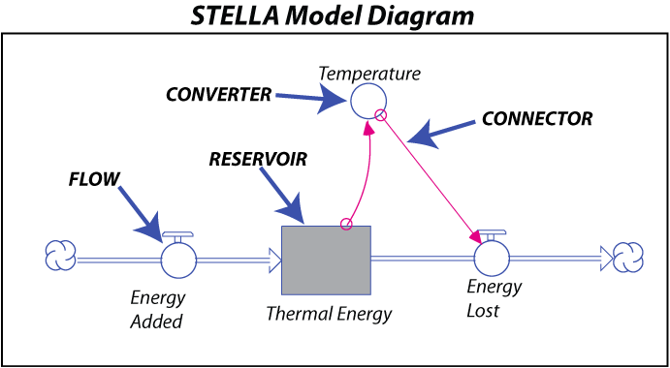
This graphical representation is meant to look a bit like a plumbing diagram, with storage tanks (reservoirs) connected to flows with valves on them to control the rate of flow in and out of the reservoir. Behind the scenes, STELLA represents these systems with a set of equations that describe how things change over time; these equations are then solved over time. Graphs then show how each model component changes over time.
Credit: David Bice

A Reservoir is a model component that stores some quantity — thermal energy in this case.
A Flow adds to or subtracts from a Reservoir — it can be thought of as a pipe with a valve attached to it that controls how much material is added or removed in a given period of time. In the above example, the Energy Added flow might be a constant value, while Energy Lost would be an equation that involves Temperature. The cloud symbols at the ends of the flows signify that the material or quantity has a limitless source, or sink.
A Connector is an arrow that establishes a link between different model components — it shows how different parts of the model influence each other. The labeled connector, for instance, tells us that the Energy Lost flow is dependent on the Temperature of the planet.
A Converter is something that does a conversion or adds information to some other part of the model. In this case, the Temperature converter takes the thermal energy stored in the Thermal Energy reservoir and converts it into a temperature using an equation.
To construct a STELLA model, you first draw the model components and then link them together. Equations and starting conditions are then added (these are hidden from view in the model) and then the timing is set — telling the computer how long to run the model and how frequently to do the calculations needed to figure out the flow and accumulation of quantities the model is keeping track of. When the system is fully constructed, you can essentially press the ‘on’ button, sit back, and watch what happens.

In this course, the models have all been made; you will interact with the models by changing variables with a user interface that has knobs and dials and then running the models to see how they change over time.

We will start with the simplest model we can imagine that represents the consumption of oil and gas and then we will work with progressively more complex versions of the model.

Oil and Gas Reserves

Oil and gas form at extremely slow rates — 10’s of millions of years — so we can consider the oil and gas present now to be all that is available. We can wait around all we want and there will be no significant increase in the oil and gas. The total amount of oil and gas in existence on Earth is sometimes called the oil in place. We can only guess at this (somewhere around 6 trillion barrels of oil equivalent), but regardless of its size, we can probably only get about 50% of it out of the ground (this recovery factor ranges from 10% to 80% for individual oil fields). The recoverable oil and gas can be divided into two types of reserves — proven and unproven. Proven reserves are the oil and gas that we know about (which means we have a 90% confidence level about them), while unproven reserves are the oil and gas that we are less certain of, but we have some indication of their existence. These reserves are usually expressed in terms of barrels of oil equivalent and includes both oil and natural gas.

It is estimated that our proven reserves are on the order of 1.5 trillion barrels of oil, and unproven reserves are thought to be in the range of 3 trillion barrels. Last year, we consumed 31 billion barrels of oil, and at this rate of consumption, we’ve got less than 50 years worth of oil in the proven reserves, and about 97 years worth in the unproven reserves.

1. The Simplest Case

In this first case, we’ll just consider the proven reserves, and we’ll assume that the oil produced is a constant percentage of how much remains in the proven reserves. The logic here is very simple — if there is more oil, you can produce more in a period of time, while if there is less oil, you produce less in the same time period — but the percentage remains the same.

Here is what the system looks like as a STELLA model:

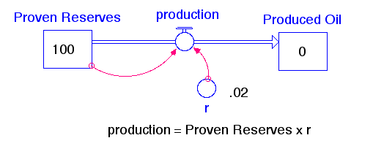

Since this model is simply meant to illustrate the general pattern of oil/gas production resulting from an assumption of how production works, we’re not going to worry about the actual values, but you can think of the starting amount of Proven Reserves as 100% of what we have. Every year, we produce oil/gas at the rate of 2% of however much remains in the Proven Reserves reservoir. The production flow transfers oil/gas into the Produced Oil reservoir, so we can keep track of the total amount of oil/gas produced over time.

Let’s see if we can predict what will happen by doing a few simple calculations. When the model first begins:
Proven Reserves = 100
production = 100 x 0.02 = 2

This will reduce the Proven Reserves by 2, so it becomes 100-2=98. Then, in the next year:
Proven Reserves = 98
production = 98 x 0.02 = 1.96

This will reduce the Proven Reserves by 1.96, so it becomes 98-1.96=96.04. So, in the next year:
Proven Reserves = 96.04
production = 96.04 x 0.02 = 1.92

Notice that the production is declining as time goes on, and the amount of decline is getting smaller. If this pattern continues, the production will follow an exponential decline curve — like this:
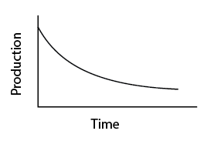

Now, let’s run the model and see what happens. First, take a minute to watch this video that explains how to work with the model using the interface, then follow this link to the model, which should be set up exactly the same as the diagram above.

1A. [1 pt] Does the production history agree with our simple calculations (position the cursor on the graph and it will show you the values at different times)?

- Yes [correct answer for practice version]
- no

2. Oil Production with Improving Technology

Oil and gas companies have certainly become better at what they do over time. Originally, they drilled near natural oil seeps and hoped for the best, but now, a good team of geoscientists can “see” exactly where the oil/gas is, and engineers can drill with great precision and then “stimulate” the oil/gas-bearing rock formations to squeeze as much oil/gas as possible out of the rocks.

One way to incorporate this into the model is to change the rate of oil/gas production, r, so that it increases as time goes on. To do this, we make a simple equation that says r = 0.0005 x TIME, so then when TIME is 10 years, r will be 0.005 and when TIME is 100 years, r will be 0.05. Other than this change, the model is the same as in experiment 1. The value 0.0005 is called tech rate in the model, and we’ll see what happens if we change it.

Let’s see how this change affects the history of oil/gas production. Run the model and then answer the following questions. As you can see, the production of oil peaks in this case. It rises because r is increasing, but as r increases, the Proven Reserves is decreasing and eventually a point is reached where the product of these two numbers (the production) starts to decline.

 | Practice | Graded
Tech rate | 0.0002 | 0.0004

2A. [1 pt] When does the production reach its maximum (peak) value?

Time of peak = [about 70 yrs for practice]

2B. [1 pt] What is the magnitude of the peak in production?

Magnitude of peak = [about 0.86 for practice]

3. Including Price in the Production Flow

In addition to technology, economics also plays a role in the production of oil/gas in the sense that higher prices will motivate greater production. Let’s assume that the as the supply of proven reserves drops, the price will rise. As long as there is a demand for oil and gas, as it becomes more scarce, it will become more valuable. This is a pretty simplistic view of what determines the price of oil and gas — reality is much more complex, which is why prices fluctuate quite a bit over time. But it is hard to escape the basic reality that as a desirable commodity becomes scarce, its value goes up.

To make this change in the model, we need to add something that will calculate the price. This new model looks like this:

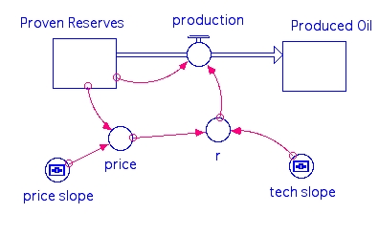

As before, production is defined as Proven Reserves x r, and r in this case is defined as price x tech_slope x TIME, so it once again has the increase over time that our previous model had, but it also increases as the price goes up. The tech_slope is just the slope of the increase in technology over time and the default value is 0.0002. Price here is defined as 0.01 + price_slope x (100 – Proven Reserves); price_slope is the slope of price increase relative to change in Proven Reserves, and is originally set to 0.05. At the beginning, Proven Reserves is 100, so this gives a price of 0.01 — very small. But, when Proven Reserves has declined to 50, we get a price of 2.51. This equation is not meant to be anything more than a way to make the price increase as the Proven Reserves get smaller. The value 0.01 at the front end of this equation is just there so that the price is not 0 at the beginning, which would then make r be 0 and no oil would ever get produced.

What we have created here is a system with a feedback mechanism. Here is how it works:

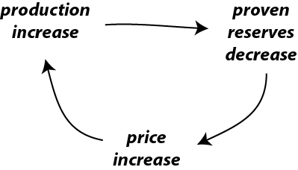
If the production increases, then the proven reserves must decrease; this triggers an increase in price, which in turns triggers an increase in production. Notice that the starting point (production increase) and the ending point (production increase) are the same. In other words, the change at the beginning of the mechanism promotes more of the same — this is what is known as a positive feedback mechanism. Positive feedback mechanisms tend to cause an acceleration of change, sometimes resulting in runaway behavior. In contrast, the are other feedback mechanisms that tend to counteract change, encouraging stability; these are known as negative feedback mechanisms. Note that in this context, positive is not necessarily good, and negative is not necessarily bad.

Open the model here, and run it. This model has two pages of graphs to look at; the first one shows the Proven Reserves, Produced Oil, price, and production, and r (which combines price and tech slope), while the second one shows just the production. The second graph retains the results from previous model runs, allowing you to make comparisons as you make changes to some of the adjustable model parameters. If you want to clear this graph, hit the Restore Graphs button.

 | Practice | Graded
Tech slope | 0.0001 | 0.0002
Price Slope | .05 | .07

3A. [2 pts] First, run the model as it is, with the price slope set to 0.05 and the tech slope set to 0.0002. Note the time and magnitude of the peak in production. Then alter the tech slope or price slope as prescribed, using the new values you were assigned. Run the model and compare the peak time and magnitude with the original case (use page 2 of the graph pad). Use “sooner” or “later” and “greater” or “smaller” to describe how your alterations changed the timing and magnitude of the peak in production.

3A Part 1 Change in time of peak = [later for practice]

3A Part 2 Change in magnitude of peak = [smaller for practice]

3B. [1 pt] Use the sliders above the graph to try out a range of different values for the price slope and the tech slope. Run the model with these different settings and see if you can make the peak in oil production go away. Is it possible to avoid a peak in production?

- Yes — there are just a few cases in which a peak in production occurs.
- No — it is impossible to avoid a peak in production; the best you can do is a broad, low peak that takes a long time to develop. [correct answer for practice]

4. Production Driven by Demand From a Growing Population

For our next experiment, we’ll try a different assumption about what drives oil/gas production — demand. The demand for oil and gas has risen over time due to an increase in the global population and an increase in the per capita energy consumption. Here is what this modified version of the model looks like:

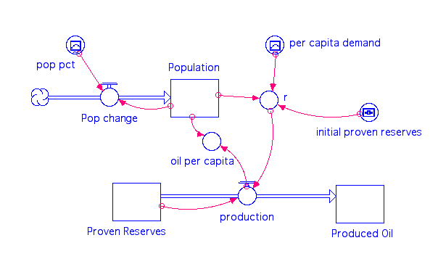

Here, the population increases according to pop pct, which is the net growth percentage per year derived from historical data and then extrapolated into the future — so it is a graphical function that changes over time. The population starts at the 1800 level of 1 billion; the net growth % drops to 0 in 2100, and at that point, the population will stabilize.

The demand for oil/gas is represented here by per capita demand, which is essentially a percentage of the proven reserves per billion people. The per capita demand is another graphical function of time, patterned after actual history up until 2010 and then extrapolated to 2100 — optimistically assuming that the per capita energy demands will level off at about 2100. Multiplying the population times the per capita demand gives us r, the fraction of the proven reserves produced in a given year, and then r multiplied by the Proven Reserves gives us the production. The fraction r will increase as the population grows and as the per capita demand grows, and if population and per capita demand level off, so will r. Recall from experiment 2 that if r is increasing over time, a peak in production is inevitable.

Because we are using real population values and real values for the per capita demand, it makes sense to use real numbers for the Proven Reserves. At the present time, the best estimates are that there are 1.5 trillion barrels of oil as proven reserves (this number includes natural gas too), and we have consumed about 1.2 trillion barrels from about 1900 to the present. This means that at the beginning of time, our Proven Reserves will be 2.7 trillion barrels.

This model also includes a component called per capita oil that keeps track of how much oil is actually available per person, by taking the production and dividing it by the population. As per capita oil increases, we can use more and more oil for our energy needs, but as it decreases, we will have to either reduce our energy consumption or turn to other sources to meet our energy demands.

4A. [1 pt] Can you guess what will happen? Remember that r here is just like r in the earlier models, and you’ve seen what happens to the production history when r increases over time. Which of the following represents your approximate prediction?
- Production will increase throughout the model run
- Production will decrease throughout the model run
- Production will peak sometime during the model run [correct answer for practice]

Now run the model, and see what happens. We will consider this as the “control” for the next experiment.

Model Values for 4B and 4C
 | Practice | Graded
Initial Proven Reserves | 2.0 | 3.5
(above numbers refer to trillions of barrels of oil)

4B. [1 pt] How will changing the initial size of the Proven Reserves reservoir affect the history of production? Set the initial Proven Reserves to the value supplied above (2.0 for practice, 3.5 for the graded version) and then run the model and see what happens, comparing the production curve with the "control" case from question 4A. Page 2 of the graph pad will be useful in making this comparison.
- It peaks at about the same time, with a larger peak
- It peaks at slightly earlier, with a smaller peak [correct answer for practice]
- It peaks later, with a smaller peak
- It peaks later, with a larger peak
- It peaks earlier, with a larger peak
- It peaks earlier with a smaller peak
- It does not peak at all

4C. [2 pts] If the production peaks and then declines, and the population grows or stays the same, then the oil per capita has to decline, because it is the production/population. With your modified model, find the oil per capita in the year 2100 and then find the time earlier in the model history when the oil per capita was about the same as your 2100 value.

Oil per capita in 2100 = (within 0.05 barrels/person) [0.02 practice version]
Previous time in history with same oil per capita = (within 5 yrs) [1865 practice version]

As you can see, this model suggests that our future use of oil will be a little like traveling back in time.

5. Adding Unproven Reserves and Unknown Oil

For our last experiment, we’ll see what happens when we add two more reservoirs, Unproven Reserves (the oil and gas that we think is likely to be discovered in the future) and Unknown Oil (the oil and gas we don’t know about, but might be there). Discovery adds Unproven Reserves to the Proven Reserves reservoir, and another flow called discovery adds Unknown Oil to the Unproven reservoir. An example from the Arctic Ocean region helps us get a grasp of these unknown reserves. In this frontier region, less than half of the offshore sedimentary basins have been explored, but based on what is known from more serious exploration off the coast of Alaska, the USGS estimates that there might be ~130 billion barrels of oil and gas — so this is a resource that we think might exist, but not enough is known about it yet to put it into the unproven reserves category, which applies to oil reserves that we know exist, but we don’t know enough about them to put them into the proven reserves. For perspective, this Arctic Ocean oil might represent 10-15% of all the unknown oil/gas that remains, and it would be enough to last for 4 years at the current rate of global use.

The discovery of these new resources is a function of a rate constant that increases over time, dictated by something called the exploration slope. The discovery flow that leads from Unknown to Unproven Reserves is set to be 1/5 the rate of the other discovery flow, reflecting the fact that it is much harder to discover something we know little about. Both of the discovery flows are controlled by switches (they can be turned on or off) and they begin (if the switch is on) at a time that can be set using the explor start time control knob. Here is what this new model looks like:
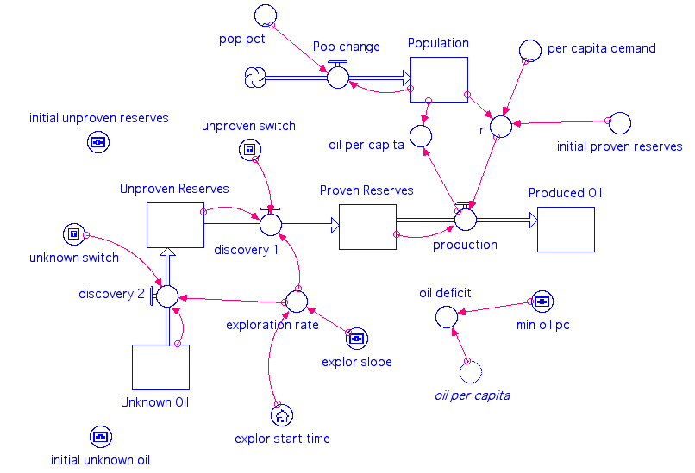

5A. [1 pt] How will these new sources of oil/gas change the production history? The total amount of produced oil obviously must be greater than in our model from experiment 4, but how about the shape of that production curve? Will there be a peak, as before? If so, what will that peak look like?
- Yes, it will still peak, but the peak will be smaller than before
- No, it will not peak — the production will rise and then remain steady
- Yes, it will peak, but the peak will be delayed and it will be bigger [correct answer for practice]

Before launching the model and experimenting with it, take a few minutes and watch this video that explains how to operate the switches that can turn the discovery flows on and off.

Open the model here, and first make sure the switches are in the off position (down), disabling the two discovery flows. Run the model and you should see exactly the same thing you saw in experiment 4B, with the difference that it runs for a longer period of time. Study graphs #3 and #7, which show comparative plots of the production (in billions of barrels per year) and oil per capita (in barrels). Make sure you watch the video above to get a general sense of what happens when you turn on the switches.

Model Values for 5B-D
 | Practice | Graded
Initial Unproven Reserves | 1.5 | 3.5
Initial Unknown Reserves | 2.0 | 2.5
Explor start time | 1980 ±1 | 2000 ±1

5B-D. Set the model up using the initial values provided in the table above. Use the slider bars at the top to set the initial unproven reserves and the initial unknown oil, and use the dial near the lower right to set the exploration start time (the time when we begin to develop and produce the unproven reserves and unknown oil). This dial is a bit hard to adjust precisely, but if you are within a year or two of the specified date, it will be fine. Run the model with both switches off, then run it again with the unproven switch turned on, and then one more time with both switches turned on. Evaluate the differences between these three model runs in terms of the production (graph #3) and the oil per capita (#7). There are many ways to evaluate the affects of adding these new sources of oil, but we’ll focus on the size and timing of the production peak, and the oil per capita in the year 2100.

5B. [1 pt] Oil per capita in 2100 with Unproven Reserve switch on (± 0.1)

[0.88 for practice]

5C. [1 pt] Oil per capita in 2100 with both switches on (± 0.1)

[1.01 for practice]

5D. [1 pt] Peak in production with both switches on compared to control (with no switches on).

- About the same time (within 10 yrs) and size (within 2 billion barrels/yr) [correct answer for practice]
- About the same time (within 10 yrs), but slightly larger (2-5 billion barrels/yr)
- Slightly later (10-20 yrs), and slightly larger (2-5 billion barrels/yr)
- Slightly later (10-20 yrs), and much larger (>5 billion barrels/yr)
- Much later (>20 yrs), and much larger (>5 billion barrels/yr)

5E. [1 pt] Can a peak in oil production be avoided? In other words, is it possible to find some combination of model parameters that results in more of a plateau in oil production? To figure this out, try changing the exploration slope (this will control that rate that the discovery flows increase), and the exploration start time. We’ll leave the unproven and unknown reserves at 3.0 because this is already a very optimistic outlook.

- Yes, a peak can be avoided
- No, a peak cannot be avoided, and no plateau greater than 10 yrs is possible
- No, a peak cannot be avoided, but a ~50 yr plateau is possible [correct answer for practice]

These next few questions are a bit broader and more general in scope — you may need to look back at some of the models we used here to answer these.

6. [1 pts] How does improving the technology of oil production (increasing the tech slope) affect the history of oil production?

- It makes the production peak sooner
- It makes the production peak later
- It makes the peak in production last longer
- It has no impact on the peak in production
- It makes the peak in production disappear

7. [1 pts] In the model, when the price slope is greater, the feedback is stronger and the production of oil is more strongly dependent upon the price. How does making this feedback stronger affect the history of oil production?

- When the feedback is stronger, the production of oil has a narrower, larger peak and it occurs earlier.
- When the feedback is stronger, the peak in production is smaller, more spread-out, and occurs later

8. [1 pts] According to the models we used in this exercise, can a peak in oil production be avoided?

- No
- Yes

9. [1 pts] What does a peak in oil production mean in terms of our future reliance on fossil fuels as the main energy source?
- It means we will have to rely on other energy sources and/or reduce our energy demands
- It means that we will have to find more oil and gas
- It means that we will have to start drilling in the Arctic since there is more than enough oil there
- It means we will be able to rely on oil and gas indefinitely into the future

10. [1 pts] Hopefully, you have a new, better understanding of "peak oil" — what it is, what causes it, and how inevitable it is. Which of the following best describes how you acquired this understanding?
- Through experimenting with models and thinking about the results from these models
- Through reflecting on your own thoughts and feeling on the subject
- Through listening what others have to say about it

Summary

We’ve just completed quite a few experiments, so it is a good idea to try to summarize a few important points.

1. When we talk about “peak oil”, we’re talking about the rate of oil production — how much oil/gas is brought to market in a given year — not the total amount of oil/gas on Earth (which peaked as soon as we started to pump it out of the ground!).

2. Improvements in our ability to extract oil/gas (i.e., improving technology) leads to a distinct peak in oil production.

3. If we assume that production is motivated by price, and price goes up as the oil becomes more scarce, this also leads to a peak in oil production.

4. If the demand for oil is related to population, and population increases, this also leads to a peak in oil production. This effect is enhanced if the per capita demand for energy increases, as it has during the last 100 years.

5. If we include unproven oil reserves and unknown reserves into the system, we can make the decline in oil production more gradual, but there is still a tendency for it to peak.

6. At the end of the day, there is a finite amount of oil and gas available to us. This fact, combined with improvements in technology, an increase in demand for production related to price, increasing population, and increased standard of living makes a peak in oil production inevitable — we cannot have a sustainable supply of oil and gas to fuel our economy. Facing up to this reality is important because it leads us to be more serious about making plans for a future where our energy needs are met without relying on fossil fuels.

