***Earth 104: Climate Modeling Activity***

In this activity, we’ll explore some relatively simple aspects of Earth’s climate system, through the use of several STELLA models — you’ve seen some of these in the Module 3 activity. STELLA models are simple computer models that are ideal for learning about the dynamics of systems — how systems change over time. The question of how Earth’s climate system changes over time is of huge importance to all of us, and we’ll make progress towards understanding the dynamics of this system through experimentation with these models. In a sense you could say that we are playing with these models, and watching how they react to changes; these observations will form the basis of a growing understanding of system dynamics that will then help us understand the dynamics of Earth’s real climate system.

If you pause for just a moment and think about what we are doing in these activities, it is really just an application of the scientific method. We start with a question, develop a hypothesis, devise and carry out an experiment to test the hypothesis or answer the question, and then study the results to see if they provide an answer to our original question. So, we are learning through experimentation.

***Introduction to a Simple Planetary Climate Model***

Our first climate model calculates how much energy is received and emitted (given off) by our planet, and how the average temperature relates to the amount of thermal energy stored. The complete model is shown below, with three different sectors of the model highlighted in color:

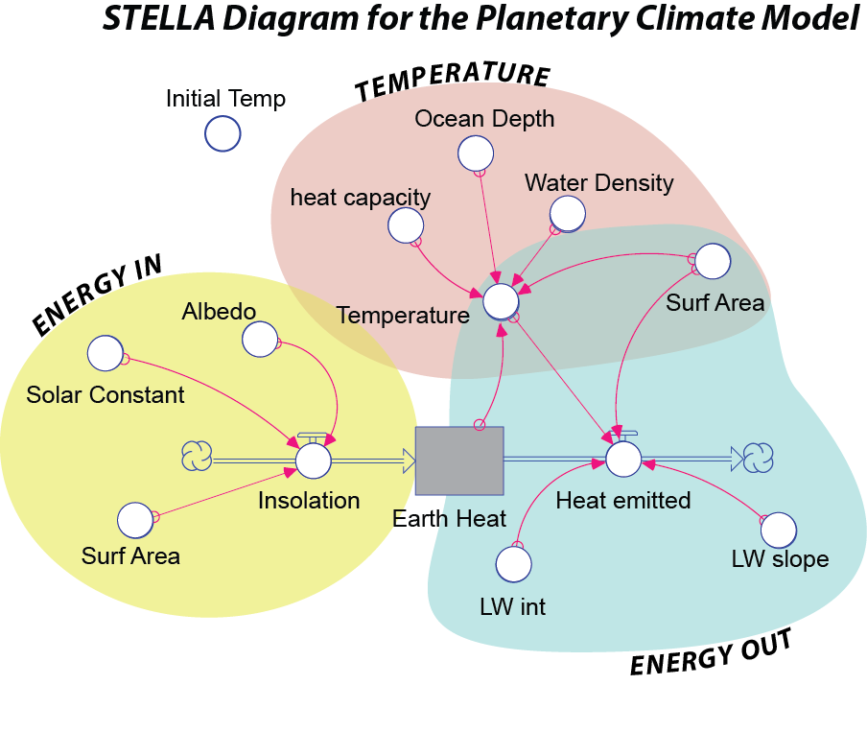

*Figure 1. A very simple STELLA model of Earth’s climate system. The three colored sectors show the parts of the model that keep track of the energy coming in to the Earth from the Sun, the energy leaving the Earth through emitted heat, and the average surface temperature of the Earth.*

*Credit: David Bice*

First, let’s define a few terms that you might not be familiar with.

***Insolation*** *— stands for Incoming Solar Radiation, which is a fancy way of saying sunlight or solar energy.*

***Albedo*** *— the fraction of light reflected from some material; 0 would be a perfectly black object (no reflected light) and 1 would be a perfectly white object (no light absorbed).*

***Heat capacity*** *— this is the amount of energy (units are Joules) needed to raise 1 kilogram of some material 1°C.*

***Ocean Depth*** — *this is the depth of the part of the ocean that is involved in climate over short time scales of decades, the part of the ocean exchanges energy with the atmosphere. While the whole ocean has an average depth of ~4000 m, the part we worry about here has a depth of less than 500 m.*

***LW Int and LW slope*** *— these are parameters used to describe the relationship between the average planetary temperature and the amount of long-wavelength (infrared, or thermal) energy emitted by the planet; more details are provided below.*

The ***Energy In*** sector (yellow in Fig. 1 above) controls the amount of insolation absorbed by the planet. The Solar Constant converter is not really a constant, but it does tend to stay close to a value of 343 Watts/m2 (think of about six 60 Watt light bulbs shining down on a patch of ground 1 meter on a side — this is what we get from the Sun). This is then multiplied by (1 – albedo) and then the surface area of the Earth, giving a result in Watts (which is a measure of energy flow and is equal to Joules per second). In the form of an equation, this is:

$$E_{in}=S×A×\left(1-α\right)$$

S is the Solar Constant (343 W/m2), A is surface area, and  is the albedo (0.3 for Earth as a whole).

The ***Energy Out*** sector (blue above) of the model controls the amount of energy emitted by the Earth in the form of infrared (thermal) radiation, which is a form of electromagnetic radiation with a wavelength longer than visible light, but shorter than microwaves. You saw earlier that this is often described using the ***Stefan-Boltzmann Law*** which says that the energy emitted is equal to the surface area times the emissivity times the Stefan-Boltzmann constant times the temperature raised to the fourth power:



A is the whole surface area of the Earth (units are m2),  is the emissivity (a number between 0 and 1 with no units),  is the Stefan-Boltzmann constant (units are W/m2 per °K4), and T is the temperature of the Earth (in °K). The problem with this approach is that it ignores the greenhouse effect, which is a very important part of our climate system. We could represent the greenhouse effect by choosing the right value for the emissivity in the Stefan-Boltzman law, but here, we will use a different approach, one in which Eout is based on actual observations. With a satellite above the atmosphere, we can measure the amount of energy emitted in different places on Earth and figure out how it relates to the surface temperature. As it turns out, this is a pretty simple relationship, described by a line:

$$E_{out}=\left({LW}_{int}+{LW}_{s}×T\right)×A$$

The part inside the parentheses is just the equation for a line, with an intercept (LWint with units of W/m2) and a slope (LWs with units of W/m2 per °C). This new way of describing Eout is shown as the red line in the figure below:

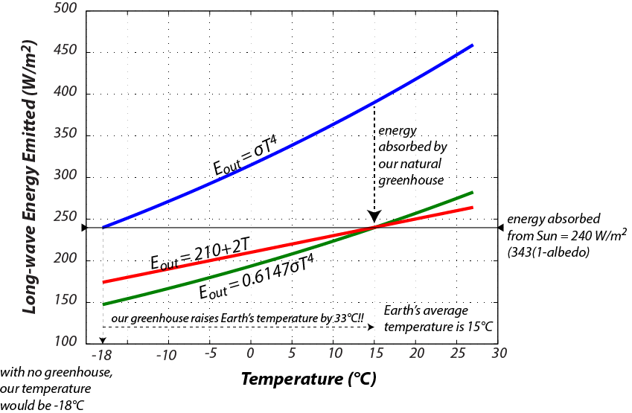

*Figure 2. Three different schemes for representing the long-wavelength energy (heat) emitted by Earth. The blue curve is the simple Stefan-Boltzman Law, which suggests that at the average temperature of the Earth (15°C), our planet would emit way more energy than we get from the Sun, and so we would cool down until the temperature reached -18°C at which point the Ein = Eout and we have a steady state. The green curve shows the Stefan-Boltzman Law modified by including a new term called emissivity (0.6147), which brings us into an energy balance (steady state) at a temperature of 15°C. The red curve instead represents this relationship based on actual measurements from satellites — notice that it too puts us at a steady state when the temperature is 15°C. The red curve is what we will use in this model.*

*Credit: David Bice*

The key thing here is that the hotter something is, the more energy it gives off, which tends to cool it and it will continue to cool until the energy it gives off is equal to the energy it receives — this represents a ***negative feedback mechanism*** that tends to lead to a steady temperature, where Ein = Eout.

The ***Temperature*** sector (brown in Fig. 1) of the model establishes the temperature of the Earth’s surface based on the amount of thermal energy stored in the Earth’s surface. In order to figure out the temperature of something given the amount of thermal energy contained in that object, we have to divide that thermal energy by the product of the mass of the object times the heat capacity of the object. Here is how it looks in the form of an equation:

$$T=\frac{E}{A×d×ρ×C_{p}}$$

Let’s look at it with just the units, to make sure that things cancel out:

$$\left[°K\right]=\frac{[J]}{\left[m^{2}\right]×\left[m\right]×\left[kg\right]×\left[m^{-3}\right]×\left[J\right]×\left[{kg}^{-1}\right]×[{°K}^{-1}]}$$

This can be simplified by combining, rearranging, and cancelling to give:

$$\left[°K\right]=\frac{\left[m^{3}\right]×\left[kg\right]×[J]×[°K]}{\left[m^{3}\right]×\left[kg\right]×\left[J\right]}$$

Here, E is the thermal energy stored in Earth’s surface [Joules], A is the surface area of the Earth [m2], d is the depth of the oceans involved in short-term climate change [m],  is the density of sea water [kg/m3] and Cp is the heat capacity of water [Joules/kg°K]. We assume water to be the main material absorbing, storing, and giving off energy in the climate system since most of Earth’s surface is covered by the oceans. The terms in the denominator of the above fraction will all remain constant during the model’s run through time — they are set at the beginning of the model and can be altered from one run to the next. This means that the only reason the temperature changes is because the energy stored changes.

The model has a few other parts to it, including the initial temperature of the Earth, which determines how much thermal energy is stored in the earth at the beginning of the model run. It also includes some other features that allow you to change the solar input and the part of the greenhouse effect due to CO2. We use the standard assumption (which is itself based on some physics calculations) that *for each doubling* of the CO2 concentration, there is an increase of 4 W/m2 in the greenhouse effect. This is often called the ***greenhouse forcing*** due to CO2. In terms of our Eout curve shown in Figure 2 above, this shifts the red curve downwards — so less energy is emitted, and thus more is retained by the Earth. Let’s consider how this works — if we start with 200 ppm of CO2 and increase it to 800 ppm, that represents 2 doublings (from 200 to 400 and then from 400 to 800), so we would get 8 W/m2 of greenhouse forcing.

One unit of time in this model is equal to a year, but the program will actually calculate the energy flows and the temperature every 0.1 years.

Now that you have seen how the model is constructed, let’s explore it by doing some experiments. Here is the link to the [model.](https://exchange.iseesystems.com/public/davidbice/earth-104-mod-4-1)

***Experiment 1: Steady State***

One of the most important components of this climate system is the relationship between temperature and the energy emitted by the planet (Fig. 2), which constitutes a negative feedback mechanism. Negative feedback mechanisms are like thermostats that act to control the temperature and maintain a steady state. In this experiment we see if that expectation is met by our model.

What happens if we start out with an Earth that is *not in a steady state*, so that $E_{in}≠E_{out}$? Use the slider controls at the top to set the initial conditions specified in the table below.

|  |  |  |
| --- | --- | --- |
|  | Practice | Graded |
| Albedo | 0.3 | 0.31 |
| CO2 Mult | 1.0 | 1.0 |
| Solar Mult | 1.0 | 1.0 |
| Initial T | 20°C for #1,2, (10°C for #3) | 5°C for #1,2, (25°C for #3) |

**1.** What will happen? How will the temperature change over time? Think about how the Ein and Eout will compare at the beginning.

1. Eout > Ein — this will cause warming
2. Eout > Ein — this will cause cooling *[correct answer for the practice version]*
3. Eout < Ein — this will cause warming
4. Eout < Ein — this will cause cooling
5. Eout = Ein — temperature will remain constant

**2.** Now, run the model and see what happens. What is the temperature at the end of the model run (to the nearest 0.1 °C)?

Ending Temperature = [ 15°C for practice version]

This has to be different in the graded version because you will change the albedo to 0.31 — thus reducing the amount of insolation absorbed by the planet

**3.** Now change the initial temperature to second value as prescribed above, run the model and see what happens. Compared to the answer to #2, is the ending temperature the same (within 0.1 °C) or different (varies by more than 0.1°C)?

1. Same *[correct answer for the practice version]*
2. Warmer
3. Cooler

**4.** ***Steady state*** for a system is the condition in which the system components are not changing in value over time even though time is running and things are moving through the system. What is the steady state temperature of your system?

Steady State Temperature = [ 15°C for practice version]

**Be sure to reset everything in the model before going to the next problem.**

**Hit the refresh button on your browser or the rest button on the model.**

***Experiment 2: A Fluctuating Sun***

The Solar Constant is not really constant over any length of time. For instance, it was only 70% as bright early in Earth’s history, and it undergoes much more rapid fluctuations (and much smaller) in association with the 11 year sunspot cycle. During a sunspot cycle, the solar constant may vary by as much as 0.3 W/m2. Let’s see what this would do to the temperature of the planet. The model has a small switch called the Solar Cycle Switch that we can use to turn on of off the effects of the solar cycle. Set the model up with the following parameters:

|  |  |  |
| --- | --- | --- |
|  | Practice | Graded |
| Albedo | 0.30 | 0.30 |
| CO2 Mult | 1.0 | 1.0 |
| Solar Mult | 1.0 | 1.0 |
| Initial T | +15 | +15 |
| Ocean depth | **100** for #5,6, (**200** for #7) | **150** for #5,6, (**50** for #7) |

**5.** Run the model and see what happens. How much does the planetary temperature change over the solar cycle (difference between peak and trough — ***measure this after the third peak***)?

Change in temperature in one cycle = [0.02°C for practice version]

To see how this answer is obtained, here are some screen shots from the model, along with some comments. First, turn on the solar switch, set the ocean depth to 100, then run the model. Then place the cursor on one of the peaks in temperature to get the value and time of that point on the graph, which shows us that the temperature is 15.01°C and the time is 27.2 years.

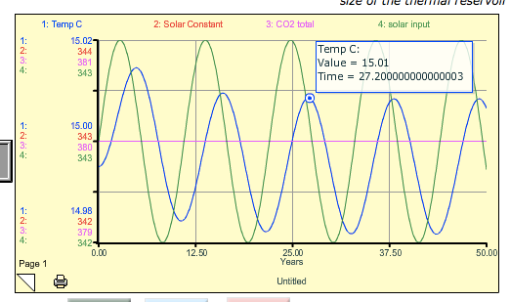

Then, move the cursor to the adjacent trough in the blue curve to get the values there, which turn out to be 14.99 at a time of 32.5 years:

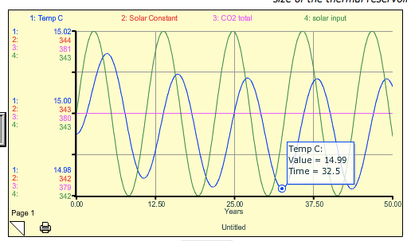

The difference in temperature is thus 0.02°C (not a very big deal), which is the answer to the question.

**6.** Notice that the temperature peaks after the Solar Constant peaks. This time delay is called a *lag time*. What is the lag time here in years? (± 0.2 yrs)

Lag Time = [2.3 yrs for practice version]

To get this answer, you need to position your cursor at the peak of the green curve (the solar constant and the solar input are the same curves in this plot) and mark the time, which is 24.9 years — this is 2.3 years earlier than the peak in the blue curve

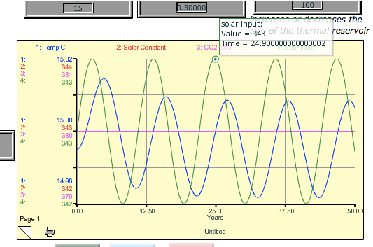

**7.** Predict how the model will change if you increase the ocean depth to the second specified depth (table above). How do you think the lag time and the magnitude of temperature will change relative to the first solar cycle model (#5,6)? In other words, make a prediction. It might help to think about what heats up faster — a pot with a little water in it, or the same pot with a lot of water in it?

1. Lag time shorter, magnitude smaller
2. Lag time shorter, magnitude greater
3. Lag time longer, magnitude smaller *[correct answer for the practice version]*
4. Lag time longer, magnitude greater

**Be sure to reset everything in the model before going to the next problem.**

***Experiment 3: Changing CO2***

Let’s see what happens when we change the concentration of CO2 in the atmosphere.

|  |  |  |
| --- | --- | --- |
|  | Practice | Graded |
| Albedo | 0.30 | 0.30 |
| CO2 Mult | **0.5** | **2.0** |
| Solar Mult | 1.0 | 1.0 |
| Initial T | 15°C | 15°C |
| Ocean depth | 100 | **50** |

First, try to predict what will happen. How much warming or cooling will occur? Will the temperature level off, or rise/fall forever? Then run the model.

**8**  You’ve changed the atmospheric CO2 concentration from its original value of 380 ppm by multiplying that value by the specified value (0.5 in the practice, 2.0 in the graded). What is the resulting atmospheric CO2 concentration in your model?

New CO2 concentration = [ 190 ppm practice version]

**9** What is the resulting temperature change at the end (50 yrs)? (±0.1 °C)

Change in temperature = [-2°C practice version]

**10** Notice that the temperature levels off at the end — it finds a new steady state. How long does it take to level off? Let’s find the response time, which is defined as the time required to accomplish 2/3 of the total temperature change. For example, if the temperature change was 1°C and it started at 15°, then we would find the time when the temperature reached 15.67°C — this would be the response time.

Find the response time for this case. (±.5 yrs)

Response Time = *[7.3 yrs for practice version — the total temp change was -2°C, and 2/3 of this is -1.33°C, so we run the cursor along the curve to find the time when the temp gets to 13.67°C (15-1.33=13.67), which occurs at about 7.3 yrs*]

New model for this next part.

***Experiment 4. Causes of Climate Change***

Things that can cause the climate to change are sometimes called climate forcings, and we’ve just tinkered with two of these — the Sun, and CO2. It is generally agreed upon that on relatively short timescales like the last 1000 years, there are 4 main forcings — solar variability, volcanic eruptions (whose erupted particles and gases block sunlight), aerosols (tiny particles suspended in the air) from pollution, and greenhouse gases (CO2 is the main one). Solar variability and volcanic eruptions are obviously natural climate forcings, while aerosols and greenhouse gases are *anthropogenic*, meaning they are related to human activities. The history of these forcings is shown in the figure below.

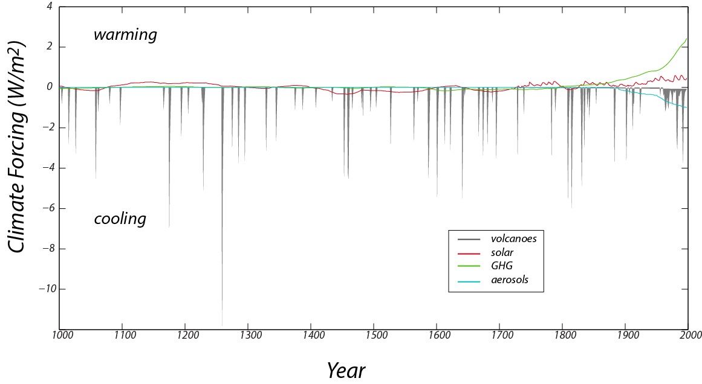

*Figure 3. The reconstructed record of important climate forcings over the past 1000 years (data from Crowley, 2000). Positive values lead to warming, while negative values lead to cooling. Note that although volcanoes have very strong cooling effects, these effects are very short-lived.*

*Credit: David Bice*

Volcanoes, by spewing ash and sulfate gases into the atmosphere block sunlight and thus have a cooling effect. This history is based on the human records of eruptions in recent times and ash deposits preserved in ice cores (which we can date because they have annual layers — we count backwards from the present) and sediment cores for older times. Note that although the volcanoes have a strong cooling effect, the history consists of very brief events. The solar variability comes from actual measurements in recent times and further back in time, on the abundance of an isotope of Beryllium, whose production in the atmosphere is a function of solar intensity — this isotope falls to the ground and is preserved in ice cores. The greenhouse gas forcing record is based on actual measurements in recent times and ice core records further in the past (the ice contains tiny bubbles that trap samples of the atmosphere from the time the snow fell). The aerosol record is based entirely on historical observations and is 0 earlier in times, before we began to burn wood and coal on a large scale.

In this experiment, we will add the history of these forcings over the last 1000 years and see how our climate system responds, comparing the model temperature with the best estimates for what the temperature actually was over that time period. Solar variability, volcanic eruptions, and aerosols all change the Ein or Insolation part of the model, while the greenhouse gas forcing change the Eout part of the model. We can turn the forcings on and off by flicking some switches, and thus get a clear sense of what each of them does and which of them is the most important at various points in time.

We can compare the model temperature history with the reconstructed (also referred to in the model as “observed”) temperature history for this time period, which comes from a combination of thermometer measurements in recent times and temperature *proxy* data for the earlier part of the history (these are data from tree rings, corals, stalactites, and ice cores, all of which provide an indirect measure of temperature). This observed temperature record, shown in graph #1 on the model, is often referred to as the “hockey stick” because it resembles (to some) a hockey stick with the upward-pointing blade on the right side of the graph.

First, open the [model](https://exchange.iseesystems.com/public/davidbice/earth-104-mod-4-2) with the forcings built in, and study the Model Diagram to get a sense of how the forcings are applied to the model. If you run the model with all of the switches in the off position, you will see our familiar steady state model temperature of 15°C over the whole length of time. The model time goes from the year 1000 to 1998 because the forcings are from a paper published in 2000.

Graph #1 plots the model temperature and the observed temperature in °C, graph #2 plots the 4 forcings in terms of W/m2, graph #5 plots the cumulative temperature difference between the model and the observed temperature (it takes the absolute value of the temperature difference at each time step and then adds them up — the lower this number at the end of time, the closer the match between the model and the observed temperatures), and graph #6 shows the same thing, but it begins keeping track of these differences in 1850, so it focuses on the more recent part of the history. Graph #1 gives you a visual comparison of the model and the observed temperatures, while graphs #5 and 6 give you a more quantitative sense of how the model compares with reality.

***Here are the parameters for the 2 versions:***

|  |  |  |
| --- | --- | --- |
|  | Practice | Graded |
| Ocean Depth | 100 | 300 |

**11.** Use the switches to examine the effect of each of the 4 forcings separately (only 1 switch on at a time), and observe how well the model temperature matches the reconstructed (observed) temperature by looking at graph #1 only. Of the 4 forcings, which gives a better fit to the general (smoothed) shape of the observed temperature? (In other words, don’t pay attention to the detailed, squiggly part of the graph).

Best fit from:

1. Solar
2. Volcanoes
3. Aerosols
4. GHG (greenhouse gases) *[correct answer for the practice version]*

**12.** Now, find the forcing that does the best job of matching the detailed ups and downs (ignoring the longer term trends).

Best fit from:

1. Solar
2. Volcanoes *[correct answer for the practice version]*
3. Aerosols
4. GHG (greenhouse gases)

**13.** Now try the combinations of the forcings listed below and choose the one that gives the best fit in a numerical sense over the whole length of the model period (years 1000 to 1998).

1. All forcings on
2. Volcanoes + GHG
3. Solar + volcanoes
4. Solar + volcanoes + GHG
5. GHG + aerosols + volcanoes *[correct answer for the practice version]*
6. GHG + solar
7. Volcanoes + aerosols

**14.** Of all the forcings, which does the best job in terms of matching the strong increase in temperature over the last 100 years? This is the upward-pointing blade of the “hockey stick” pattern. Base your answer on a visual inspection of graph #1.

1. Solar
2. Aerosols
3. Volcanoes
4. GHG (greenhouse gases) *[correct answer for the practice version]*

***Summary***

As before, let’s try to recap some of the main points from this activity.

1. Earth’s climate system is an energy balance system in which the energy absorbed from the Sun is equal to the energy emitted (in the form of infrared radiation) by the Earth.

2. The simple fact that the energy emitted is directly related to the temperature provides a powerful negative feedback mechanism that drives the system to a steady state (where the energy in is equal to the energy out).

3. Although the system has a tendency to find a steady state, changes in the solar input, the albedo, and the greenhouse effect can change the steady state and the system takes a while to adjust and get into the new steady state.

4. The influence of CO2 on Earth’s climate is a logarithmic one, meaning that for each doubling, the amount of extra heat retained in our system increases by 4 W/m2 — so changing the concentration from 200 ppm to 400 ppm has more of an effect than changing it from 400 ppm to 600 ppm.

5. We hypothesize that over the past 1000 years, there are four main forcings that cause our climate to change — solar variability, volcanic eruptions, aerosols (or pollutants), and greenhouse gases. By applying these forcings to our simple climate model, we can see that combined, they provide a fairly good match with the observed temperature record (supporting our hypothesis). Of these forcings, the greenhouse gases are by far the most important in terms of matching the observed temperatures over the past 100 years. Thus, we conclude that the increase in CO2 over this time period is the primary cause of the warming. None of the other forcings are capable of explaining this warming.