Earth 107: Module 1 Lab

Important! We advise you to either print or download/save this document as it contains the steps you need to take to complete the Lab in Google Earth. In addition, it contains prompts for measurements and questions that you should take note of (by writing down or typing in) as you work through the Lab.

Once you have worked through all of the steps and completed the measurements, you will go to the Module 1 Lab in Canvas to complete the Lab by answering multiple-choice questions. The answers to questions on this Lab worksheet will match choices in the multiple-choice questions in Canvas. Submit the quiz in Canvas for credit.

General Instructions for Module 1 Lab
- Be sure that you read the City Profiles for Guangzhou, China and New Orleans, LA on the course web site.
- Download the KMZ file from the course web site and open it in Google Earth. It will appear in the “Places” pane on the left of the screen. You will need to open the contents by checking the box next to the KMZ file name and clicking the arrow next to the box. You will need to open the folder containing all the locations by clicking on the folder icon. You will see a list of all the cities included in the tour - these are the cities ranked highly in the World Bank study.
- For this Lab, we will be touring just two cities that appear on both World Bank lists: Guangzhou, China and New Orleans, LA. Check the boxes next to these cities in the Google Earth sidebar and keep the other cities unchecked for now. The other cities are included in case you want to explore them, or if you choose one of these cities for your Capstone, you can use the KMZ file again to locate and explore the city on Google Earth.
- To fly to one of our cities of interest, click on the city name. We begin our tour by going to Guangzhou. We will be going to each city in turn and considering the similarities and differences between these places to better understand their ranking.
- Once you “arrive” at your destination city, follow the steps below to explore and complete the table for each city.

Guangzhou, China Exploration

Measure distance, area, and elevation.
- Fly to Guangzhou by clicking on the city's name in the Google Earth My Places pane to the left of the screen.
- At 350 km eye alt. with borders and Labels turned on, using the Ruler Tool, estimate distance from the push pin place marker in the city of Guangzhou to the S. China Sea (a point near Hong Kong).
- Use the Polygon tool to get an estimate of the area of greater Guangzhou. Draw a polygon around the built area of Guangzhou. Because Guangzhou is part of a huge metropolis, it is hard to distinguish the area of the city to include. To keep our answers somewhat uniform, draw your polygon around the area of the city that is north of where the tributaries enter the wider part of the estuary and keep to the west of the eastern edge of the estuary. Click on “measurements” to get the area and be sure to express it in km.
- At eye alt of ~50 km, starting at the mouth of the Pearl River estuary (where it meets the ocean), move your mouse north towards Guangzhou, mousing over the land near the river. Note the variations in elevation shown at the bottom of the screen. What range do you observe?

Create an Elevation Profile.
With Eye altitude at 50 km, create an elevation profile beginning at the “push pin” in the center of Guangzhou, and traveling SW to the bank of the Pearl River downstream from the city.

Directions for elevation profile:
- We will create an elevation transect line from a point near the center of Guangzhou to the tidal Pearl River to SE of the city. To begin, you will use the “add path” tool to draw the shortest possible straight line traveling approximately southwest between the center of Guangzhou (shown by the yellow push pin labeled Guangzhou”) and the bank of the Pearl River estuary. The “add path” button is at the top left of the Google Earth window, as shown below.
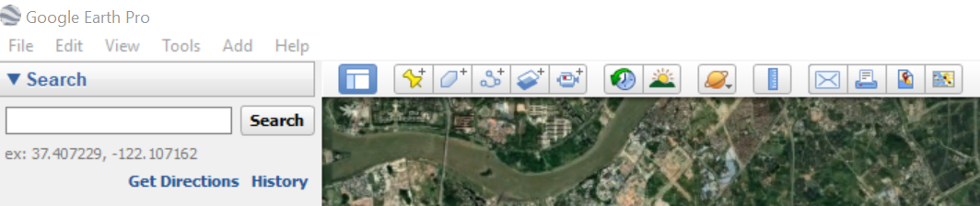

- Clicking this button will open the “New Path” window. Type “Guangzhou Elevation” into the name field. Note that your mouse pointer now looks like a crosshair when you move it over the map.

- With the window still open, use the crosshair to click once near (but not on) the red dot at the center of Guangzhou, and then click one more time at the nearest point in the bank of the wide portion of the river where it is flowing south. Your screen should now look like this:

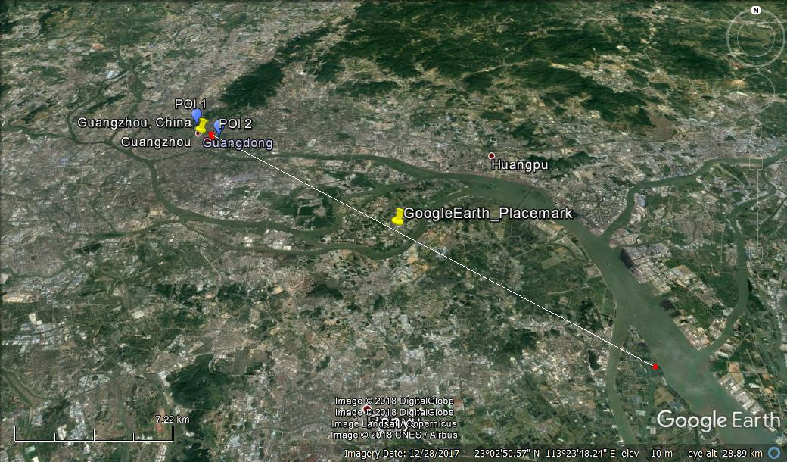

- Click OK to close the window. In the “places” window on the left-hand side of your screen, find the item named “Guangzhou Elevation” that you just created, right click on it, and select “Show Elevation Profile.”

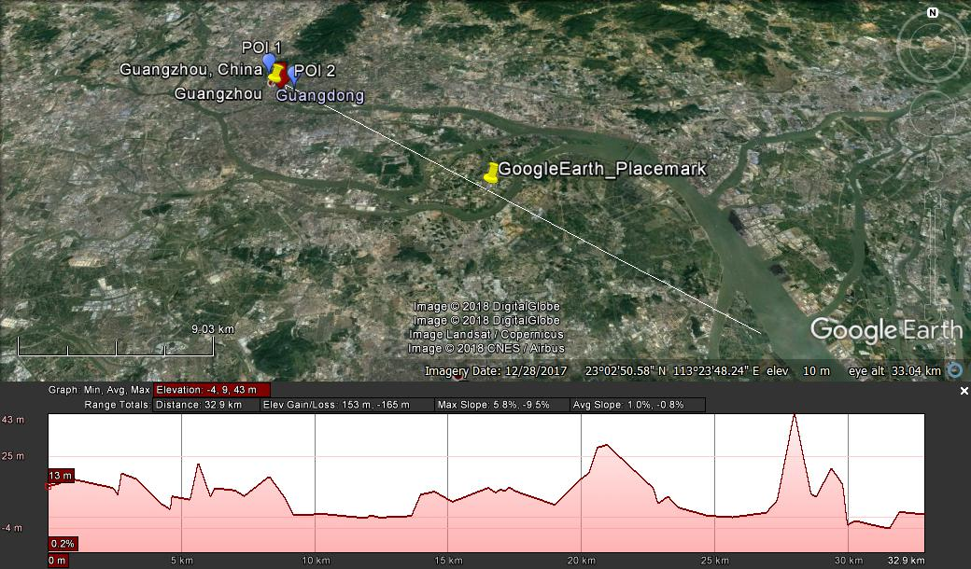

- The graph showing at the bottom of your screen shows the elevation at every point along the line from your starting point (Guangzhou city center, on the left) and your ending point (the ocean, on the right). If you run your mouse along the length of the graph, a red arrow will show you the corresponding location and elevation on the map. On the graph there will be a box at top right that shows the minimum, maximum and average elevations along your transect.

Questions for Guangzhou Exploration

- What are the minimum, average and maximum values shown on your elevation profile transect?

- How would you describe the observed topography of your transect?

- What are your observations about land use at higher elevations versus lower elevations?

- Imagine a typhoon storm surge pushes ocean water from the South China Sea into the Pearl River estuary. The height of the storm surge is 5 meters (~15 ft). Estimate the approximate percent of the land area in your transect that would be flooded.

- Based on your observations, why do you think Guangzhou ranks so high on the World Bank list of coastal cities vulnerable to flooding?

New Orleans, Louisiana, USA Exploration

Measure distance.
- Fly to New Orleans by clicking on the city’s name in the Google Earth My Places pane to the left of the screen.
- At 350 km eye alt. with borders and Labels turned on, use the Ruler Tool, estimate distance from the push pin place marker in the city of New Orleans to the mouth of the Mississippi River.
- Use the Polygon tool to get an estimate of the area of greater New Orleans. Draw a polygon around the built area of the city. Click on “measurements” to get an estimate of the area.
- At eye alt of ~10 km, starting to the south of the city near the Mississippi River, move your mouse north towards the city, mousing over the land near the river. Note the variations in elevation shown at the bottom of the screen. What range do you observe?
- Staying at ~10 km eye altitude, move your mouse around beginning near the river to the south east of the push pin. This is downtown New Orleans. Now travel roughly north, watching the elevation numbers. Keep moving across the city with your mouse and observe the changes in elevation. What do you observe?

Create an elevation profile.
- At 50 km eye alt, create an elevation profile, using the same method as you did for Guangzhou, from the shore of Lake Pontchartrain at Latitude/ Longitude*: 30.027778 -90.111111. (beginning just in the water) traveling SW for approximately 37 km until you cross the hurricane protection levee to the southeast of the city at Lat/long: 29.847222, -89.822222. Your profile should end just outside the levee, which appears as a faint, pale line on the image. Note that this levee surrounds the city on all sides.
Note: when using Google Earth search, express coordinates in decimal degrees as shown above, rather than degrees, minutes and seconds. Other ways of writing the coordinates may not allow you to use the search function to find your location.
You transect should look similar to the image below.
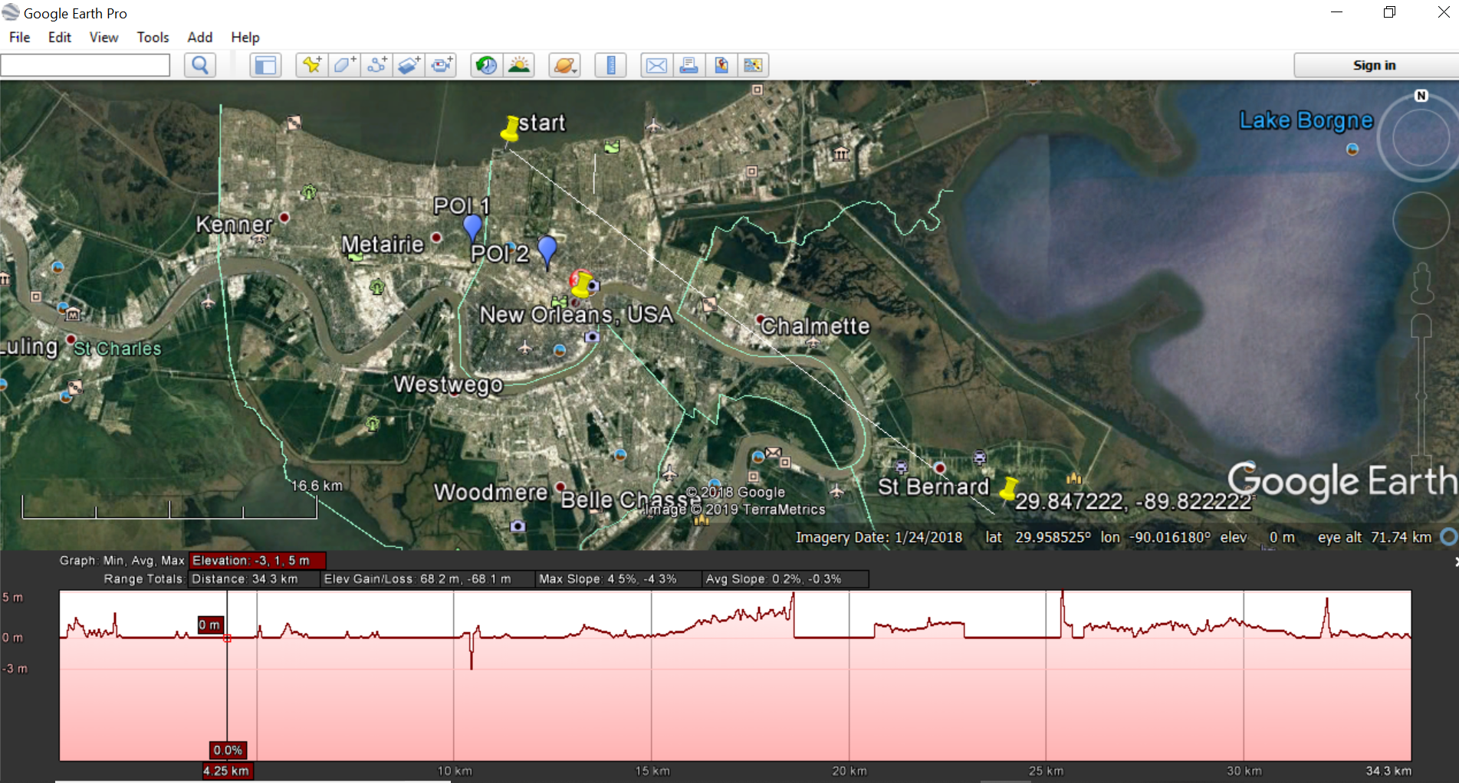

- First mouse over this transect and observe the elevations shown in bottom right of screen. At the levee, zoom to 1 km altitude and note the elevation right at the levee. You need to be at a low altitude to get accurate elevations in this flat landscape.

Questions for New Orleans Exploration

- What are the minimum, average and maximum values shown on your transect? Do you notice anything unusual about the elevations showing on your transect inside the levee system? Do they completely agree with the elevations you see on the screen as you move your mouse over the map in the same location? Why do you think there is a difference?

- What is the approximate height of the levee?

- How would you describe the observed topography of your transect?

- Imagine a hurricane storm surge pushes ocean water from the Gulf of Mexico into the Lake Pontchartrain estuary. The height of the storm surge is 5 meters (~15 ft). What percent of the land covered by your transect would be inundated by water?

- What if the storm surge was 10 m (~30 ft)? What percent of the land area would be flooded?

- What are the reasons New Orleans ranks so high on the World Bank list of coastal cities vulnerable to flooding?

- What is one factor that would cause New Orleans to be reduced in rank among flood prone coastal cities?

- Guangzhou outranks New Orleans in flood vulnerability. Why do you think that is?

Lab Completion Instructions

Once you have worked through all of the steps and completed the measurements for the Guangzhou and New Orleans explorations, go to the Module 1 Lab in Canvas to complete the Lab by answering multiple-choice questions. Remember, the answers to questions on this Lab worksheet will match choices in the multiple-choice questions in Canvas. Submit the quiz in Canvas for credit.

