Earth 107: Module 6 Lab
Important! We advise you to either print or download/save this document as it contains the steps you need to take to complete the Lab in Google Earth. In addition, it contains prompts for measurements and questions that you should take note of (by writing down or typing in) as you work through the Lab.
Once you have worked through all of the steps, you will go to the Module 6 Lab in Canvas to complete the Lab by answering multiple-choice questions. The answers to questions on this Lab worksheet will match choices in the multiple-choice questions in Canvas. Submit the quiz in Canvas for credit.

General Instructions for Module 6 Lab

Analyzing Hurricane Impacts

The goal of this short lab is to use Google Earth to estimate the rate of damage to coastal residential areas in coastal Mississippi and New Jersey as a result of two major hurricanes, and to compare the rate of rebuilding in these two communities in the years following the storms. Our method for quantifying the rate of damage and rebuilding is quite subjective and is an estimate only. We will look at a small area in each community and count the number of houses before and after the storm, and then look at the condition of the two neighborhoods six years later. Because we must focus on a small area, which may not be representative of the community as a whole, our method may be a little flawed, but it is a way to get an idea of how things played out after a major disaster and to consider some of the factors that determine if and how a coastal community rebuilds in place. These two locations were chosen for ease of quantifying damage and recovery. There are countless other locations we could analyze.

We will be touring two locations to view impacts from storms: Hurricane Katrina (Aug 29, 2005) in Pass Christian, MS and Hurricane Sandy (Oct 31, 2012) in Mantoloking, near Atlantic City, NJ.

Copy and paste the coordinates provided in the Google Earth Search Pane to navigate to the locations. Once you “arrive” at your destination, follow the steps below to explore, calculate changes over time, completed the tables, and answer the questions.

Note: Further information about the two hurricanes and communities examined can be found on the Module 6 Lab page (where you downloaded this Worksheet) under “Downloads/Resources.”

Hurricane Katrina and Pass Christian, MS
- Open Google Earth.
- Copy and paste coordinates: 30.329434, -89.198009 (Pass Christian, MS) into the search pane in Google Earth.
- Focus on the housing that form a rectangle bounded by a road (count all houses inside the road and the row of houses to the north on the road), where the coordinates 30.329434, -89.198009 are located in the middle of the southern edge of this rectangle. See screenshot below.
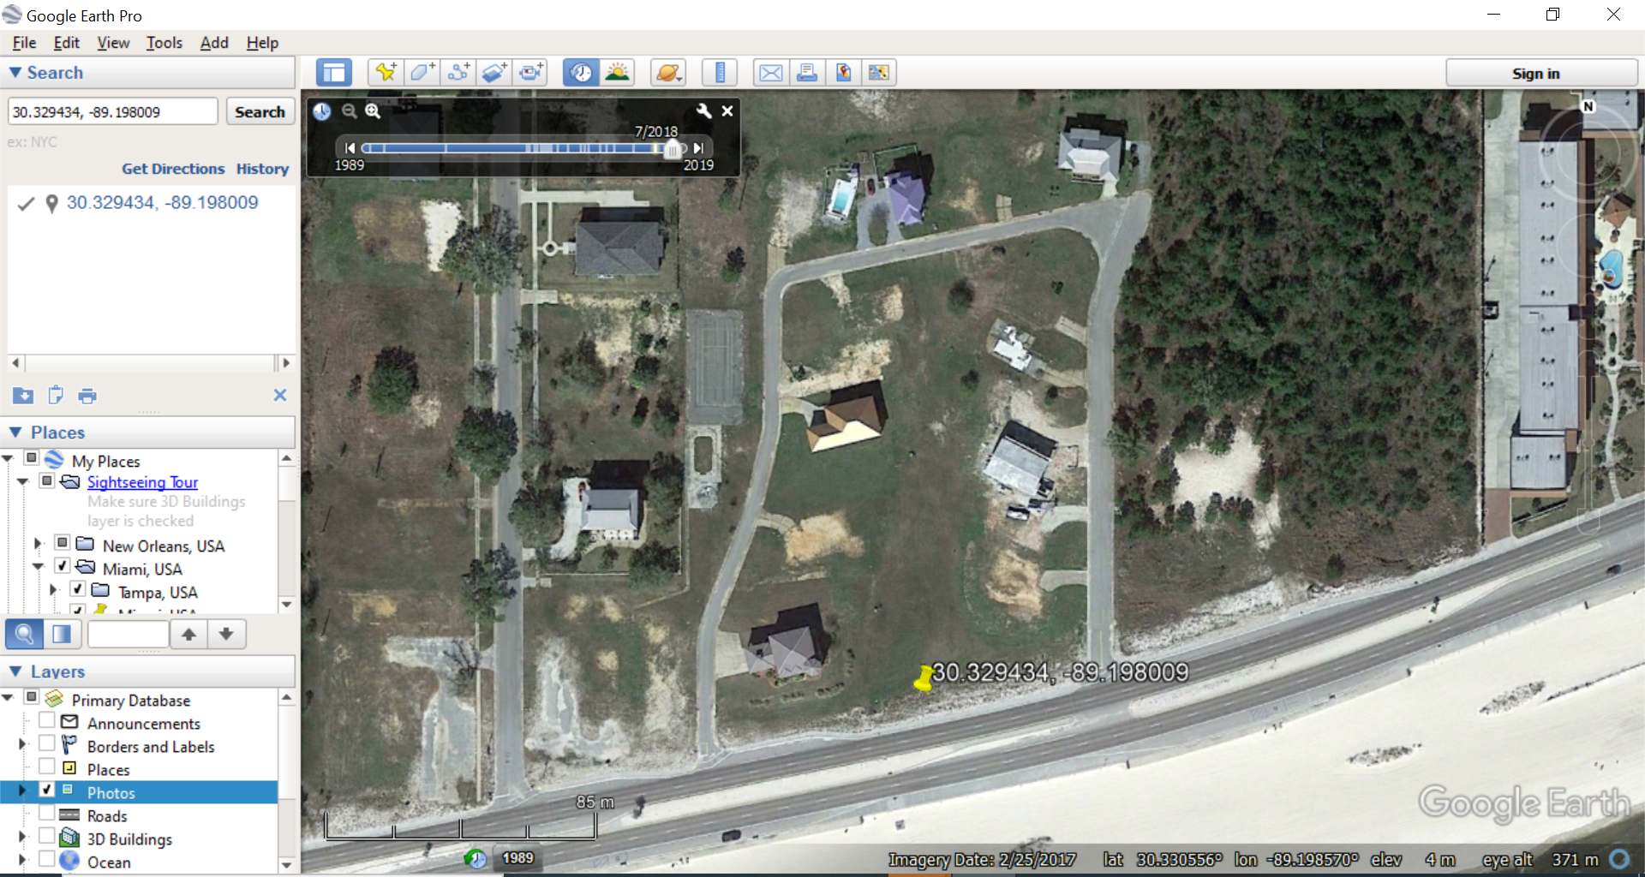
- Using the timeline tool, view 7/2005, 8/2005 and 11/2011.
- Compare the views for each of these dates. Make notes on the evidence of damage from Hurricane Katrina. With the eye altitude set between 500 and 250 m, make an estimate of the number of houses that were destroyed by the storm in this location. Estimate the number of houses rebuilt by 11/2011 (6 years later).
- Now observe the changes to the beach in this location at these time periods. Note if the beach width changed significantly between each of the dates and look for evidence of major erosion and beach restoration.
- Use the street view to observe the community and the nature of the beach.
- Complete the table with results for each location and date.

Date | 7/2005 (pre-Hurricane Katrina) | 8/2005 (immediately after Hurricane Katrina) | 11/2011 (6 years after Hurricane Katrina | % houses destroyed | % destroyed houses rebuilt
Number of intact houses around the rectangle bounded by the road.

Questions 1-3

- Approximately what percentage of houses were destroyed by Hurricane Katrina in this neighborhood in Pass Christian, MS?
- Approximately what percentage of houses destroyed were rebuilt in this neighborhood in Pass Christian, MS by 2011 (6 years after the hurricane)?
- When viewing at approximately 600 m, and comparing time periods, do you see evidence of major beach erosion and man-made beach restoration at this location?
Hurricane Sandy and Mantoloking, NJ
Mantoloking, NJ 2010 – 2018

Now we will look at the community of Mantoloking, NJ, which received the storm surge of Hurricane Sandy in 2012.

- Copy and paste coordinates: 40.036948 -74.050919 (Mantoloking, near Atlantic City, NJ).
- Focus on the first 3 rows of housing from the shoreline back and south of the bridge, where the coordinates 40.036948 -74.050919 are located at the corner of intersecting streets on the bottom (southern) edge of your screen. See Screenshot below.
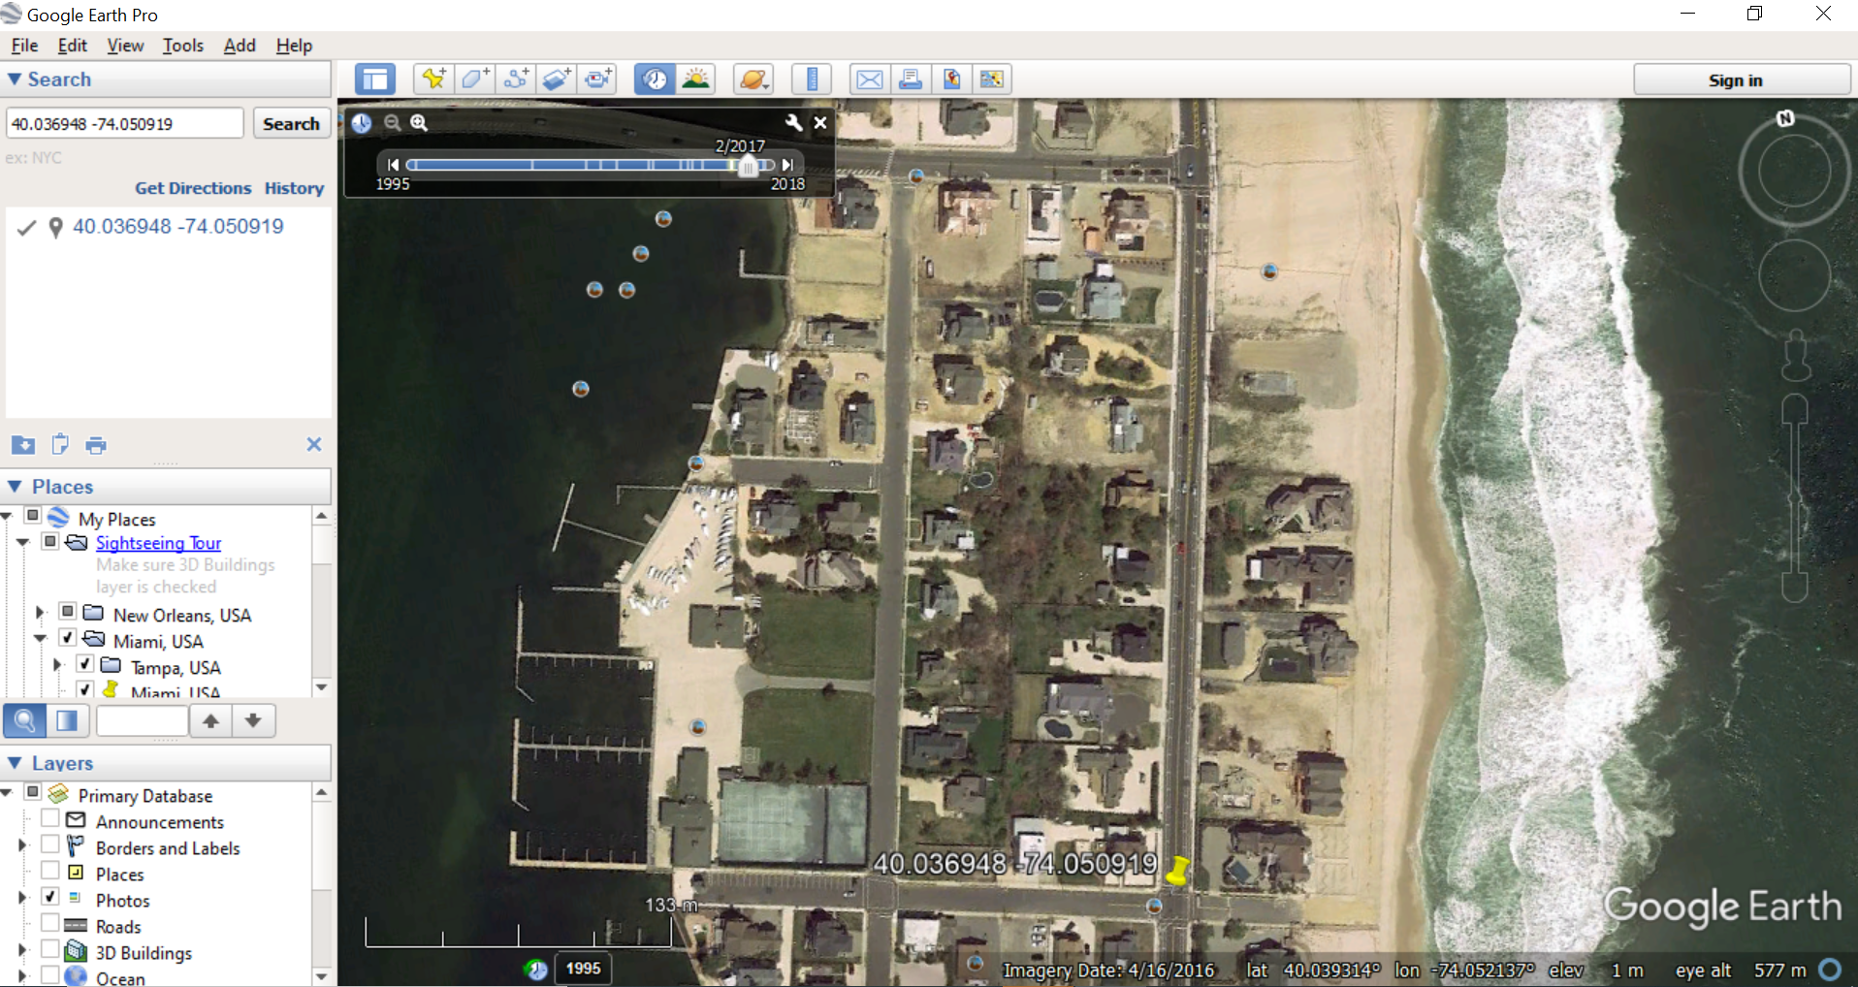
- Using the timeline tool, view 9/2010, 11/2012, and 7/2018. Compare the views for each of these dates.
- Make notes on the evidence of damage from Hurricane Sandy. With the eye altitude set between 500 and 250 m, make an estimate of the percent of houses that were damaged by the storm in this location. Estimate the percent of houses repaired by 2018.
- Use the street view to observe the community and the nature of the beach.
- Complete the table below with results for each location and date.

Mantoloking, NJ, 40.036948 -74.050919
Date | 9/2010 | 11/2012 | 7/2018 (6 years after Sandy) | % houses destroyed/ | % of destroyed houses rebuilt
Number of intact houses in the first two blocks back from the beach (count 3 rows of houses)

Questions 4-7

- Approximately what percentage of houses were destroyed by Hurricane Sandy in this part of Mantoloking, NJ?
- Approximately what percentage of houses destroyed were rebuilt in this part of Mantoloking, NJ by 2018?
- Go back to the 11/2012 view of Mantoloking and look at the area immediately north of the neighborhood we focused on, near the foot of the Barnegat Bay Bridge. Which of the following would most accurately describe what happened here as a result of Hurricane Sandy?
- When viewing at approximately 600 m, and comparing time periods, do you see evidence of major beach erosion and man-made beach restoration at this location?
Comparing the Impact and Recovery of the Two Communities
- Which of the two communities examined on Google Earth sustained the greatest percent of completely destroyed houses in the area examined?
- Which of the two communities examined on Google Earth rebuilt the greatest percent of houses in a six-year period after the hurricane, to replace those destroyed?
- Comparing the geomorphology of the two locations and any relevant information from the Wikipedia articles on the communities and the hurricanes that impacted them, which of the following statements most accurately describes the situations in the two places?

Lab Completion Instructions
Once you have worked through all of the steps, go to the Module 6 Lab in Canvas to complete the Lab by answering the multiple-choice questions. Remember, the answers to questions on this Lab worksheet will match choices in the multiple-choice questions in Canvas. Submit the quiz in Canvas for credit.

Note: Our observations suggest that in some locations the trend has been to rebuild after a major coastal catastrophic event like these two hurricanes. The data we looked at for the Module 1 Graded Discussion looked at how coastal communities are likely to become more vulnerable to flooding in the future. Other data we have read about suggest that building and rebuilding in these places continues (although maybe it is slowing down over time). This is not a lab question, but what are your thoughts about the wisdom of rebuilding in a place subject to storm surges like those of Katrina and Sandy? What factors could drive an individual homeowner’s decision to rebuild or not after their house is destroyed by a storm surge? We will consider these questions more in another module.

