Earth 107: Module 7 Lab

Important! We advise you to either print or download/save this document as it contains the steps you need to take to complete the Lab in Google Earth. In addition, it contains prompts for measurements and questions that you should take note of (by writing down or typing in) as you work through the Lab.

Once you have worked through all of the steps, you will go to the Module 7 Lab in Canvas to complete the Lab by answering multiple-choice questions. The answers to questions on this Lab worksheet will match choices in the multiple-choice questions in Canvas. Submit the quiz in Canvas for credit.

General Instructions for Module 7 Lab

For this Lab you will thoroughly read the article “SPUR: The Future of Ocean Beach” from The Urbanist (access the article on the Module 7 Roadmap on the course web site). The article details the coastal erosion and management issues at Ocean Beach.

After reading the article, follow the steps below for exploring the site in Google Earth.

Open Google Earth
Navigate to Ocean Beach, San Francisco by searching for the coordinates 37.7475, -122.5088 in decimal degrees. Turn on “borders and places”, and “roads” by checking the appropriate boxes in the lower left menu in Google Earth. Start at an eye altitude of ~9 km. Ocean Beach stretches from the rocky headland at Sutro Heights to the north (near Seal Rocks) to the Fort Funston, Lake Merced area (near the San Francisco Zoo) to the south. Zoom in and explore the full length of the beach, noting how the width varies and any structures on the beach.
Now navigate to the Fort Funston area at 37.7288, -122.5069 in decimal degrees, and zoom into an eye altitude of ~500 m. Note the position of the shoreline, bluff toe, roadway, and armor stone revetment. Turn on "Historical Imagery" using the "View" menu or by clicking the icon on the menu bar at the top of the screen that looks like a clock winding backward. To see how much the shoreline position has changed through time, adjust the slider to the following dates:
- 7/1938 (see what the beach looked like before construction of the Great Highway)
- 3/2000
- 2/2004
- 2/2007
- 9/2008
- 10/2009
- 11/2010

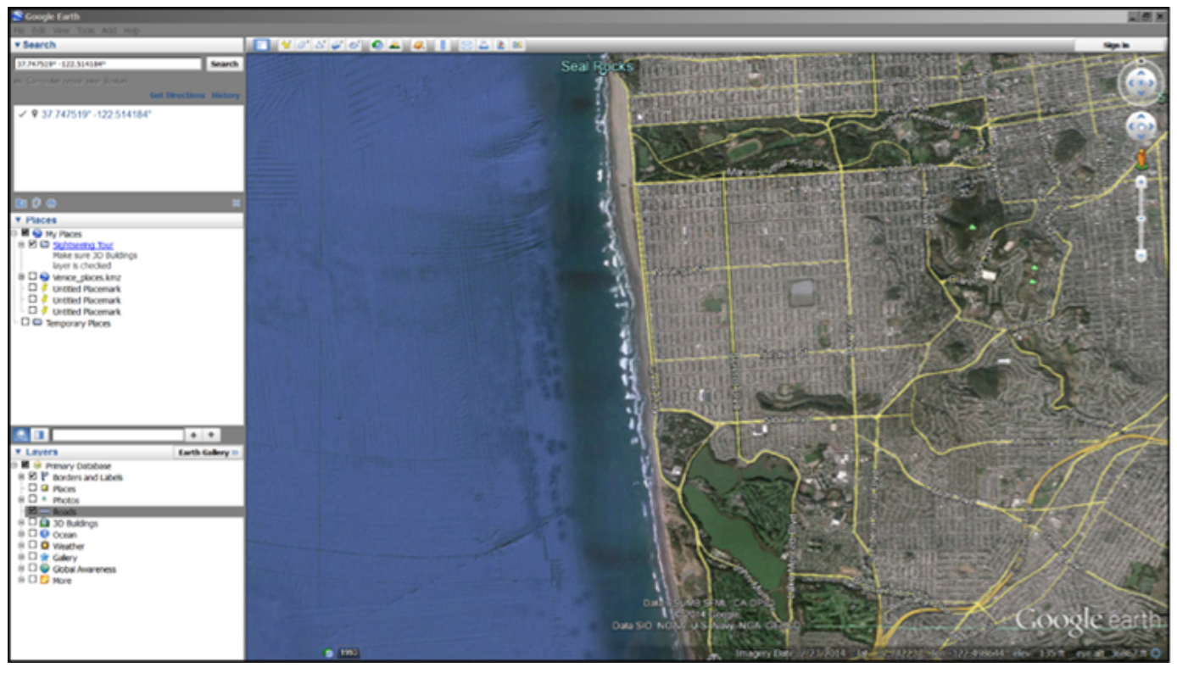

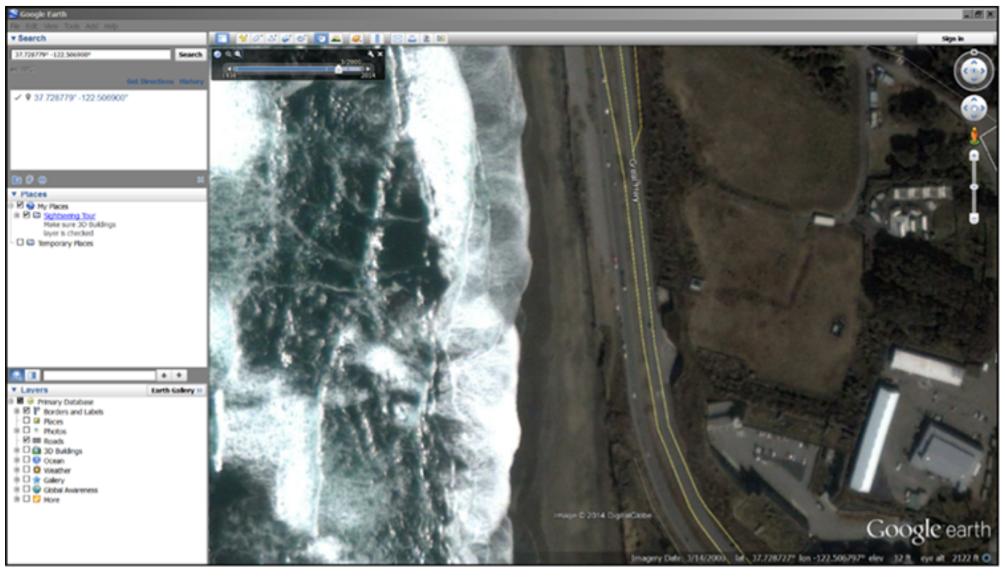
Example of Changing Shoreline
Credit: Google Earth

Questions 1-5

- Based on what you have learned in Module 7, what are some examples of hard structures for shoreline stabilization?

- Based on what you have learned in Module 7, what are some examples of soft structures for shoreline stabilization?

- What are some potential disadvantages of using hard structure construction to protect an eroding shoreline?

- Which highly traveled man-made structure in San Francisco is threatened by the erosion of Ocean Beach?

- Which important underground utility is also threatened by beachfront erosion?

Navigate to 37.7288, -122.5069 in Google Earth and compare the images from 9/2008 and 11/2010 by selecting "Historical Imagery" in the "View" menu.

Questions 6-8
- What was the effect of the 2009-2010 El Niño at this location?

- Comparing the same two images (9/2008 and 11/2010) at this location in Google Earth, what new structural measures for erosion protection do you observe?

- Do these measures provide a long-term solution to the erosion problem at Ocean Beach?

Go to the SPUR: The Future of Ocean Beach article and scroll down to the "Ocean Beach site overview" figure (note that South is at the top and North is at the bottom in this particular figure).

Questions 9, 10
- What are some examples of hard structures for erosion control?

- According to the "Ocean Beach site overview," what are some natural and man-made features threatened by the erosion of Ocean Beach?

- Based on the information in the SPUR article and your reading in Module 7, how do the natural processes of shoreline sediment movement affect the observed erosion issues at Ocean Beach?

- Go to coordinates 37.755900, -122.509900. Examine the features on the shoreline and use the ground level view (by bringing the “yellow man” down to the closest blue line along the highway at this location), to view these features more closely. What types of features are they and, based on the SPUR article, are they wholly natural or man-made? How could these features be altered to help with the erosion problems?

- In the longer term, what strategy will become necessary to address the problems described in the SPUR article, if erosion continues as predicted?

Lab Completion Instructions

Once you have worked through all of the steps, go to the Module 7 Lab in Canvas to complete the Lab by answering the multiple-choice questions. Remember, the answers to questions on this Lab worksheet will match choices in the multiple-choice questions in Canvas. Submit the quiz in Canvas for credit.

