Earth 107: Module 8 Lab

Important! We advise you to either print or download/save this document as it contains the steps you need to take to complete the Lab in Google Earth. In addition, it contains prompts for measurements and questions that you should take note of (by writing down or typing in) as you work through the Lab.

Once you have worked through all of the steps, you will go to the Module 8 Lab in Canvas to complete the Lab by answering multiple-choice questions. The answers to questions on this Lab worksheet will match choices in the multiple-choice questions in Canvas. Submit the quiz in Canvas for credit.

General Instructions for Module 8 Lab

Objective of the Lab: To explore a low profile coastal area in Louisiana and use tools in Google Earth to measure the slope and evaluate the protective potential of the coastal wetlands and man-made levees separating the coastal communities from the Gulf of Mexico.

For this Lab you will be using Google Earth to explore the coastal area of Isle de Jean Charles and use data from a storm surge model to analyze the potential impacts of storm surges on this and nearby communities. You will consider the protective functions of the coastal marshes as well as the new hurricane levee that is designed to protect some communities but not Isle de Jean Charles.

To begin, open Google Earth and follow the steps below.

Part I: Investigating a Coastal Community in Louisiana

Calculating distances between Isle De Jean Charles and the coastline

- Open Google Earth. Find Isle de Jean Charles, Louisiana, by entering the name in the search window in Google Earth or navigating to 29.389500, -90.48500.
- Adjust the altitude to an eye altitude of approximately 20 km.
Isle de jean Charles is in the center, bottom third of the view (see below). Note the linear pattern of ancient waterways that were distributary channels of a long abandoned delta lobe built by the Mississippi River. Each of these represents a ridge of higher elevation ground on which the long, linear communities are established.

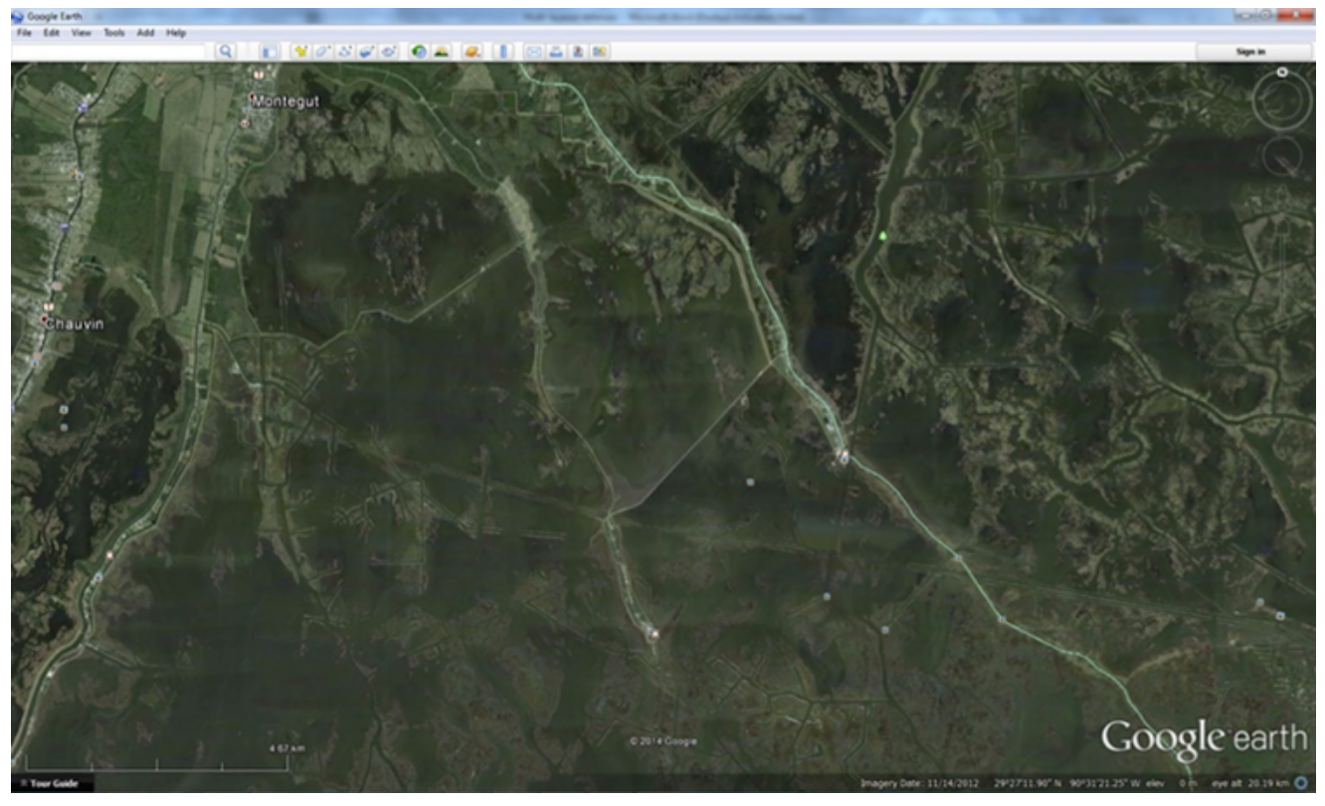

Google Earth Screenshot. Investigating a Coastal Community in Louisiana.
Credit: Google Earth

- Locate Louisiana Highway 665 and then find Island Road. You may need to zoom back in to find the label. Island Road connects Highway 665 to Isle de Jean Charles (“The Island”). Island Road is the only land connection to the town of Isle de Jean Charles, which is actually located on the remnant of a natural ridge of higher ground created by an old, abandoned distributary channel of the Mississippi River. Notice the broken-up nature of the surrounding marshes and the pattern of old oil and gas access canals throughout this area. These are the indicators of the rapid loss of land that has taken place over the past century in this area. As the vegetated marsh turns to open water, the protective buffer between the community and the Gulf of Mexico is reduced.
- Zoom into Isle de Jean Charles to less than 500 m eye altitude. Observe the elevation of the ground as you mouse over the community. Note the small levee surrounding the “Island.” Note the elevation at this location.
- Now navigate due south to Timbalier Island at 29.064100, -90.484600. We'll call this the "shoreline" for this area. Explore the island to get a good sense of the elevation range.
- Zoom out so your eye altitude view is at 85 – 90 km. Select the ruler icon at the top of the view. Draw a line with your mouse between Isle de Jean Charles and Timbalier Island.
- Use the mouse to continue south from Timbalier Island into the Gulf of Mexico. Find the first location where the elevation is -10 m (10 m below sea level). Use the ruler tool to measure from this point to Isle de Jean Charles.

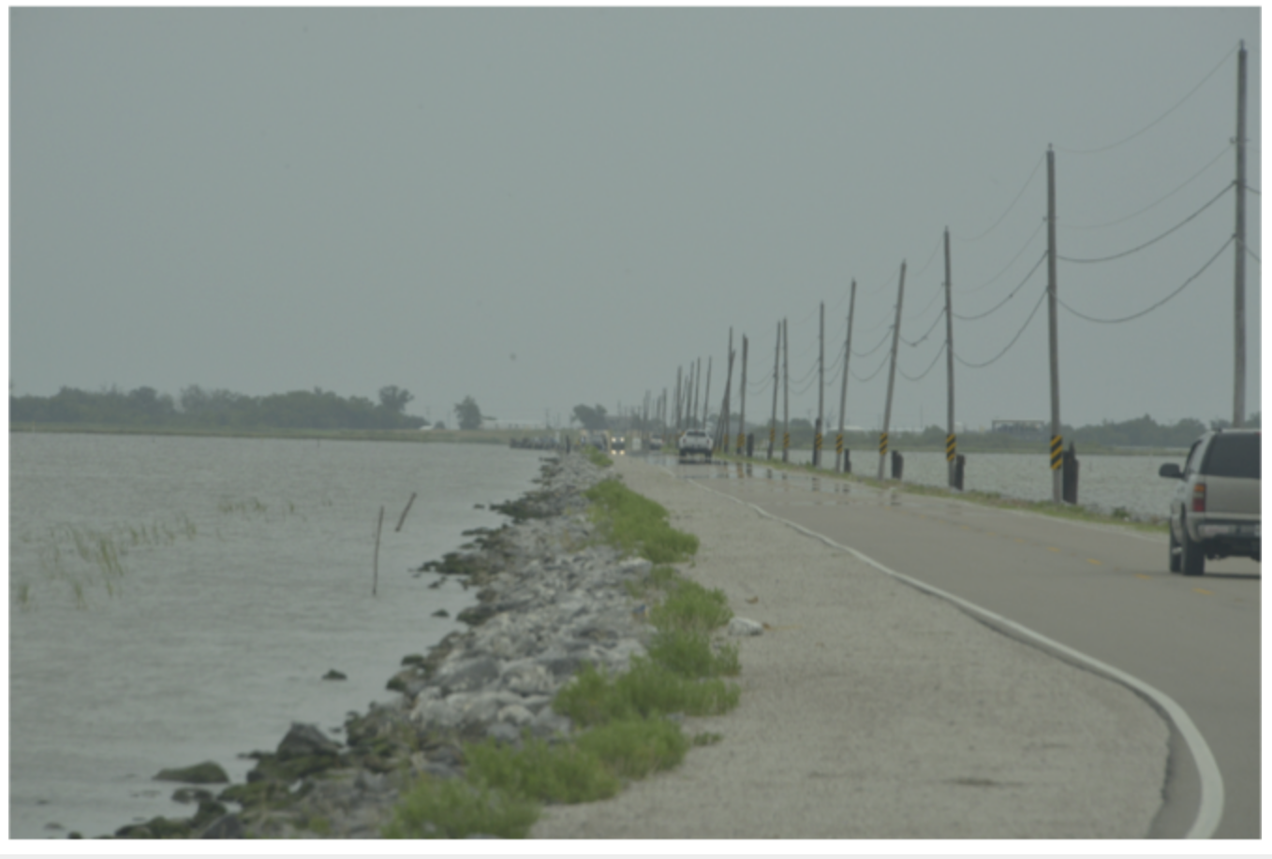
Island Road, Isle de Jean Charles
Credit: Gary Allen

Questions for Part I

- What is the average elevation of the land at Isle de Jean Charles, not counting the levee?

- What is the elevation of the levee?

- What is the average elevation of the land at Timbalier Island?

- What is the distance between Isle de Jean Charles and Timbalier Island?

- What is the distance from Isle de Jean Charles (passing through Timbalier Island) to the first place where seafloor elevation is -10 meters?

Part II: Visualizing the Louisiana Coast: Slope Calculation

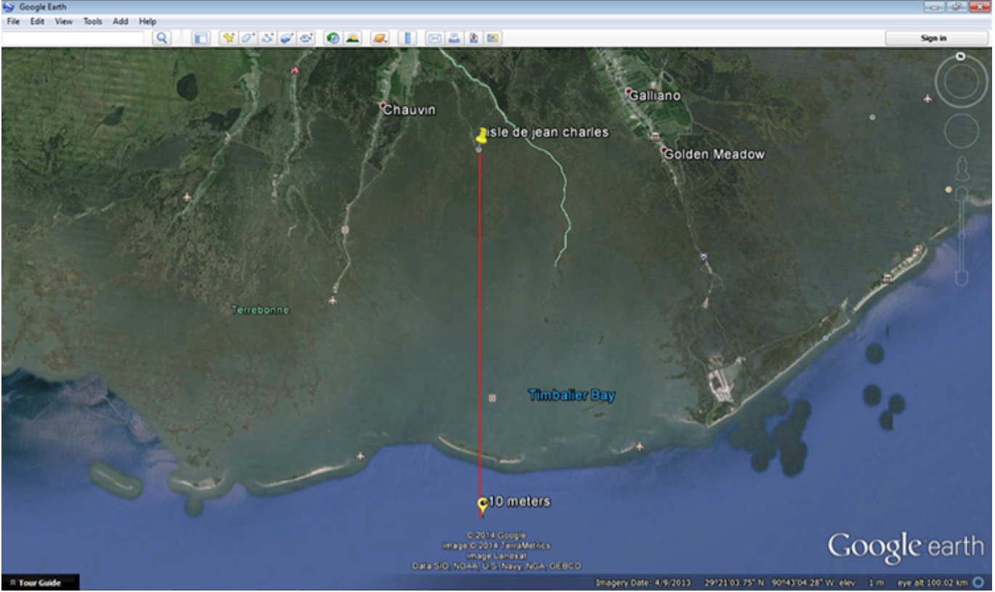
Google Earth Screenshot. Visualizing the Louisiana Coast.
Credit: Google Earth

Calculating slope (example)

Simple calculation:
If a house is located 1 km (1000 m) from the shoreline and is 1 meter above mean sea level, then the slope can be expressed as slope = rise/run = 1/1000 = 0.001 or 0.1%
We can also draw this on graph paper using a scale of:
X axis: 1 square = 10 meters of horizontal distance so 100 squares = 1 km (1000m)
Y axis: 1 square = .2 meters of vertical distance (5 squares = 1 meter)

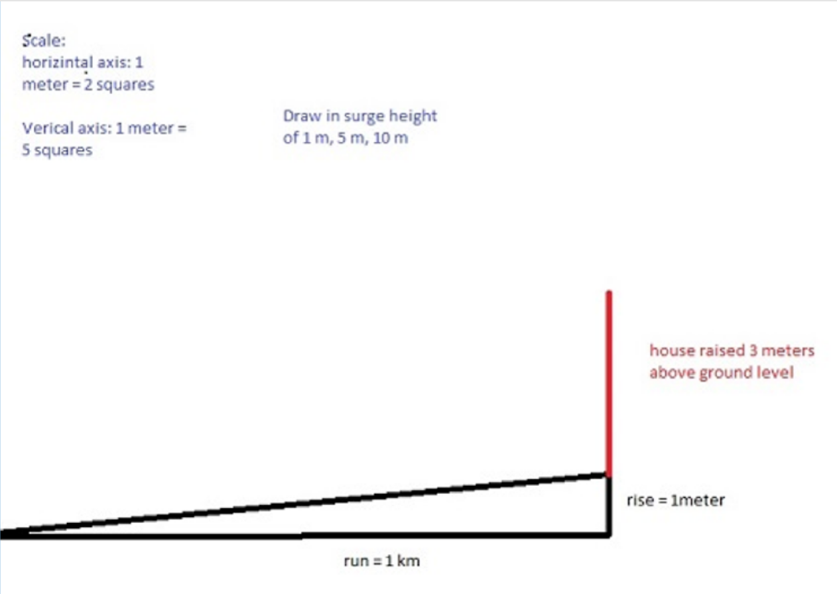
Calculating Slope

Calculating the bed slope of the Louisiana Coastline at Isle de Jean Charles
You will now use your measurements from Google Earth to calculate the total slope of the coastline. This will enable you to use data shown below to find projected storm surge levels with different storm strengths.
You will use the measured distance from the -10 m depth point in the Gulf of Mexico to Isle de Jean Charles (from step 7 above).
The lowest elevation will be -10 m and the highest is the elevation above sea level you determined for the levee around Isle de Jean Charles (Step 4 above).
The total slope will be determined for the entire distance from the -10 m depth to Isle de Jean Charles.
The total slope will be determined for the entire distance from the -10 m depth to Isle de Jean Charles.
Total rise = 10 + (elevation of levee around Isle de Jean Charles) = ____
Total run = distance from the -10 m depth to Isle De Jean Charles = ____
Slope = rise/ run = ________ (slope of coast between Timbalier Island and Isle de Jean Charles)
See “Calculating bed slope for Isle de Jean Charles, LA.”
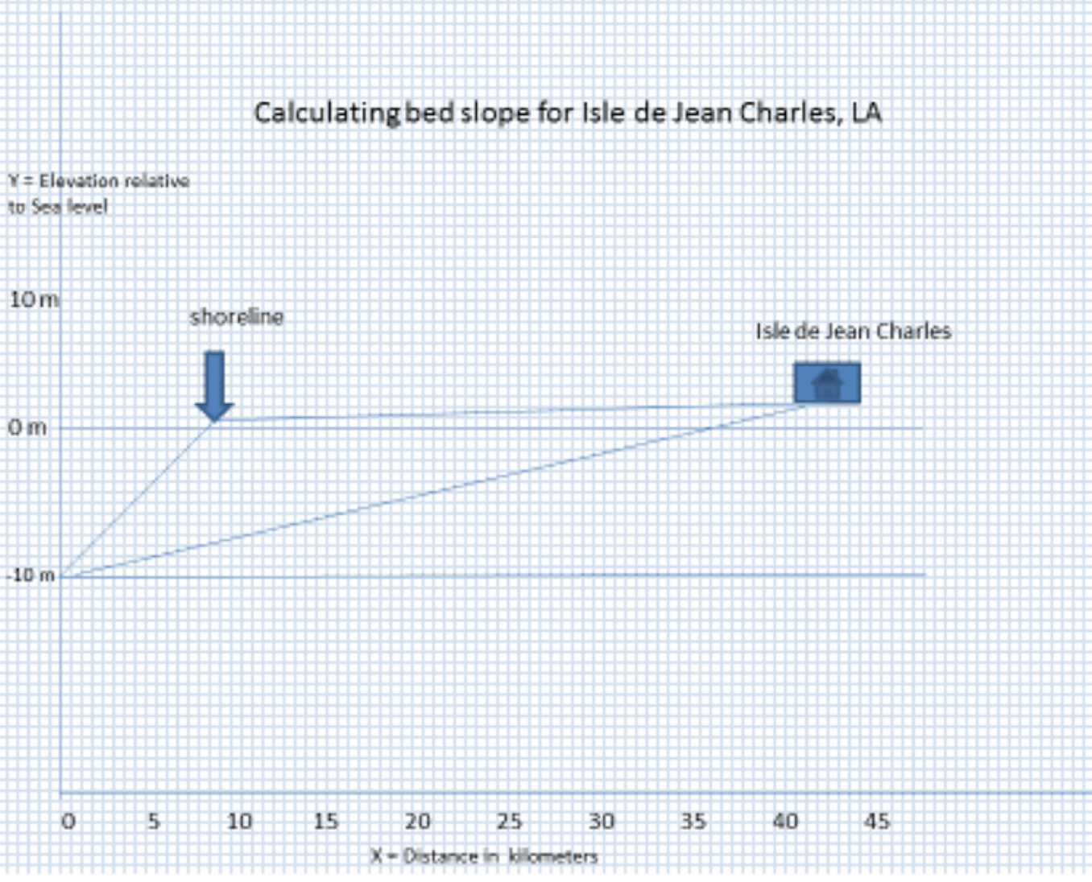

Questions for Part II
6. If the distance from Isle de Jean Charles to the -10 meter point in the Gulf of Mexico is your run, and the total change in elevation from -10 meters to the top of the levee is your rise, what is the closest calculated shoreline slope value (where slope = rise/run)?

Part III: Investigating Influence of Wind Speed on Storm Surge

Storm Surge and Isle de Jean Charles
The bed slope calculated in question 6 and a water depth of -10 m are both constant in the model shown below used to calculate the surge level at certain wind speeds. Look at the plot of wind velocity vs. surge height to see how wind velocity affects the storm surge level. Use the graph to locate the wind speed and its corresponding surge height.
Tip: To “visualize” the wind speeds in more familiar units of miles/hour (mph) – roughly double the m/s value, so 20 m/s = 44.74 mph; 60 m/s = 134 mph) A hurricane with wind speed of 130 - 156 mph is a category 4, according to the Saffir-Simpson Scale.
Proceed to the “Questions for Part III” box below to enter your storm surge height results.

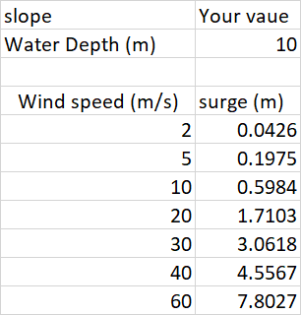

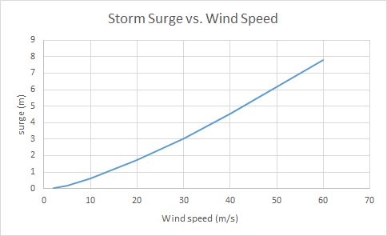
Data plot: Storm Surge vs. Wind Speed from One-D Surge Model

Questions for Part III
7. Using the model results shown on the graph, what is the closest value for storm surge at the shoreline for a wind velocity of ~20 m/s?

8. What is the closest value for storm surge at the shoreline for a wind velocity of ~40 m/s?

9. What is the closest value for storm surge at the shoreline for a wind velocity of ~60 m/s?

10. Based on the graphed model results, what is the effect of doubling the wind speed (assuming a constant slope and water depth)?

Part IV: Compare Isle de Jean Charles to a Nearby Community

Reduction of storm surge by protective landscape features
First, let's consider how protective natural landscape features (barrier islands, marshes, ridges of high ground, etc.) can reduce (or attenuate) the storm surge by offering friction and reducing the energy of the water. The actual rate at which this happens varies according to many variables, including the dimensions of the barrier island, the health or level of degradation of the marsh, the height of the levee, etc. It is hard to quantify this, so we will use an arbitrary (estimated) number for now. We will say every 1 km of marshland reduces the surge by 10 cm.

Questions for Part IV (11 and 12)
11. Using the metric for reduction of storm surge = 1 km of coastal land reduces the storm surge by 10 cm - if there is an 8 m storm surge at Timbalier Island and the distance from Timbalier Island to Isle de Jean Charles is ~35 km, what will the height of the storm surge be at Isle de Jean Charles?

12. Would the 2-meter high levee protect Isle de Jean Charles from such a storm surge?

Storm surge effects
A storm surge of just 3 meters (9.84 ft.) can do considerable damage. The energy of the water, combined with the wind, can move large objects and flood any houses that are not raised above this level. Higher storm surges, of course, do even more damage. The residents of Isle de Jean Charles receive frequent flooding from storm surges. Many surges that reach the community are less than 1 meter, so the small levee protects them.

Compare Isle de Jean Charles to a nearby community to be protected by the “Morganza to the Gulf” hurricane protection levee

Note: Please be sure that you have read the “U.S. Army Corps of Engineers: Morganza to the Gulf - Fact Sheet” Required Reading from the Module 8 Roadmap.
Examine the map of the levee alignment in the fact sheet on the Morganza to the Gulf Levee. Locate the towns of Montegut, Chauvin, and Dulac. These communities are at a similar distance from the Gulf as is Isle de Jean Charles, but they will be within the footprint of the Morganza to the Gulf Levee. The elevation of the levee will be between 10.5 and 24 feet (3.2 – 7.3 meters). This is an average of about 5 meters. We will use this number in our calculations.
- Navigate to Dulac, LA (29.385500, -90.715300) using Google Earth.
- Measure the distance from Dulac directly south to Trinity Island (29.050766, -90.715950).
Record the distance in the “Questions for Part IV” box below under Question 13.
- Using the hypothetical storm surge of 8 m at landfall and the estimated surge reduction factor used previously (1 km of land reduces the surge height by 10 cm), to calculate the height the storm surge will be when it reaches Dulac. Enter your answers in the Part IV box below.

Disclaimer
This is just an estimate for the purposes of understanding the challenges faced by those living in these coastal communities. We cannot quantify exactly how the various landscape features protect now and in the future, sea level rise and further erosion of barrier islands and marshes must be factored into any calculations.
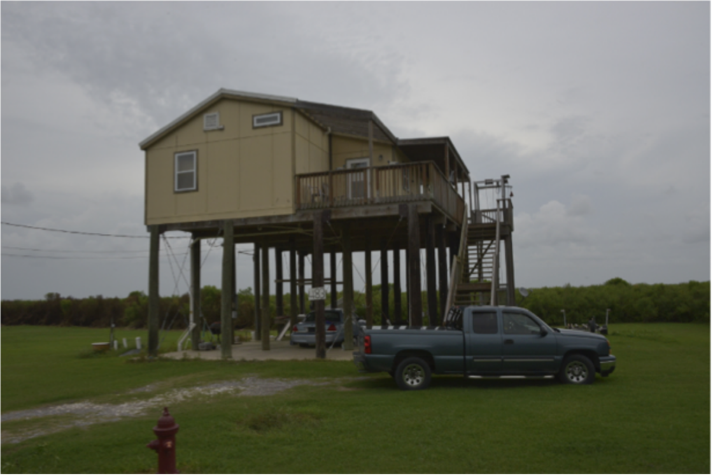
Raised House, Isle de Jean Charles.
Credit: Gary Allen

Questions for Part IV (13 and 14)

13. What is the closest distance measured from Dulac southward to Trinity Island?

14. If there is an 8-meter storm surge at Trinity Island, would the ~5 meter high "Morganza to the Gulf" levee protect Dulac in this case (using the metric for reduction of storm surge = 1 km of coastal land reduces the storm surge by 10 cm)?

Lab Completion Instructions

Once you have worked through all of the steps, go to the Module 8 Lab in Canvas to complete the Lab by answering the multiple-choice questions. Remember, the answers to questions on this Lab worksheet will match choices in the multiple-choice questions in Canvas. Submit the quiz in Canvas for credit.

