Earth 107: Module 10 Lab

Important! We advise you to either print or download/save this document as it contains the steps you need to take to complete the Lab in Google Earth. In addition, it contains prompts for measurements and questions that you should take note of (by writing down or typing in) as you work through the Lab.

Once you have worked through all of the steps, you will go to the Module 10 Lab in Canvas to complete the Lab by answering multiple-choice questions. The answers to questions on this Lab worksheet will match choices in the multiple-choice questions in Canvas. Submit the quiz in Canvas for credit.

General Instructions for Module 10 Lab
Objective of the Lab: The objective of this activity is for you to explore smart building measures for a city that is threatened by sea level rise and storms.
Read the background information below and use the figures in this worksheet and Google Earth to guide and inform your investigation of the smart building options for Tampa Bay.
Background
A group of cities surrounds Tampa Bay, FL, a bay/estuary along a tectonically inactive, trailing margin coastline. The coastline surrounding the bay inlet is composed of sandy beaches and barriers, and elevations range from lowlands near mean sea level to Pleistocene uplands of over 10 m. This coastal region is exposed to tropical storms and hurricanes that can produce storm surges of several meters above mean sea level.
Figure 1 shows an orthoimage of the region, and Figure 2 shows combined bathymetric and topographic elevations along with contours at 0, 5, and 10 meters.
There is growing demand for new development because the city’s population is growing. Figure 3 shows the population density in persons/acre for each census tract, highlighting the most densely populated portions of the urban area. Figure 4 gives the predicted storm surge elevations for the region that have a 1 percent annual chance of occurrence.
The city must expand with new development to continue growing; however, the new development areas should not create significant risk due to the region’s exposure to hurricanes. You are a coastal planner employed by the metropolitan area planning commission and must come up with a recommended course of action.
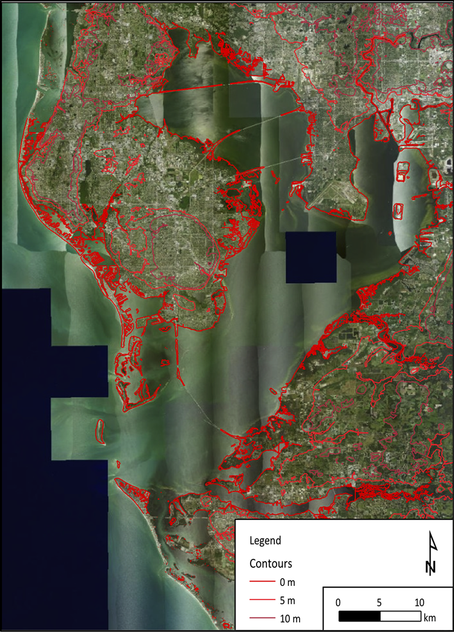
Figure 1: Project Area Overview with Elevation Contours.
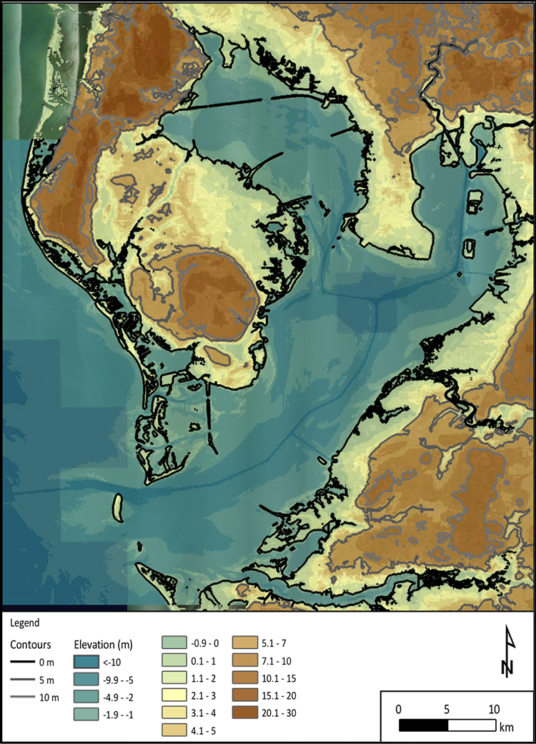

Figure 2: Project Area Elevation.

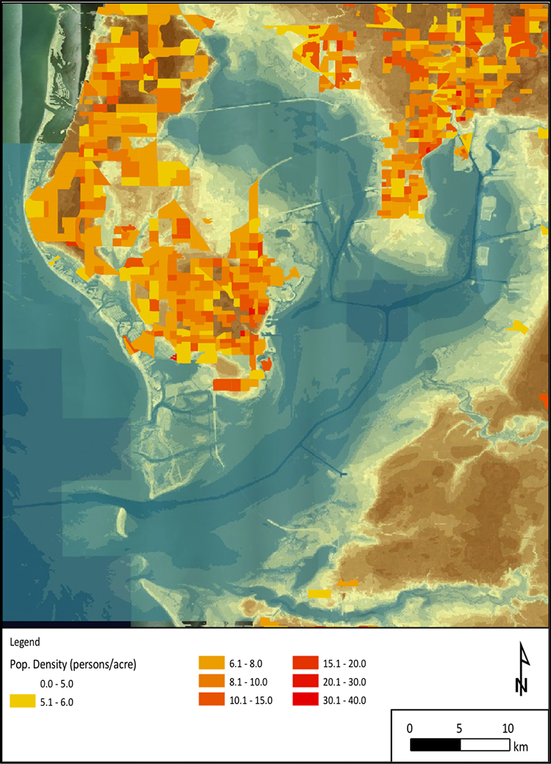

Lab Figure 3: Project Area Population Density.

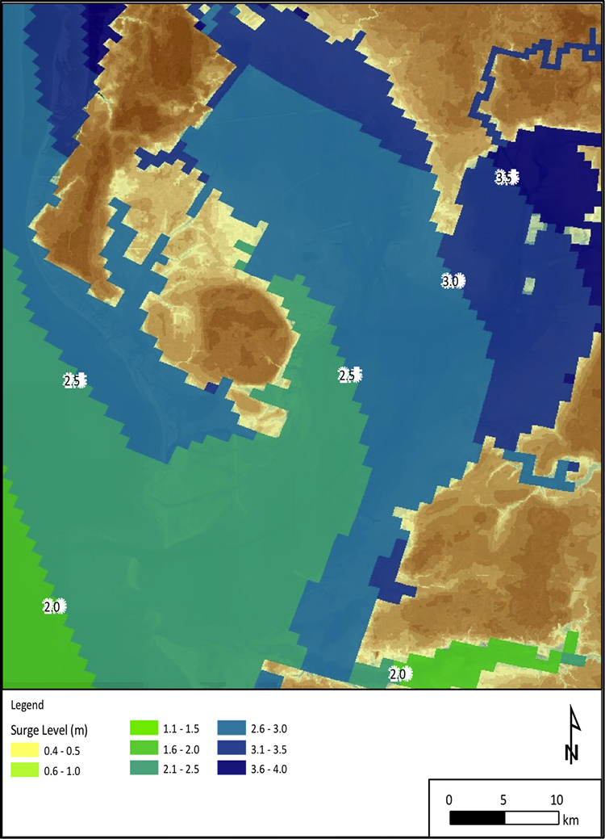

Figure 4: Predicted 1 Percent Annual Chance Storm Surge Levels from Hurricanes Impacting the Region.
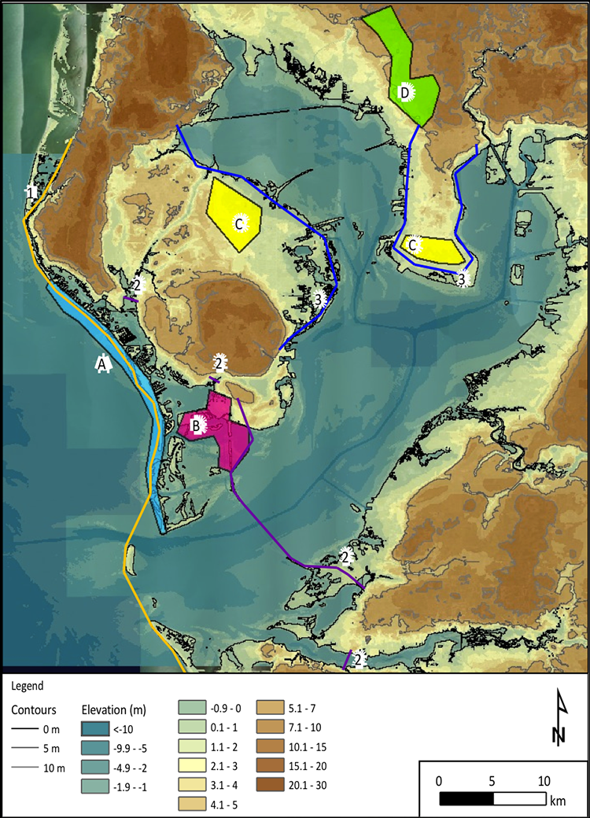

Figure 5: Development and Flood Protection Project Alternatives.

To begin, open Google Earth and follow the steps below.

Development of Smart Building for a Rapidly Growing Coastal Community (Tampa Bay, FL)
We will begin by exploring Tampa Bay in Google Earth.
- Open Google Earth.
- Navigate to 27.7690, -82.5510 using the Google Earth search function, and zoom to an eye altitude of ~85 km. You should see a bay and coastline similar to what is shown in Figures 1 and 2.
- Explore the area by zooming in on various features of the bay and coastline, paying specific attention to the shaded areas denoted A, B, C, and D, in Figure 5.
- Click on some photos in these areas to get a better sense of what they look like from the ground.

Questions
For the following questions use the shaded features identified in Figure 5, information in Figures 1-4, and your observations in Google Earth. Draft your answers below and then record your answers using the Module 10 Lab in Canvas.

Questions for Module 10 Lab

- Search for coordinates 27.7166, -82.7399 by entering the Google Earth Search box. View at an eye altitude of approximately 7 km for the area considered. Zoom in to explore in more detail. How would you accurately describe the present development in this area?

- Search for coordinates 27.707675 -82.712509 by entering the Google Earth Search box. View at an eye altitude of approximately 7 km for the area considered. Zoom in to explore in more detail. How would you accurately describe the present development in this area?

- Search for coordinates 27.9100 -82.71155 by entering the Google Earth Search box. View at an eye altitude of approximately 7 km for the area considered. Zoom in to explore in more detail. How would you accurately describe the present development in this area?

- Search for coordinates 28.009727 -82.736362 by entering the Google Earth Search box. View at an eye altitude of approximately 7 km for the area considered. Zoom in to explore in more detail. How would you accurately describe the present development in this area?

- Based on your observations in Google Earth and the maps provided, which of the labeled areas on Figure 5 match with the following descriptions?
- A low-lying wetland area for which development would require “poldering” or land reclamation practices
- High value beachfront barrier island property
- A higher (greater than 5 m) elevation tract of land close to residential and commercial development
- Lower (less than 5 m) elevation property close to existing residential development
- Which of these areas would be most suitable for expansion and development if the goal of the city planners is to follow guidelines considering smart building and greater resilience for their city?

- If the goal is to protect the majority of the residents of the city from “typical” tropical cyclone storm conditions (shown in Figure 4), describe the option for the “smart building” concept discussed in Module 10 that would provide adequate protection for residents?

- If the predicted of sea level rise by 2100 of 1 m occurred, re-evaluate the threats to Tampa Bay given the estimated rise in sea level and a 10% rise in both surge level and wave height (due to a possible increase in storm magnitude with climate change). If development is constructed in location C along with the seawalls of +4 m elevation along line 3, to approximately what level should the seawalls be raised to prevent overtopping in 2100?

- Which smart building option(s) described in Module 10 could possibly be employed in Area A to combat sea level rise?

- Which smart building option described in Module 10 could possibly be employed in Area B to mitigate land loss in this area?

Lab Completion Instructions

Once you have worked through all of the steps, go to the Module 10 Lab in Canvas to complete the Lab by answering the multiple-choice questions. Remember, the answers to questions on this Lab worksheet will match choices in the multiple-choice questions in Canvas. Submit the quiz in Canvas for credit.

