Your Name:

Your PSU Access ID:

Part 1: Snell’s Law warm-up calculations

- Calculate the angle of refraction for a ray of light passing from air to water with an incident angle of 45°. Assume the index of refraction of water (n_{water})is 1.33 and n_{air} is 1. Sketch the path of the ray through the water layer.
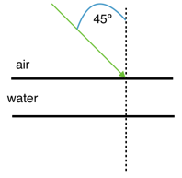
2. Calculate the angle of refraction for a ray of light passing from water to air with an incident angle of 30°. Sketch the path of the ray through the air layer.
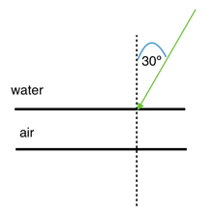
3. Suppose you have a ray of light that passes through three layers: air - water - air. The angle of incidence at the first air - water boundary is 20°. Calculate the angle of refraction at the first boundary and calculate both the angle of incidence and angle of refraction at the second (water - air) boundary.
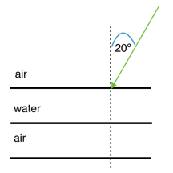

4. Now let's consider the path taken by a seismic wave instead of light. For the purposes of this calculation, we'll pretend the Earth is flat. An earthquake happens at the surface of a series of layers as pictured below. Consider a P wave that leaves the source along the path as shown in the cartoon and hits the boundary between the upper layer and the second layer with an angle of incidence of 30°. Given the transmitting velocities for a P wave in all the subsequent layers, sketch the path of the ray until it hits the bottom, and find all the angles of incidence and refraction along the way.
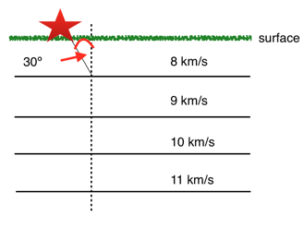

5. Let’s consider a seismic wave that passes through the square-shaped object below. In this object there is a fast center and an outer layer of slower material. The P wave leaves the source and hits the first boundary with an incident angle of 40°. Sketch the path taken by the P wave until it gets back to the outer surface of the square and calculate all the angles of incidence and refraction along the way.
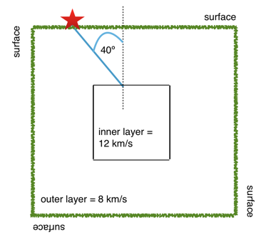

6. Now let’s say that same square-shaped object in #5 is actually homogeneous. Draw the path that the P wave would have followed to get from the source to the position of the “receiver” (where you calculated that it arrived at the outer surface in #5). Is the distance traveled as measured along the surface the same, shorter or longer as the distance as measured along the surface in #5? Is the actual path traversed by the P wave the same, shorter, or longer than the actual path traversed by the P wave in #5?
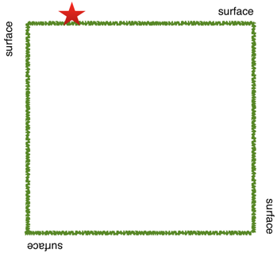

Part 2: Collecting data, making observations, constructing models

The seismograms you need to look at for this activity are on the "What path does a P wave take through the mantle?" course page.

For #s 1, 2, and 3 I find it easiest to make a table in which I write down the station name in column 1, The P wave arrival time at that station in column 2, the travel time in column 3 and the distance in degrees in column 4. Doing so will make it a lot easier to make your plots. I am leaving it up to you to construct such a table, or if you hate tables, to ignore this advice.
2.1. For each seismogram, pick the arrival time of the P wave. The P wave is the first impulsive arrival that rises appreciably higher than the background noise level. *There is a screencast hint about how to pick P waves on the course web site.
2.2. Calculate the time it took the P wave to get to each station. *There is a screencast hint showing this calculation.
2.3 Calculate the distance between each station and the event in degrees. *There is a screencast hint demonstrating this calculation.
2.4. Make a plot of distance in degrees vs. P wave travel-time.
2.5 Which station was closest and which station was farthest away? What were the distances between the earthquake and each of these two stations? What was the difference in arrival time between those two stations?
2.6 This event was large enough that it was recorded by stations even farther away than the farthest station you worked with. Why didn't I make you pick P waves for farther away stations?
2.7 We know the travel time of the P wave to each station and we know the surface distance between the earthquake and each station but we don’t know the actual path the P wave took and we don’t know whether velocity was constant along that path or not (Remember that those are the two things we are trying to find out in this lab exercise). So when we calculate velocity, keep in mind that it is an apparent, average velocity. What is the apparent average velocity of the P wave for the closest station? What is the apparent average velocity of the P wave for the farthest station?
2.8 Look at your plot from #2.4 and explain how the apparent average velocity changes with station distance. For example, are the data randomly scattered with no relationship among them? Is there a smooth variation with distance? If there’s a smooth variation, does velocity increase or decrease? Or, does the velocity stay about the same? Are there sudden jumps?
3.1 If the great circle distance between an earthquake and a station is 45º, what is the straight-line path distance through the Earth between them?

3.2 Suppose a P wave traveled along the path you calculated in #3.1 at a constant speed of 8 km/s. Calculate its travel time between the earthquake and the station.

3.3 Suppose a P wave traveled along the path you calculated in #3.1 at a constant speed of 10 km/s. Calculate its travel time between the earthquake and the station.

3.4 Suppose a P wave traveled along the path you calculated in #3.1 at a constant speed of 12 km/s. Calculate its travel time between the earthquake and the station.
3.5 Assume constant mantle velocities of 8, 10, and 12 km/sec. Draw the three travel-time curves that correspond to these velocities on one set of axes. *There are hints on the course web site explaining how to do this.
3.6 Combine your plot from #2.4 and your plot from #2.9 on the same axes. Can your data be fit with a curve representing constant velocity? Feel free to try other values for the velocity if 8, 10, and 12 don’t work.
3.7 Time to answer the big question from the beginning of the problem set! Does the P wave follow a straight line path through the mantle? How do you know? Lead me through your logic and your observations from this lab to answer this question.

