The Future of Food, Module 3: Diet, Nutrition, and Food Systems.
Formative Assessment 3.1
Using an online diet analysis tool to form basic conclusions about diet.
Instructions:
Go to the website www.myfoodrecord.com . This is a commercial website with free functionality. We are not endorsing it. There are other free tools and software on the internet from nonprofit organizations but they are more complicated to use (for a more functional and complex spreadsheet-based software see “nutrisurvey” at http://www.nutrisurvey.de/ ). We are using the “my food record” website to illustrate some basic principles of diet from this module.
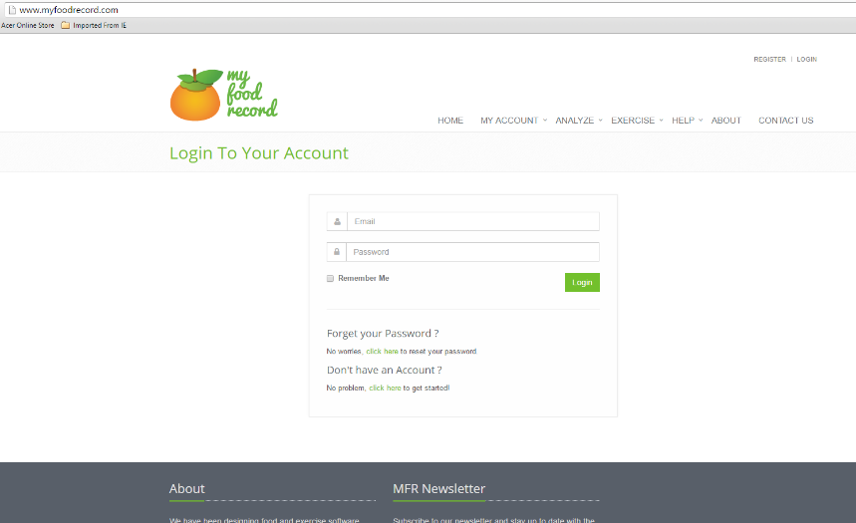
The website will ask you to log in, but you can run all the analyses for this assessment without doing so by clicking on the “analyze” tab and then selecting “one day analysis”, the first option. If you are interested in this website and saving your analyses you can create a username and log in, which will allow you to save some results and preferences and analyze diets beyond this course.
Fig. 1. The My Food Record website and the Analyze Tab. You do not need to log in, just use the analyze tab.
After click on the analyze tab, the website will ask you some information about height, weight, date of birth, and sex. This is to calibrate the nutrition models used by the website (for example, it’s likely that it will assign a different daily requirement of iron to men than women). Then, the analysis of one day of diet information has several steps:
- You search for and select foods to add to the diet (lower part of analyze page), specifying the food as exactly as possible and the number of servings. IMPORTANT: Because there are many items in the database, you should use the search terms we supply you with to find items quickly.
- The overall strategy is to add foods from the database until you have created the diet to your satisfaction in the upper part of the page, then you will click on the “save and analyze day” (see Figure 2)
- The website outputs a nutritional report that has % of daily recommended values and the absolute amounts of different diet constituents (energy, protein, fat, fiber, minerals, etc.)
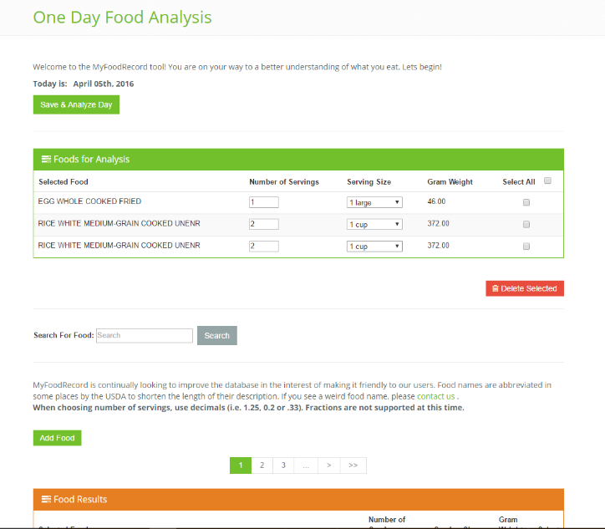
Fig. 2. The Analyze one day tool in the My Food Record website, with the food search at middle and list of foods for analyzing at top.
As you work through the diet information for each diet example you will log the results in an excel spreadsheet or “scorecard” that will allow you to compare the diets. If you haven’t already, download the spreadsheet from the module 11.1 formative assessment webpage. We’ve created the excel spreadsheet so that it color codes the cells where you enter each result from the diet as high or low, showing whether the diet outputs are deficient, adequate, or in excess. In this way, as your diet becomes more sufficient in nutrients (and in some cases, excess) the colors of your result cells will change from red towards yellow and green.
We have already entered the data in the Excel spreadsheet for cases 1, 2, and 5 below, which will make it faster for you to analyze diets that create key messages. You will need to fill in the information for cases 3, 4, and 7 and answer some questions about the diets.
We have already filled in the excel spreadsheet with the results from a highly simplified, monotonous diet representative of food insecurity and potential malnutrition. Then we’ll move from there to improve this diet. All the case numbers (Case 1, Case 2, etc.) below each refer to a line of the excel table, where you’ll be able to track the quality of the diet.
Case 1. (Already filled in) Monotonous diet deficient in protein and energy. We entered an age, height and weight corresponding to a typical adult. If you are especially light this diet may be more sufficient for you than for other students. But there are big issues with this diet nonetheless, which might represent what people might consume in a situation of extreme food insecurity. Here is how we filled in this diet:
- Two meals of two cups rice each were added to the analysis tool. We searched for “rice white cooked” which narrows the search, and then chose “rice white medium grain unenr.” and specified 2 servings of 1 cups each before clicking “add food”. We used unenriched rice to test the nutrients that foods supply in their simplest form.
- We also searched for “egg fried” and added one fried egg. Specify one serving in the box and click “add food” The diet box appeared like this, for an entire day of food, which should already look problematic to you from the standpoint of a sufficient and complete diet:
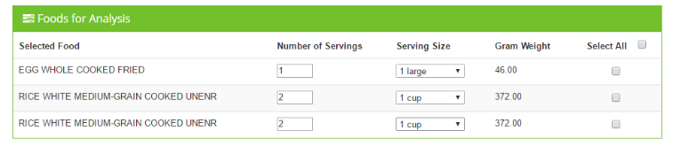
- Then click on “save and analyze day” at top. A report will be produced, and some deficient values will be shown in red.
- After clicking on “save and analyze day” we entered the percent daily value (“%DV”) results from the diet report into the excel spreadsheet in the first “Case 1” row. Note that For unsaturated fats (generally plant or fish based) there is not a “%DV”—here we summed the grams (g) of mono- and poly-unsaturated fats and enter this value (for the Case 1 diet specified here it will be 2+3=5 g unsaturated fat). You should see that this diet is widely deficient in many constituents, with a generally red bar of cells.
Case 2 (already filled in). Sufficiency in Protein and Energy, but what else is missing? Unless you are a very small person, the case 1 diet would make you feel very hungry. One impulse would be to adjust this by adding calories and protein using more of the same foods, which can happen where the food supply is very monotonous:
- Two more fried eggs and one or two more meals of rice of two cups each were added to this diet, to try to bring both calories and protein up to required levels.
- The results are now given in the excel spreadsheet “scorecard”. What changes? Did adding more rice and eggs allow the diet to be sufficient in calories and protein? What other aspects of the diet still have problems?
Case 3 (You fill in). Going Vegan. You may be interested in whether one could not eat the eggs and get the same result. So let’s try what could be the world’s most monotonous vegan diet and see how it improves things or not. As you may know, rice and beans is monotonous but not that rare around the world.
- You’ll need to add the servings of rice that we added in case one and two on your own. Search for “rice white cooked medium” in the search box (you can copy the search term out of this worksheet or just type it in). This will narrow the search and you should be able to choose “rice white medium grain unenr.” and specify 4 servings of 1 cups each before clicking “add food”.
- Search for beans using “beans black turtle cooked” as a search term and choose “BEANS BLACK TURTLE MATURE SEEDS COOKED BOILED WITH SALT”. We’ll introduce some salt to the diet which is quite realistic, and necessary as you may be able to see from your results so far for sodium in the diet, which should be deficient. Enter 3 servings and add to the diet. Your diet for analysis should appear as below. Be sure the gram weight of rice is 744 grams, and the total mass of cooked beans is 555 g. Note that 3 cups of cooked beans sounds like a lot of beans, but if spread throughout an entire day would not be that much bulk of food.
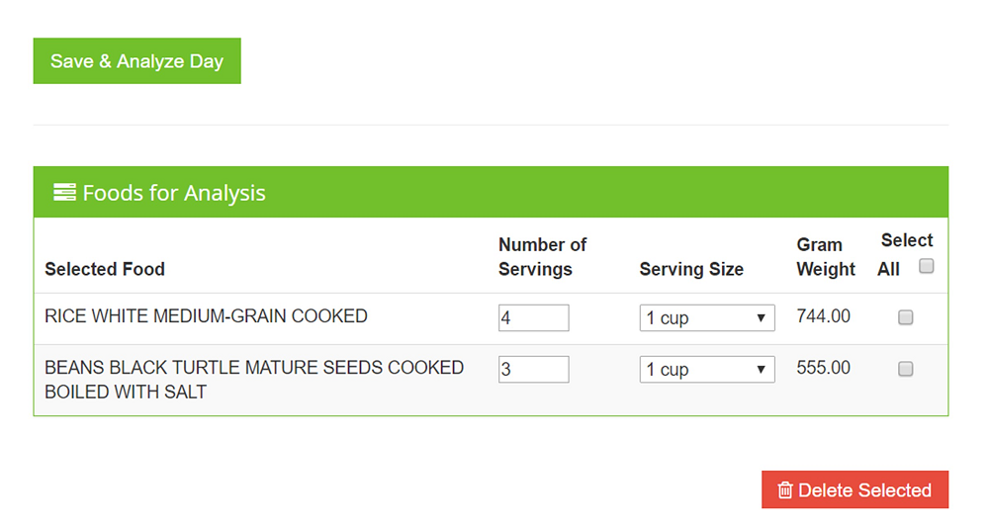
- Now analyze the diet (“save and analyze day” on the screen above) and enter the results to the excel spreadsheet. Be careful to not change the row of “100 s” at the bottom of the excel spreadsheet since these are the basis of comparison for the nutrient values.
- Now in writing and based on the excel scoresheet, answer how the bean diet compares to the egg diet in terms of:
  - Protein: _________________________________________________
  - Fiber: ___________________________________________________
  - Unsaturated (“good”) fats: __________________________________
  - Vitamin A: ________________________________________________
Case 4. The impact of meat. (You fill in)
- Return to the analysis page and take out the bean meal from the diet by checking the bean meal with 3 servings and clicking on “delete selected”
- Search for “chicken broilers drumstk roast” – note the abbreviated spelling of drumstick; and add 3 servings of roasted chicken drumsticks, using the “meat and skn” to the diet. (Total of the drumstick servings should be 315 grams).
- Analyze the diet and enter your results into the excel sheet.
- In writing, how do the bean and drumstick options compare in terms of :
  - Protein? _______________________________________________
  - Iron? _________________________________________________
  - Total Fat? _____________________________________________
  - Fiber?________________________________________________
  - Zinc? _________________________________________________
(note that the iron comparison is somewhat inaccurate because the iron in the chicken is more bioavailable than that from the beans – ie more easily absorbed by our bodies; the take-home message here is that beans and chicken do compare reasonably well as an iron source)

- In writing: What MAJOR groups of foods have these diets ignored so far, in terms of the “healthy eating plate” diagram reproduced in module 3 below? _____________________________________________________________
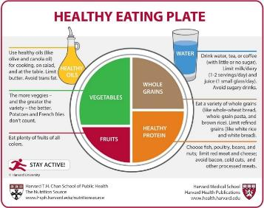
Healthy eating plate (credit: Harvard University)
Case 5. (already filled in) The healthy eating plate- a more balanced diet. Now we want to contrast these relatively monotonous diets with a balanced diet. The simpler diets were partly designed to test what shortages arise from sole consumption of non-whole grains and protein foods without fruits and vegetables. Here is the diet we analyzed in “my food record” and reported in the Excel spreadsheet:
- 2 cups of white rice, i.e half of what was present in the above diets.
- 2 servings of medium grain brown rice.
- 6 servings (6 slices) whole wheat bread. This is about the same dry weight as a rice serving.
- 1 chicken drumstick, as above in case 4 (there you added 3 servings).
- 1 serving cooked black turtle beans from case 3 (there you added 3 servings).
- 1 fried egg as above in cases 1 and 2 (there we added more than one egg).
- 2 servings cooked broccoli without salt.
- 1 serving cooked collard greens with salt.
- 1 serving raw carrots (1 cup) as a snack or meal accompaniment.
- 2 servings fresh oranges
- 1 serving fortified milk. Note that this would not be a universally appealing choice around the world but is a good source of calcium and vitamin D.
- 2 tablespoons soy oil. This is realistic given the above foods and will add unsaturated plant-based fats.

- Observe the entries in the excel scorecard that have been filled in. Do you notice any trends in comparison to the previous cases?
- You’ll note that vitamin D is still deficient with this diet, however vitamin D is intended only as a supplement in the diet since humans make this vitamin when skin is exposed to sunshine.
- Calories are now a bit over, but keep in mind that these estimates are for a completely sedentary state without some of the habitual exercise (even walking) that most people include in their daily activities. That said, dramatically boosting calories without exercise (say to 200% of those needed) will contribute to weight gain over time and diet-related diseases over the lifetime of any given person. Nevertheless research is increasingly finding that predisposition to weight gain and diet-related diseases varies greatly from person to person.

Case 6 (you fill in): A day of fast food (or other restaurants). Now we would like to compare this to the sort of diet we would get if we purchased all our meals for a day at fast food restaurants. This is not just a dig at fast food – many restaurants of all types make their food more appealing to consumers by adding extra fat and salt compared to how many of us might cook at home.
- Clear all the foods from case 5 from the analysis page, and then add these foods before running the analysis.
  - For breakfast, eat a hearty steak, egg, and cheese sandwich bagel. Search “fast foods bagel” – and select 1 serving of “fast foods bagel with breakfast steak egg cheese and condensed mnt” (apologies to those of you who are vegetarians – this is just an example.
  - For lunch, deepen your appreciation of U.S. fast food with restaurant chicken tenders: search “restaurant chicken tenders” and select one serving.
  - For dinner, go with the emblematic McDonalds Big mac, search “big mac” and add one serving.
  - At dinner, you also remember that it is important to eat vegetables, so you order a small restaurant salad – “fast foods salad vegetable tossed wo/drsng” – search “fast foods salad”. We won’t count the dressing in this case to simplify.
- How does this diet compare to the previous ones in terms of:
  - Total fat: _________________________________
  - Sodium: _________________________________
  - Fiber: ___________________________________
  - Protein: __________________________________
  - Iron: ___________________________________
  - Vitamin C: ________________________________

Case 7 (you fill in): A typical lunch or dinner: try entering a recent meal you consumed into the diet analysis tool, or invent one you would like to eat. Multiply the quantities by three to provide an approximate sense of how that meal would compare if eaten 3x per day as the basis of a daily diet. This is not entirely accurate of course but may give you a good sense and takes less time than finding all the foods in your daily diet. Keep in mind that this database uses “cooked” and “raw” (instead of “fresh”) as modifiers for the foods, which can help you narrow down your search.
Final Question: Please explain in a few sentences below what you observed about your diet in case 7, including what you ate:

