The Future of Food Module 3.1. Name: ________________________________
Formative Assessment: mapping soil properties important for food production.
- In a web browser, please direct yourself to the online soil property mapper from the International Soil Resource Information Centre (ISRIC) at http://soilgrids.org/. Once at this website, and after clicking on the introductory window to close it, you should see a global map of soil types in different colors covering the different continents. There are typical navigation tools like in Google Earth for dragging with the mouse cursor clicked, zooming, panning with arrow keys etc.
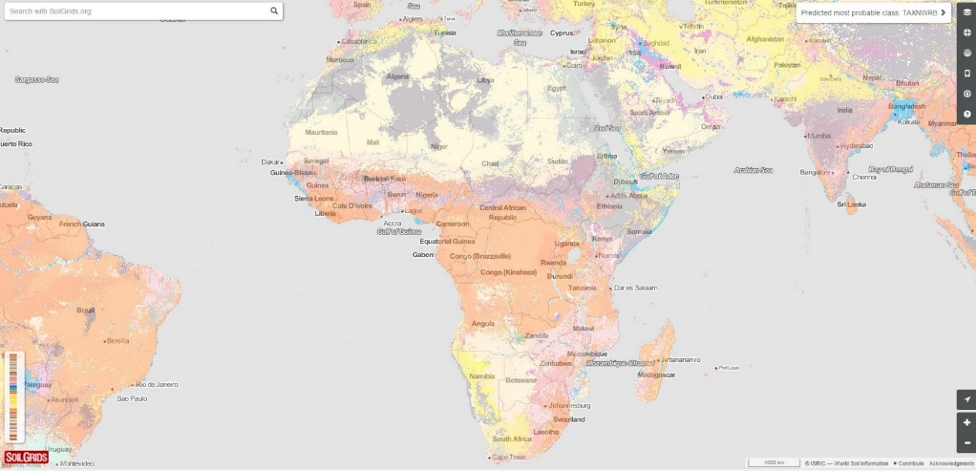
Figure 1. The ISRIC Soil Grids Opening map screen. Different colors indicated different classifications of soils in the World Reference Base system.
Image credit: Images in this worksheet were generated using the SoilGrids data portal, and are used with permission of the International Soil Reference and Information Centre (ISRIC) according to the terms of an open database license (ODbL). Sharing and adapting of data is permitted.

- There are commands on the right sidebar of the screen, including HELP which may be instructive if any of the following is confusing.
- Click, hold, and drag to pan (drag) the map towards North America so you can see soil information for different places across the United States. This is shown in Figure 2 where we are also showing eight points where you should gather information on soil pH using the SoilInfo tool.
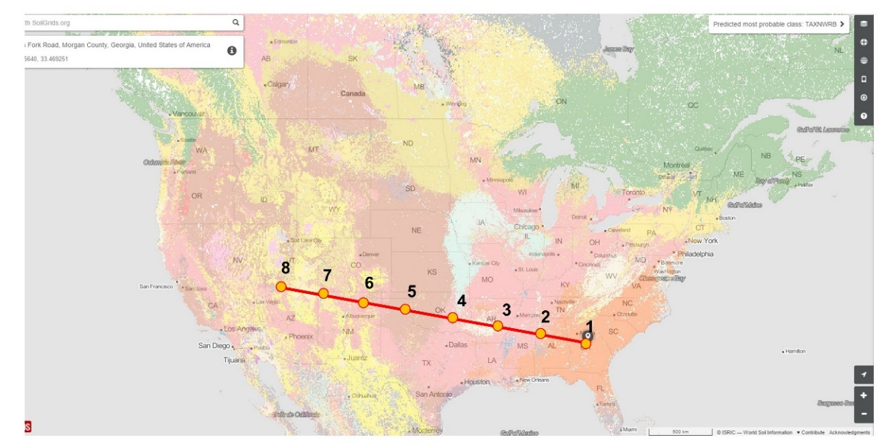
Figure 2. The transect across the southern United States where you will be asked to log soil pH using the SoilGrids website in the data table below.
- Now you will record eight approximately evenly spaced pH values for soil along a transect (geographic line along which data is taken) from the U.S. Southeast to the U.S. Southwest (see Fig. 2). You don’t need to actually draw this line on the map, just take the query data approximately along the line by doing the following:
  - Left click (normal click) on the point where you want to know about the pH. The map may readjust and re-center on this point. You will also see a precise estimate for the location including an address, at upper left on the SoilGrids screen.
  - You will also see a circle with a prominent lower case ‘I’ for information at upper left. If you click on this, a left sidebar will open with lots of different information on that point for soils. You are interested in the section on “chemical properties” for pH. Click on this bar and a list of chemical soil properties will unfold below (see Fig. 3). Scroll down within these to find “Soil pH in H2O (PHIHOX)”. Where you will see a depth profile through the soil. Record the topmost or surface value in the table below, next to your point “1”.
  - Now move on to point 2 of the transect by clicking where you would like on the map, slightly further to the west. The info sidebar will not close, but you will have to reopen the “chemical properties” list and find the pH section to record the surface pH again.
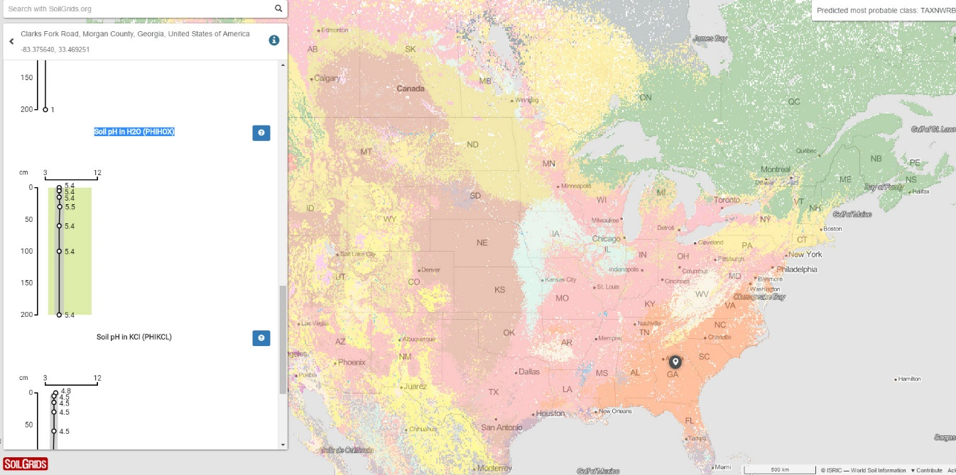
Figure 3. An illustration of the listing of data, including soil pH, that opens when you click on the ‘I’ button of the left menu bar for a location selected with the mouse (note location cursor at right in the state of Georgia)

Table for logging pH data from transects:
Transect point | East to West,  southern U.S.: soil pH | East to west, Amazon to the Peruvian coast: soil pH
1
2
3
4
5
6
7
8

- After completing the U.S. transect, zoom in on the Andes in Peru, South America (Fig. 4) and make a similar transect from east in the lowland amazon basin to the Peruvian coast.
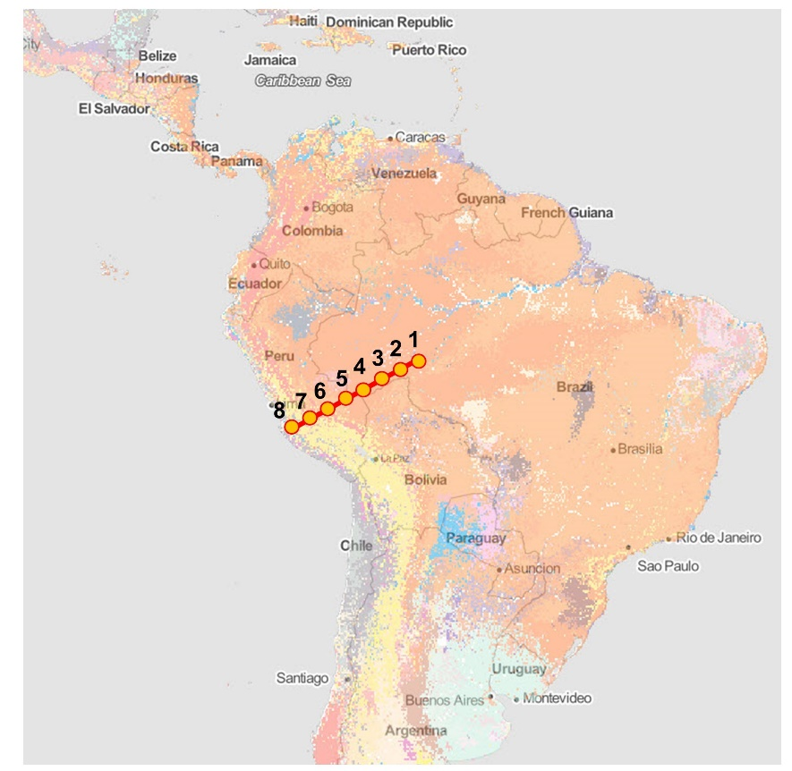
Figure 4. A similar transect to the one for the United States, across the Andes from the Amazon basin to the Peruvian coast. You will also log pH data from these approximate locations in the table above.

- After completing the two transects, answer the following questions:
  - What is the trend in east to west of soil pH in each of the transects?

  - What are possible explanations for this trend? Based on the description of soil pH in module 5.1, Think of at least two possible causes for this trend and note them:

    - ______________________________________________________

    - ______________________________________________________

- Now consult the global annual precipitation map at (the link is also on the formative assessment 5.1 page of the module, for clicking directly)
https://nelson.wisc.edu/sage/data-and-models/atlas/maps/anntotprecip/atl_anntotprecip.jpg

- What is the relationship between rainfall and soil pH you have verified?

_____________________________________________________________________________
- Based on the soil forming factors you understand now from the reading, at which end of these transects would you expect mineral nutrients for plants such as Calcium, Magnesium, Phosphorus and Boron to be most plentiful (in an undisturbed soil before soils are fertilized by farmers?).

- What would you predict for the amount of soil organic matter along ONE of these transects, and why?
____________________________________________________________________________
- Now return to the SoilGrids website. Instead of using the “info” function with location, change the map so that it displays soil carbon as the mapped variable by doing the following:
  - Click the topmost icon at right in the toolbar which shows stacked squares for “layer options”. You will see a right sidebar open that allows you to change what data is displayed in the map.
  - Move down the list to the “chemical properties” list and click on it, which will open four possible soil properties that can be mapped. Among these are “Soil organic carbon content (fine earth fraction) in g per kg”. Soil organic carbon is basically equivalent to soil organic matter – we are just referring to the 40% or so of soil organic matter that comprises carbon.
  - If you click on this, SoilGrids will ask you to what depth you would like to map this parameter. You can choose 15 cm by using the pulldown arrow at right on this “Available Depths” box. 15 cm is a typical depth for thinking about how soils contribute to growing crops and producing food.
  - After choosing this parameter the map will change and you will see different colors on the map that correspond to different levels of soil organic carbon.
  - Examine the colors that show along the approximate route of the transect where you made the prediction above in question 10. Does your prediction hold true?

_______________________________________________________________________________

- Explore some other layers as you did for soil organic carbon by choosing different parameters in the right menu bar of SoilGrids. See if you can notice any other interesting pattern (e.g. about the amount of sand in soil; about soil properties in the place where you are from, some global tropics to arctic pattern etc.) and describe that pattern briefly here (a wide variety of responses will be acceptable, the point is for you to explore the data viewer and use it to observe patterns)

_________________________________________________________________________

