Name: ________________________

Part 1: Turning water into food
Watch the following video (https://youtu.be/qEbdv3bFKww) and fill in the worksheet below as you watch the video.
- Fill in the table below summarizing the average human consumption of water per day:

Drinking water + water in your food | Domestic water use:  Washing yourself, your clothes, dishes, toilets, etc. | Water used to grow the food you eat
_________ gal/day | __________ gal/day | ___________ gal/day

- __________________ % of water resources in the US used for agriculture

- One hamburger is roughly equivalent to taking a ________________ min shower.

- What provides the energy to evaporate water from the ocean? _____________________

- Where does irrigation need to deliver water to the plant to be most efficient? __________________

- The diagram below illustrates the processes of precipitation, evaporation and evapotranspiration, as well as water being taken up by plants.

Indicate whether water is in the form of water vapor or liquid water for each of the following processes shown on the diagram:

- ___________________
- ___________________
- ___________________
- ___________________

Identify the processes of precipitation, evaporation, evapotranspiration and plant uptake of water (A., B., C., or D.) below:

______ precipitation ______ evaporation ______ evapotranspiration ______ plant uptake

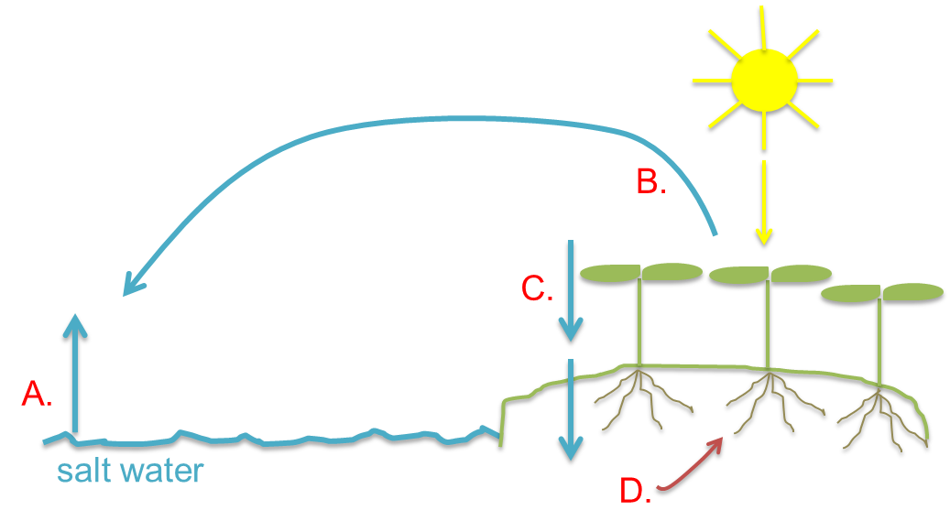

- _______________________ and ____________________ are the biggest crops for direct human consumption on the planet and provide the vast majority of ________________________ consumed by humans.

- Why can growing plants hydroponically use less water than growing plants in the field?

- If perfectly efficient, _____________ gallons of water are needed to grow the __________________ to produce one loaf of bread.

- If the spaceman wanted to get 25% of his calories from animal products (which is the national average in the US), how much more land area does he need to grow his food?

- What would your global food-print represent? How does eating meat versus plant products affect your global food-print?

Part 2 – The food component of your water footprint
What is a water footprint?
A water footprint measures the amount of water used to produce each of the goods and services we use, including the food we eat, the clothes we wear, the energy we use, the cars we drive, and the electronics we enjoy.

The average American uses about 2,000 gallons of water per day to support their lifestyle, or twice the global average. Only 5% of that is water in your home flowing through toilets, taps and garden hoses. Nearly 95 percent of the water you consume is hidden in the energy you use, the food you eat, the products you buy and the services that support your lifestyle.

U.S. average water footprint in gallons of water per day
Home | 100
Diet | 1,056
Energy | 700
Stuff | 232
Total | 2,088
(From http://environment.nationalgeographic.com/environment/freshwater/change-the-course/water-footprint-calculator/)

How much water is used to grow, process and transport the food you eat?
We’re going to use a water footprint calculator that estimates your water consumption per year for the food you eat, based on your country of resident, gender, gross yearly income and dietary habits. This calculator was developed in the United Kingdom, so the units for volume of water are cubic meters (m³). A cubic meters of water is equal to about 264 gallons.
- Go to http://waterfootprint.org/en/resources/interactive-tools/personal-water-footprint-calculator/
- Select your country of residence, gender and gross yearly income.
- Calculate your water footprint for each of the three different dietary habit categories:
vegetarian, average meat consumer and high meat consumer.
- Fill in the table below

 | Global average water footprint (m³/year) | Your water footprint (m³/year) | Food component of your water footprint (m³/year) | Meat category of the food component of your water footprint (m³/year)
Vegetarian
Average meat consumer
High meat consumer

- How does your water footprint compare to the global average? Is it higher or lower? By how much?

- Read the text below the graphs. How is this water footprint calculated? (If you’re interested in a more detailed analysis, click on the link for the “extended version” of the calculator).

- How does your water footprint change as you increase your consumption of meat? Explain why.

Part 3 – Virtual Water: How much water is embedded in your everyday life?
Visit the following website (please copy and paste the link into your browser if you have trouble launching the link.)

http://www.unesco.org/new/fileadmin/MULTIMEDIA/FIELD/Venice/pdf/special_events/bozza_scheda_DOW04_1.0.pdf

Answer the following questions:

- Which meat uses the least amount of water to produce? How much?

- Which meat uses the most? How much?

- Which grains use the most and least water to produce? How much water?

- Click through more foods and products and discuss the information provided about water use. What did you learn? What surprised you the most? Do the data presented on this site support the idea that eating a vegetarian diet would use less water?

