Food, Water, and Pawnee County, Kansas

Introduction
The objective of this assignment is to assess the benefits of more efficient irrigation methods on a farm in Kansas using your knowledge from Module 4 about water for crops combined with an online tool that estimates crop yield from different irrigation strategies.

The farm is located in Pawnee County, Kansas (Figure 1). Pawnee County is in the Arkansas River drainage basin and runoff from the land in the county flows into the Mississippi River and then into the Gulf of Mexico. In addition, many farms in Pawnee County extract irrigation water from the Ogallala Aquifer, one of the world’s largest and most over-exploited aquifers.

Pawnee County is an agricultural county in Kansas where 75% of the market value of agricultural products sold in the county is from livestock sales (more than $270 million) and the remaining 25% are crop sales (more than $92 million). Wheat, grain sorghum, and corn are Pawnee County’s biggest crops. Both grain sorghum and corn are used for cattle feed.

(Note: If the file does not open, copy and paste the link into your browser) http://www.agcensus.usda.gov/Publications/2012/Online_Resources/County_Profiles/Kansas/cp20145.pdf

The Great Plains of the US, where Pawnee County is located, is one of the world’s largest exporters of commodities like corn and soybeans, and the region is extremely water stressed. Because of precipitation rates on the Great Plains, much of the agriculture on the US plains relies on irrigation from groundwater pumped from the Ogallala Aquifer. Crops can be grown in this region without irrigation. Farming without irrigation in a semi-arid region is called “dryland farming”. Dryland farming is possible, but crop yields are much lower and crop choices are limited to those crops that are productive with limited water.

The three main types of irrigation used are flood/furrow, center-pivot sprinklers and surface or subsurface drip. Flood/furrow is least efficient with only about 50% of the water applied actually being used for crop growth. Sprinklers are roughly 75% efficient, while drip irrigation can be up to 90% efficient. Use of sprinklers is becoming more widespread, but drip irrigation is not yet widely adopted because of the initial expense to install a drip system. The resulting increase in crop yields over time with drip irrigation can offset the initial expense.

One of your friends at school is from a farming and ranching family in Pawnee County, Kansas. She mentioned that her family is considering transitioning some of their acreage from flood and furrow irrigated feed crops into high-value fruits and vegetables using a high efficiency irrigation system. She explained that there is debate among the neighboring farmers about the cost to transition (cost of irrigation system, etc.) versus the benefits. She knew that you were taking a class related to food and the environment and she asked you to explain what the benefits might be of making such a transition.

Background reading and video
- Watch the short video entitled Snapshot of Success, Research and Extension Outreach, Subsurface Drip Irrigation: https://www.youtube.com/watch?v=w2Vi72PbA5k
- Read the short article below that includes recent data about the Dead Zone in the Gulf of Mexico
Gulf of Mexico Dead Zone Largest Since 2002
By JoAnna Wendel 6 August 2015, eos.org
https://eos.org/articles/gulf-of-mexico-dead-zone-largest-since-2002

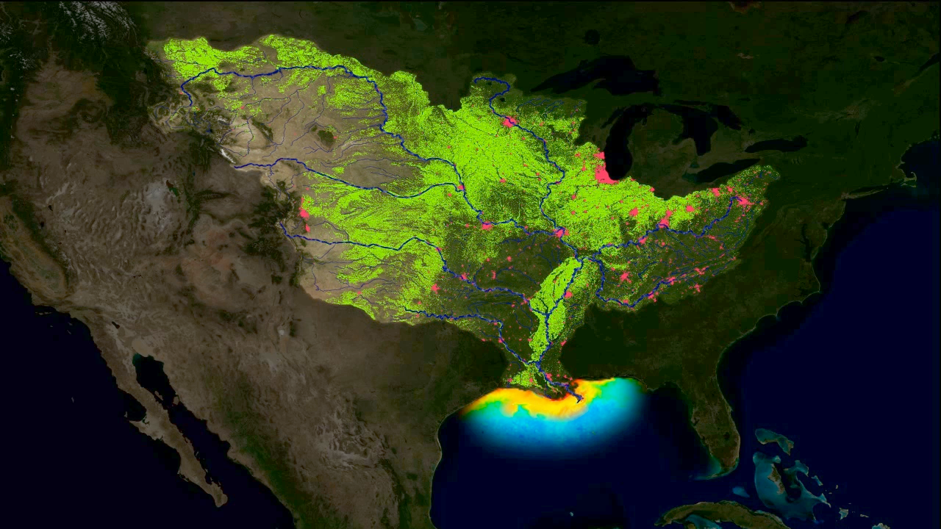
Pawnee County, KS
Figure 1 - A visualization of how nutrient runoff from farms (green) and cities (red) in the Mississippi River Basin influences algal blooms in the Gulf of Mexico. The warmer colors represent a higher concentration of algae. NOAA scientists predict that the size of the 2015 Gulf of Mexico dead zone, which is caused by the decomposition of these blooms, will be about the size of Connecticut. Credit: NOAA, https://oceanservice.noaa.gov/podcast/feb18/nop13-hypoxia.html.

**For all of the following exercises fill in your answers into the Excel spreadsheet provided “Module4_SummativeResults.xlsx”. Your answers should be input into the shaded cells. As you add values to the spreadsheet, the graph will populate.

Part 1: Precipitation
- Go to the “Water sources for crops” page in Module 4.1 (https://www.e-education.psu.edu/geog3/node/1093).
- Use Figure 4.1.5 to determine the range of annual precipitation for Pawnee County, Kansas? Pawnee county is located a bit southwest of the center of the state of Kansas (Figures 1 and 2 indicate the location of the county). Record your answer in the results spreadsheet.

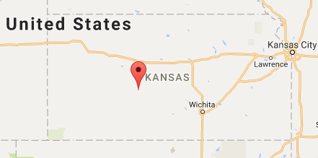
Figure 2 – Location of Pawnee County, Kansas

Part 2: Crops
- On the “Water sources for crops” page in Module 4.1 (https://www.e-education.psu.edu/geog3/node/1093, find Figure 4.1.6, which shows water use for different crops in California. Which crops have a median water application depth less than the natural precipitation rate in Pawnee County, KS (assuming that the water application rate in Kansas is similar to that of California)? Record your list in the results spreadsheet.
- It’s important to remember that all of the annual precipitation doesn’t fall during the growing season. Also, the annual precipitation rate we’re using from Figure 4.1.5 is an average. Some years are drier and some are wetter than this average. This list gives you an idea of what crops could be farmed in Kansas using dryland farming.

Part 3: Irrigation Efficiency and Crop Yield
The next section instructs you how to use an online tool to estimate the impact of different irrigation efficiencies and annual rainfall amounts on crop yield. Follow the instructions below to fill out the table at the end.

- Visit http://www.bae.ksu.edu/mobileirrigationlab/cwa2, the Crop Water Allocator.
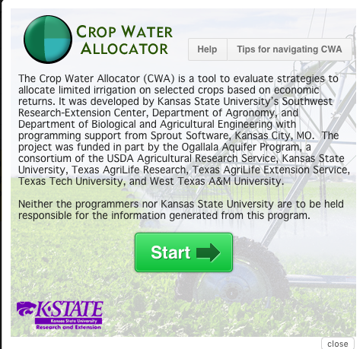
- Click the green Start button:

- You will land on a page that looks like this:
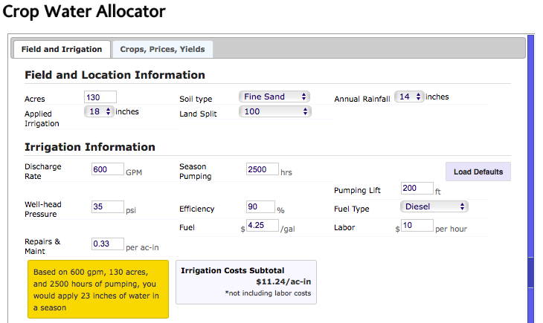

- Double-click on the vertical blue bar at the right side of the pane to open the results pane on the right.
- Click on the “Crops, Prices, Yields” tab.
- Check the boxes for all of the crops shown including fallow.
- Click the green Calculate button at the bottom.
- The results pane on the right should populate with information about all of the crops, as in Figure 3.
  - Notice that there is a horizontal scroll bar at the bottom of the right pane that allows you to see all of the results in the pane.
  - Also, the vertical blue bar can be dragged left or right to display more or less of the right and left panes.
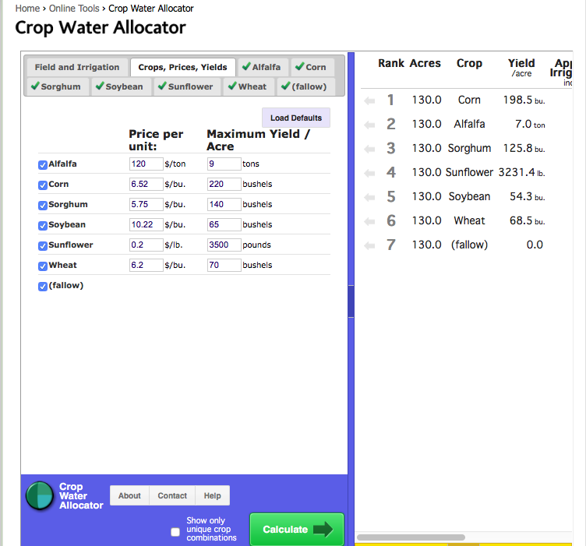
Drag the blue bar left or right to reveal more of either pane
Use this scroll bar to see all of the results in the right pane
Figure 3 - Crop Water Allocator

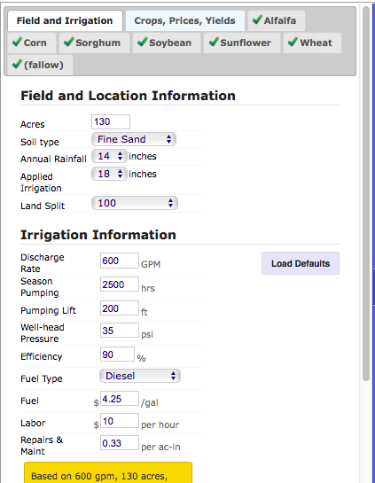
- Click on the Field and Irrigation tab on the left. Use the fields on this page to adjust for different irrigation strategies according to the instructions below
  - The default scenario is 130 acres, 100% irrigated agriculture.
  - You will only change two settings:
    - Annual Precipitation, inches
    - Efficiency, %
  - Use the values in Table 1 to setup six different scenarios of precipitation and irrigation efficiency.
  - Click the green Calculate button at the bottom.
  - Scroll through the results in the right pane.
  - Notice that the crop yield column reports yield with different units of measure for different crops. It’s beyond the scope of this class to get into why some crops are reported in bushels and others in pounds or tons. The key results to consider right now are the financial returns per acre.
- Record the results for “Total Return – net $ per acre” for each scenario for the seven crops in the results spreadsheet.

Table 1 – Six rainfall and irrigation efficiency scenarios
 | Scenario 1  Avg rainfall, flood furrow irrigation | Scenario 2  Avg rainfall, center-pivot sprinkler | Scenario 3  Avg rainfall, drip irrigation | Scenario 4  Drought year, flood furrow irrigation | Scenario 5 Drought year, center-pivot sprinkler | Scenario 6 Drought year, drip irrigation
Annual Precipitation (inches) | Middle of range from Part 1 | Middle of range from Part 1 | Middle of range from Part 1 | 25% less than avg precip | 25% less than avg precip | 25% less than avg precip
Efficiency | 50% | 75% | 90% | 50% | 75% | 90%

Part 4: Discussion and Synthesis

Write a short discussion (~2 paragraphs) of the benefits of the two different farming strategies: traditional cattle ranching, feedlots, and wheat, grain sorghum, and corn crops vs. high value fruits and vegetables with high-efficiency irrigation. In your discussion:
- include the concepts of water footprints, water scarcity, dead zones, and irrigation efficiency
- consider both the quantity of water used (e.g., method of irrigation, water footprints) and the impacts to water quality (e.g., fertilizer runoff and the dead zone)
- refer to your scenarios from Part 3
- the possible response in the human system to the formation of dead zones. Propose strategies that could be implemented to reduce the amount of fertilizer running off from the farmland to minimize the farm’s contribution to the dead zone in the Gulf of Mexico. Review the coupled human-natural system diagram below.

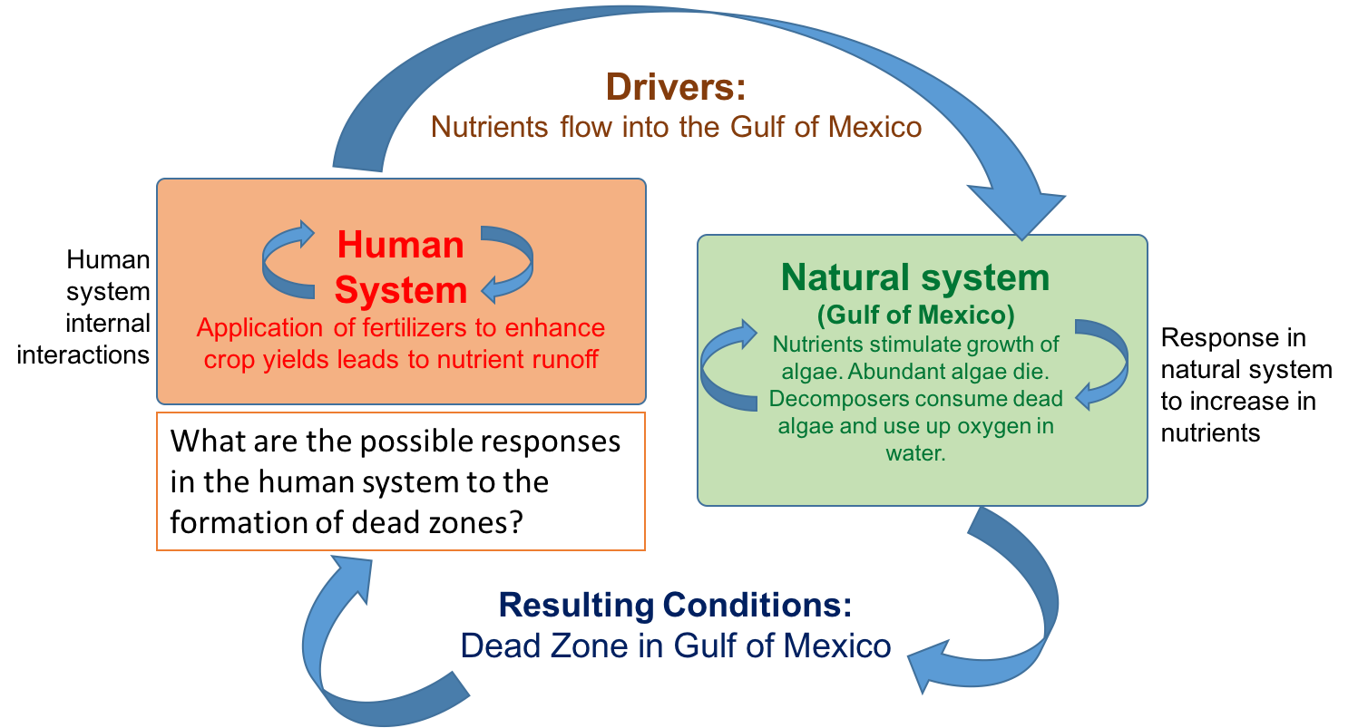

For the on-line class
The discussion portion of the worksheet is incorporated into the weekly discussion post. You will not be quizzed on the discussion portion of the assessment but will answer similar questions in the weekly discussion.

Assessment Rubric

Criteria | Possible Points | Points Awarded
Part 1: Precipitation
Precipitation rates from map are correct. | 2
Part 2: Crops
List of crops correctly represents crops that could be grown with natural precipitation | 4
Part 3:
Scenario table correctly populated with results from the Crop Water Allocator | 14
Part 4: Discussion and Synthesis
Includes correct usage of the concept of water footprints and connection between diet and water consumption. | 5
Clearly explains connections between farming, water scarcity, dead zones, and irrigation efficiency. Also demonstrates clearly the connection between increased water consumption and impacts to water resources, including quality and quantity impacts, such as nutrient pollution and groundwater depletions. | 10
Well-written, proper spelling and grammar, and uses complete and well-crafted sentences. | 2
Logical presentation of topics. Reasonable length. | 3
TOTAL | 40

