Module 8.1 Formative Assessment: Australian grain crop IPM and Determining the Economic Threshold for potato leafhopper in alfalfa

Part 1: Australian grain crop IPM

Watch the following video that explains IPM adoption in grain crops in Australia. Then answer this question:

1. Identify and explain three benefits of utilizing IPM discussed in the Australian video.

Part 2: Determining the Economic Threshold of Potato Leafhoppers in Alfalfa

Read the Penn State University Potato Leafhopper on Alfalfa Fact Sheet

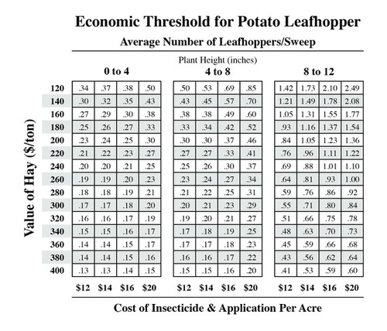

Economic Threshold for Potato Leafhoppers
Credit: Penn State University Potato Leafhopper on Alfalfa Fact Sheet

Scenario

Assume that you followed the procedure described in the Penn State fact sheet to scout for Potato Leafhoppers in alfalfa field by sweeping 20 times with your sweepnet in each of 5 different locations in an alfalfa field.

The number of leafhoppers that you found from the 20 sweeps in 5 different locations were: 15, 12, 16, 7, 13, when the alfalfa crop was about 11 inches tall. You would like the alfalfa to grow about 25-30 inches height before harvesting it for hay, which could require 2 to 3 weeks depending on rainfall. Based on current alfalfa hay prices in your region, you estimate it is worth about $240/Ton, and the insecticide you would spray to control the leafhoppers would cost about $16/A. The forage cannot be harvest until 7 days after spraying the insecticide, and due to toxicity to bees, the alfalfa should not be sprayed if it is flowering.

Answer the following questions:

- Calculate the average number of leafhoppers per sweep. Add the number of potato leafhoppers from the 20 sweeps in each of the 5 locations. You collected a total of 100 sweeps (20 X 5= 100 sweeps). Divide the total number of leafhoppers you found by 100 to calculate the number of leafhoppers per sweep. Use the Economic Threshold Table from the Fact Sheet for Potato Leafhoppers, shown here. Has the insect population reached an economic threshold for your crop at this height?

- Based on the average number of leafhoppers per sweep, what should you do? Why?

- If your crop height was 7 inches tall and you had the same number of leafhoppers per sweep that you calculated here, would your pest management decision change and how?

- Discuss at least two potential benefits of using the economic threshold decision tool rather than spraying as soon as potato leafhoppers were first visible.

Submitting Your Assessment
Please submit your assignment through the CMS.

