GEOG 438W Syllabus - Human Dimensions of Global Warming

Instructor
Brandi Robinson
Assistant Teaching Professor
John and Willie Leone Family Department of Energy and Mineral Engineering
Dutton e-Education Institute
College of Earth and Mineral Sciences
Phone: 814.867.4539
Office Hours: online via Zoom, by appointment
Contacting your instructor: Rather than emailing questions directly to me, I encourage you post any question to the General Questions and Discussion forum which you would raise your hand to ask in a traditional class. Asking questions on our forums can benefit all students in that everyone will see the discussions and answers regarding class questions. For questions which are more personal in nature, please contact me through the course e-mail system in Canvas.
NOTE: I will read and respond to e-mail and discussion forums at least once per day during the work week (Monday through Friday) and if time permits on weekends. In other words, even if you plan to do the bulk of your work over the weekend, it is prudent you submit questions to me by Friday to ensure I'm able to respond with enough time for you to utilize my answers to your questions for on-time submissions by Sunday night.

Course Overview
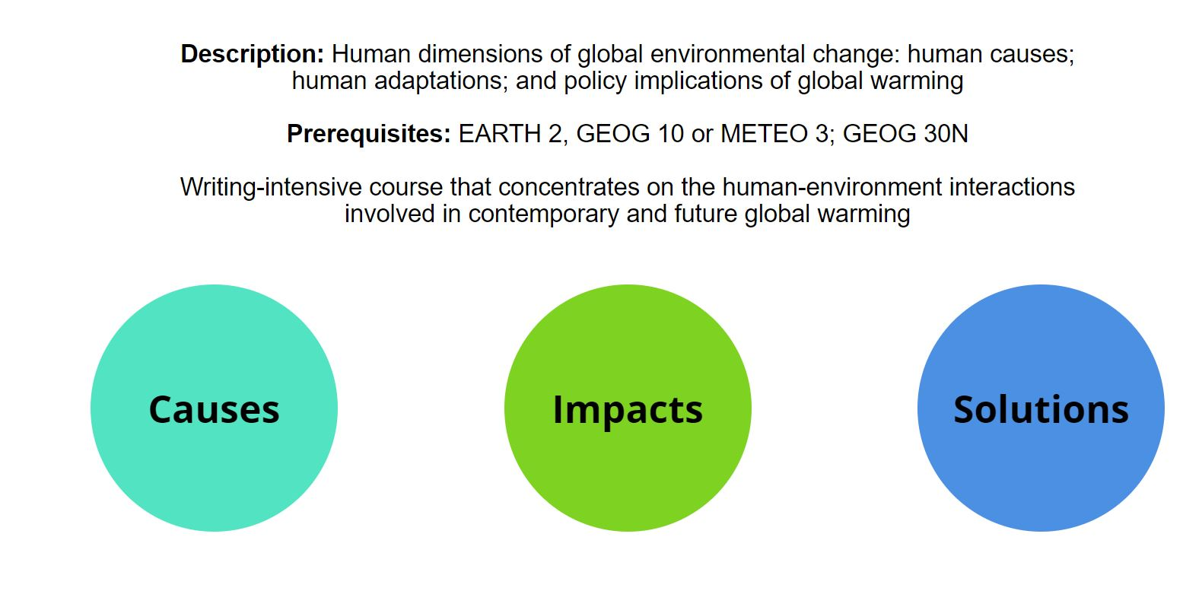
Geography 438W is a writing-intensive course that concentrates on the human-environment interactions involved in contemporary and future global warming. The course features two broad topical areas: global warming impacts, which comprises the first half of the course, and global warming mitigation and policy, which encompasses the second half of the course. Each week highlights a theme – such as the impacts of climate change on human health or greenhouse gas emissions from transportation – that weaves through the course lecture, reading assignment, class discussion, and writing activity.

What I Expect of You
On average, most students spend eight to ten hours per week working on course assignments. Your workload may be more or less depending on your study habits.
Ie have worked hard to make this the most effective and convenient educational experience possible, as well as fun! The Internet may still be a novel learning environment for you, but, in one sense, it is no different than a traditional college class: how much and how well you learn is ultimately up to you. You will succeed if you are diligent about keeping up with the class schedule, and if you take advantage of opportunities to communicate with us as well as with your fellow students.

Course Goals and Outcomes
At the successful completion of this course, you will be able to:
- explain the human causes of climate change and the potential mitigation alternatives for these causes;
- examine human vulnerability to and adaptation to climate change impacts and how these vary across space, populations, and other variables;
- write well-organized, thoroughly supported, and critical discussions of complex issues related to the human dimensions of climate change.
By the end of the semester, students will have broad understanding of the human dimensions of global warming, better writing ability, and improved critical reading skill.
Specific learning objectives for each lesson and project are detailed within each lesson. The class schedule is published on the Canvas Calendar.

Required Course Materials
All materials needed for this course are presented online through our Course website and in Canvas. In order to access all materials, you need to have an active Penn State Access Account user ID and password (used to access the online course resources). If you have any questions about obtaining or activating your Penn State Access Account and are a World Campus student, please contact the Outreach Helpdesk. If you are a resident education student, please contact the ITS Help Desk.

Assignments and Grading
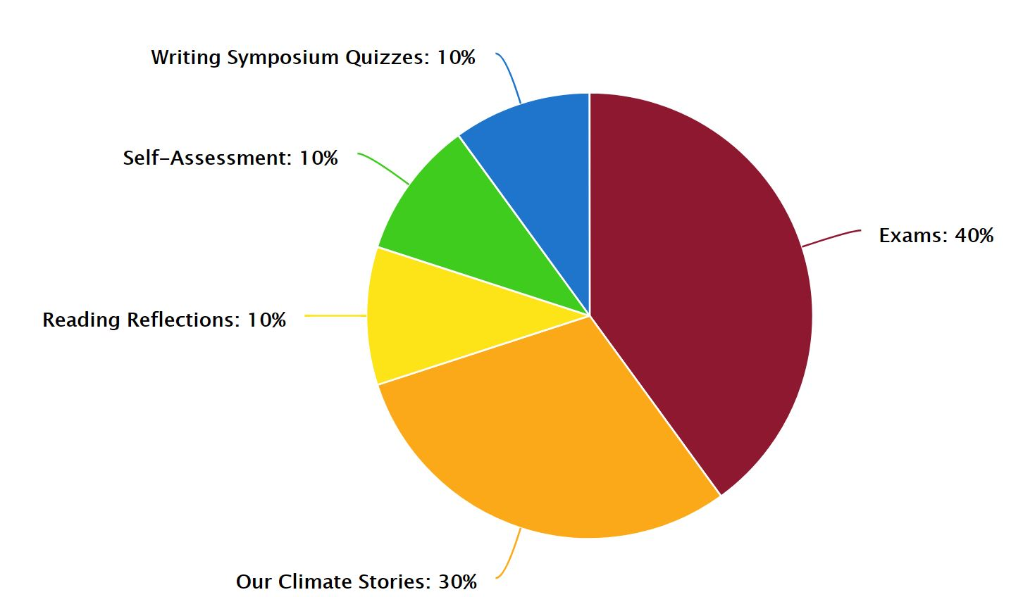
The course has 4 units, each comprised of 3 lessons. We will spend one week on each lesson. At the end of each unit, there will be a non-cumulative essay exam as well as self-assessment of your writing progress. In each of the lessons, to reach course goals, students will read online course content and reading assignments, study and be quizzed on the writing symposia, and participate in a reading reflection. Each unit also includes one additional creative assignment, Our Climate Stories.

Exams
There will be four essay exams. In addition to be being graded on your understanding of the content presented in class, you'll also be assessed on your ability to communicate these concepts eloquently in formal academic writing. You will have one week each for Exams 1-3. Exam 4 will open at the beginning of Unit 4 and is due December 11.
Two of the course emphases are self-editing and drafting. Consequently, all exams will not only require the submissions of a clean final draft, but also drafts that demonstrate considerable self-editing via Track Changes(link is external) in Microsoft Word. Failure to include these drafts and follow other prescribed formatting guidelines will result in point deductions. Detailed instructions will be provided.

Recognizing that the goal of the course is to improve one’s writing, the Exams are deliberately not weighted equally. Instead, the exams carry more weight as the semester progresses, and therefore provides students with the opportunity to employ writing suggestions and symposium material in later exams to earn proportionally more credit. The exams are weighted as follows: Exam 1 – 5%, Exam 2 – 8%, Exam 3 – 12%, and Exam 4 – 15%.

Our Climate Stories
Each unit includes a creative assignment which challenges you to connect the content to your own life. Students are given creative license for the format in which assignments are submitted. Assignments are shared with a subset of the class via the assigned discussion forum.

Self-Assessments
At the end of each unit, students will complete a self-assessment and grading rubric for your performance on the exam. This is an opportunity to reflect on the areas in your writing with which you struggle and those you feel you’re improving through continued practice in the course.

Reading Reflections
To ensure we move through the course material according to schedule, there will be a short reading reflection assignment at the end of each lesson in which students will need to demonstrate comprehension of the lesson material and external readings. These are structured as Canvas quizzes with a mix of automated questions and open-ended written responses.

Writing Symposium Quizzes
In addition to course material itself, we will also devote time each week (lessons 2-11) to targeted improvement of your academic writing. You will find a writing symposium page in each of these lessons with topics ranging from paragraph structure and subject/verb agreement to avoiding run-ons and how to properly cite sources. To ensure that you're integrating this material into your writing, not only will your writing assignments in the corresponding weeks be edited carefully for the topic covered, but there will also be a short, automated quiz in Canvas. Writing symposium quizzes constitute 10% of your course grade (1% each; 10 quizzes).

Grading Scale
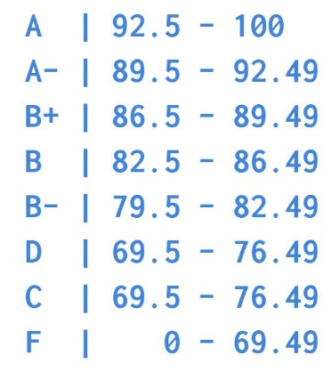
Letter grades will be based on the following percentages (percentages refer to the proportion of all possible points earned by the student). No rounding. No extra credit. Try your best on all assigned work!

Course Schedule
You should refer to the Canvas calendar for all due dates, also described below. If you notice any inconsistencies or conflicting information, let me know and I'll clarify. Our course schedule for this semester will be Monday-Sunday. Lessons open each week on Monday morning, and you have until the following Sunday night at 11:59 pm to complete the associated work and deliverables.
While not called out as a deliverable, students are expected to read all online course content and associated links as well as assigned external readings in addition to completing the deliverables described below.

Unit 1: Covering the Basics
Orientation and Lesson 1: Introduction to the Human Dimensions of Climate Change
Date: | August 20-26
Deliverables: | - Complete Orientation Tasks (introductions, quiz and all 3 library badges)  - Reading Reflections

Lesson 2: Human Causes and Mitigation of Climate Change
Date: | August 27 – September 2
Deliverables: | - Reading Reflections  - Writing Symposium Quiz

Lesson 3: Vulnerability and Adaptation
Date: | September 3-9
Deliverables: | - Reading Reflections  - Writing Symposium Quiz  - Unit 1 Our Climate Stories

Unit 1 Exam Period
Date: | September 10-16
Deliverables: | - Unit 1 Exam  - Unit 1 Self-Assessment

Unit 2: Greenhouse Gas Emissions and Mitigation
Lesson 4: Energy Sector GHG Emissions and Mitigation
Date: | September 17-23
Deliverables: | - Reading Reflections  - Writing Symposium Quiz

Lesson 5: Transportation Sector GHG Emissions and Mitigation
Date: | September 24-30
Deliverables: | - Reading Reflections  - Writing Symposium Quiz

Lesson 6: Local Scale Emissions and Mitigation
Date: | October 1-7
Deliverables: | - Reading Reflections  - Writing Symposium Quiz  - Unit 2 Our Climate Stories

Unit 2 Exam Period
Date: | October 8-14
Deliverables: | - Unit 2 Exam  - Unit 2 Self-Assessment

Unit 3: Impacts of Climate Change
Lesson 7: Impacts on Human Health
Date: | October 15-21
Deliverables: | - Reading Reflections  - Writing Symposium Quiz

Lesson 8: Impacts on Water Resources
Date: | October 22-28
Deliverables: | - Reading Reflections  - Writing Symposium Quiz

Lesson 9: Impacts on Our Coasts and Cities
Date: | October 29- November 4
Deliverables: | - Reading Reflections  - Writing Symposium Quiz  - Unit 3 Our Climate Stories

Unit 3 Exam Period
Date: | November 5-11
Deliverables: | - Unit 3 Exam  - Unit 3 Self-Assessment

Unit 4: The Politics and Policy of a Changing Climate
Lesson 10: Climate Policy
Date: | November 12-18
Deliverables: | - Reading Reflections  - Writing Symposium Quiz

Thanksgiving Week
Date: | November 19-25
Deliverables: | - Enjoy your break!

Lesson 11: Climate Wars
Date: | November 26 - December 2
Deliverables: | - Reading Reflections  - Writing Symposium Quiz (last one!)

Lesson 12: Climate Action
Date: | December 3-9
Deliverables: | - Reading Reflections  - Unit 4: Our Climate Stories

Unit 4 Exam Period
Date: | November 12 – December 11
Deliverables: | - Unit 4 Exam  - Unit 4 Self-Assessment

Course Policies

Don’t Tempt Fate!

Technology only fails you when you need it most. Waiting until the very last minute to submit something invites technical issues that cost you a late penalty. Part of your responsibility in this class to ensure that your work is received by the prescribed deadline (not simply that it’s done by then).

Late Policy
You are expected to submit all of your work on time, as scheduled; however, late completions are possible if arranged beforehand in the case of documented illness or emergency. If you find yourself falling behind, talk to the instructor *before* you miss a deadline, not after. Instructors are people too, and we understand that life happens. Late submissions of any kind incur 10% per day penalty unless approved by the instructor.

Technical Requirements
For this course, we recommend the minimum technical requirements outlined on the World Campus Technical Requirements page, including the requirements listed for same-time, synchronous communications. If you need technical assistance at any point during the course, please contact the (for World Campus students) or the ITS Help Desk (for students at all other campus locations).

Internet Connection
Access to a reliable broadband Internet connection is required for this course. A problem with your Internet access may not be used as an excuse for late, missing, or incomplete coursework. If you experience problems with your Internet connection while working on this course, it is your responsibility to find an alternative Internet access point, such as a public library or wireless hotspot.

Mixed Content
This site is considered a secure website which means that your connection is encrypted. We do, however, link to content that isn't necessarily encrypted. This is called mixed content. By default, mixed content is blocked in Internet Explorer, Firefox and Chrome. This may result in a blank page or a message saying that only secure content is displayed. Follow the directions on our technical requirements page of the course orientation to view the mixed content.

Penn State E-mail Accounts
All official communications from the Penn State World Campus are sent to students' Penn State e-mail accounts. Be sure to check your Penn State account regularly so you don't miss any important information.

Academic Integrity
This course follows the guidelines for academic integrity of Penn State's College of Earth and Mineral Sciences. Penn State defines academic integrity as "the pursuit of scholarly activity in an open, honest and responsible manner." Academic integrity includes "a commitment not to engage in or tolerate acts of falsification, misrepresentation, or deception." In particular, the University defines plagiarism as "the fabrication of information and citations; submitting others' work from professional journals, books, articles, and papers; submission of other students' papers, lab results or project reports and representing the work as one's own." Penalties for violations of academic integrity may include course failure. To learn more, see Penn State's "Plagiarism Tutorial for Students."

Course Copyright
All course materials students receive or to which students have online access are protected by copyright laws. Students may use course materials and make copies for their own use as needed, but unauthorized distribution and/or uploading of materials without the instructor’s express permission is strictly prohibited. University Policy AD 40, the University Policy for the Recording of Classroom Activities and Note Taking Services addresses this issue. Students who engage in the unauthorized distribution of copyrighted materials may be held in violation of the University’s Code of Conduct, and/or liable under Federal and State laws.

Accommodations for Students with Disabilities
Penn State welcomes students with disabilities into the University's educational programs. Every Penn State campus has an office for students with disabilities. The Student Disability Resources (SDR) website provides contact information for every Penn State campus: Contacts for Disability Services at all Penn State Campuses. For further information, please visit the Student Disability Resources (SDR) website.
In order to receive consideration for reasonable accommodations, you must contact the appropriate disability services office at the campus where you are officially enrolled, participate in an intake interview, and provide documentation. If the documentation supports your request for reasonable accommodations, your campus’s disability services office will provide you with an accommodation letter. Please share this letter with your instructors and discuss the accommodations with them as early in your courses as possible. You must follow this process for every semester that you request accommodations.

Military Personnel
Veterans and currently serving military personnel and/or spouses with unique circumstances (e.g., upcoming deployments, drill/duty requirements, disabilities, VA appointments, etc.) are welcome and encouraged to communicate these, in advance if possible, to the instructor in the case that special arrangements need to be made.

Inclement Weather
In case of weather-related delays at the University, this online course will proceed as planned. Your instructor will inform you if there are any extenuating circumstances regarding content or activity due dates in the course due to weather delays. If you are affected by a weather-related emergency, please contact your instructor at the earliest possible time to make special arrangements.

Connect Online with Caution
Penn State is committed to educational access for all. Our students come from all walks of life and have diverse life experiences. As with any other online community, the lack of physical interaction in an online classroom can create a false sense of anonymity and security. While one can make new friends online, digital relationships can also be misleading. Good judgment and decision making are critical when choosing to disclose personal information with others whom you do not know.

Reporting Bias-Motivated Incidents
Penn State takes great pride to foster a diverse and inclusive environment for students, faculty, and staff. Acts of intolerance, discrimination, or harassment due to age, ancestry, color, disability, gender, gender identity, national origin, race, religious belief, sexual orientation, or veteran status are not tolerated (https://policy.psu.edu/policies/ad29) and can be reported through Educational Equity via the Report Bias webpage.

Counseling and Psychological Services
Many students at Penn State face personal challenges or have psychological needs that may interfere with their academic progress, social development, or emotional wellbeing. The university offers a variety of confidential services to help you through difficult times, including individual and group counseling, crisis intervention, consultations, online chats, and mental health screenings. These services are provided by staff who welcome all students and embrace a philosophy respectful of clients’ cultural and religious backgrounds, and sensitive to differences in race, ability, gender identity and sexual orientation. Services include the following:
Counseling and Psychological Services at University Park (CAPS): 814-863-0395
Counseling and Psychological Services at Commonwealth Campuses
Penn State Crisis Line (24 hours/7 days/week): 877-229-6400
Crisis Text Line (24 hours/7 days/week): Text LIONS to 741741

Attendance
This course will be conducted entirely online. There will be no set class meeting times, but you will be required to complete assignments with specific due dates. Many of the assignments are open for multiple days. It is your responsibility to complete the work on time, which may require you to complete the work early if you plan to travel or participate in national holidays, religious observances, or University-approved activities.
If you need to request an exception due to a personal or medical emergency, contact the instructor directly as soon as you are able. The instructor's ability to accommodate you is dependent on the earliest possible notification. Such requests will be considered on a case-by-case basis.

Netiquette
The term "Netiquette" refers to the etiquette guidelines for electronic communications, such as e-mail and bulletin board postings. Netiquette covers not only rules to maintain civility in discussions, but also special guidelines unique to the electronic nature of forum messages. Please review some general Netiquette guidelines that should be followed when communicating in this course.

Mandated Reporting Statement
Penn State’s policies require me, as a faculty member, to share information about incidents of sex-based discrimination and harassment (discrimination, harassment, sexual harassment, sexual misconduct, dating violence, domestic violence, stalking, and retaliation) with Penn State’s Title IX coordinator or deputy coordinators, regardless of whether the incidents are stated to me in person or shared by students as part of their coursework. For more information regarding the University's policies and procedures for responding to reports of sexual or gender-based harassment or misconduct, please visit Penn State's Office of Sexual Misconduct Prevention & Response website.
Additionally, I am required to make a report on any reasonable suspicion of child abuse in accordance with the Pennsylvania Child Protective Services Law.

Diversity, Inclusion, and Respect
Penn State is “committed to creating an educational environment which is free from intolerance directed toward individuals or groups and strives to create and maintain an environment that fosters respect for others” as stated in Policy AD29 Statement on Intolerance. All members of this class are expected to contribute to a respectful, welcoming and inclusive environment and to interact with civility.

For additional information, see:
- Penn State Affirmative Action non-discrimination statement
- Policy AD 85 Sexual and gender-based harassment and misconduct, Title IX
- Policy AD91 Discrimination and Harassment, and Related inappropriate Conduct
- Penn State Statement on Diversity, Equity, and Inclusive Excellence
- Penn State Values
- Penn State Principles
- All In at Penn State: A Commitment to Diversity and Inclusion

Disclaimer
Please note that the specifics of this Course Syllabus can be changed at any time, and you will be responsible for abiding by any such changes. All changes will be communicated with you via email, course announcement and/or course discussion forum.

