GEOGRAPHY 469
REQUESTING, DOWNLOADING, INSTALLING, AUTHORIZING AND OPENING ARCGIS PRO

REQUESTING THE ESRI SOFTWARE
1. Request an Esri Authorization Code from Sue Spaugh sns4@psu.edu
2. In the same email to Sue, request an invitation to access the Esri Academy. This will be used to access your Esri Tutorials.
3. You will receive an email from sue with your Esri Authorization Code.
4. The Esri Authorization Code will look similar to this: EVA484466481

DOWNLOADING THE SOFTWARE
1. Click on the link in the email sent to you by Sue.
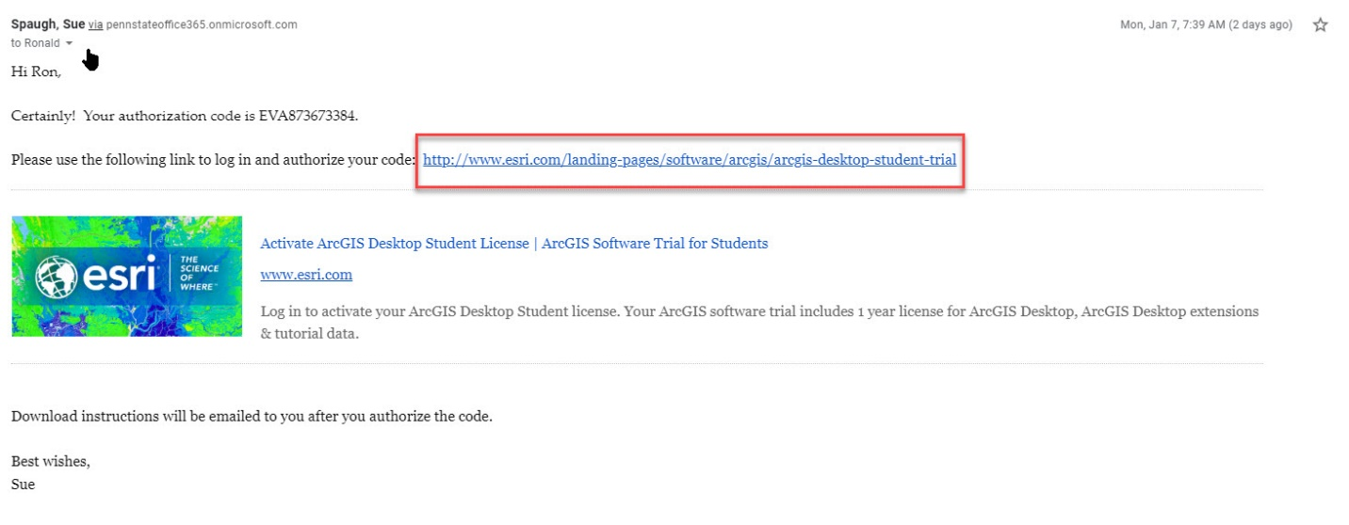

2. Create a new UserID and Password. IT CANNOT BE YOUR PENN STATE USER ID & PASSWORD. Click the Sign In box.
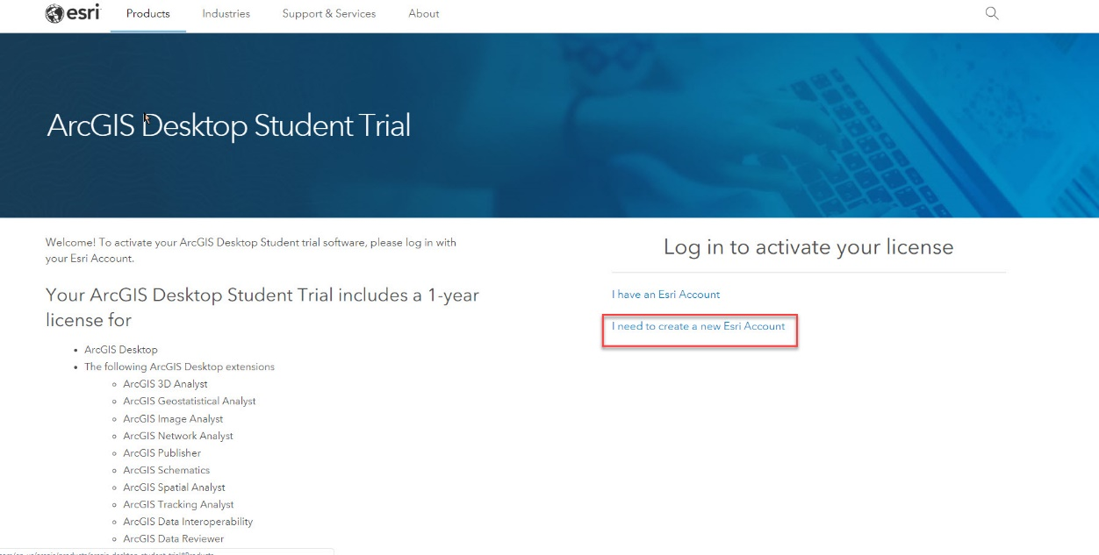
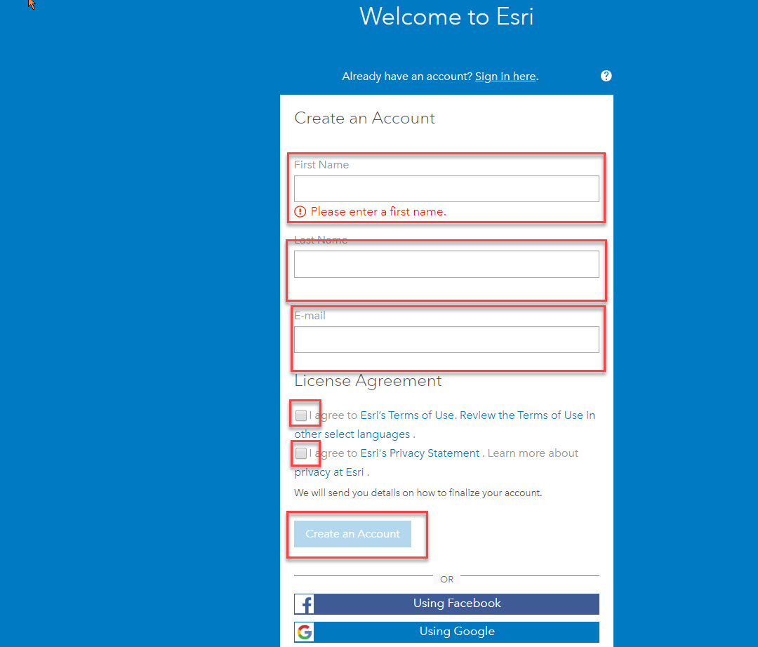
Check your Spam folder if you do not receive an email from Esri about activating your account.
3. Enter the Esri Authorization Code you received from Sue. Click: Activate ArcGIS
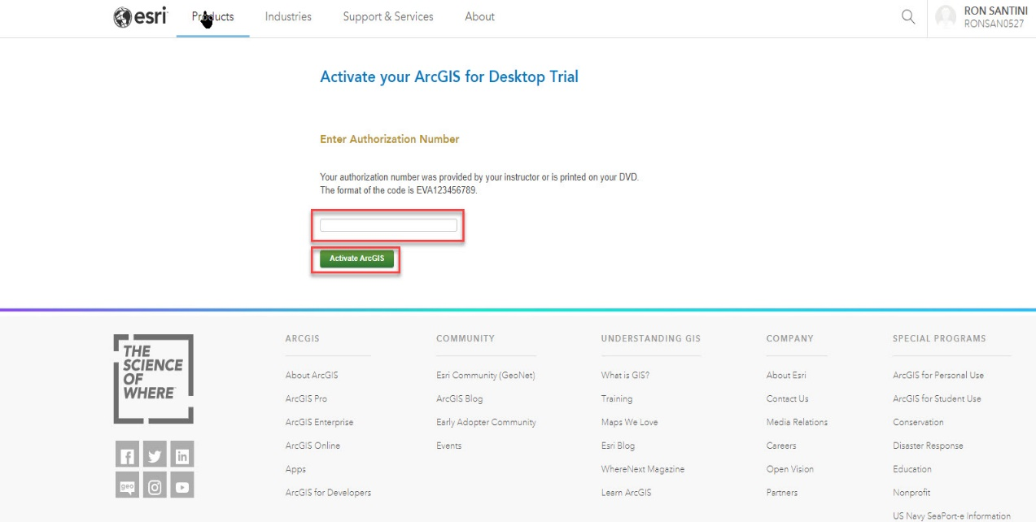
4. Click on ArcGIS Pro 2.2/ArcGIS 10.6.1 This will start the load process.
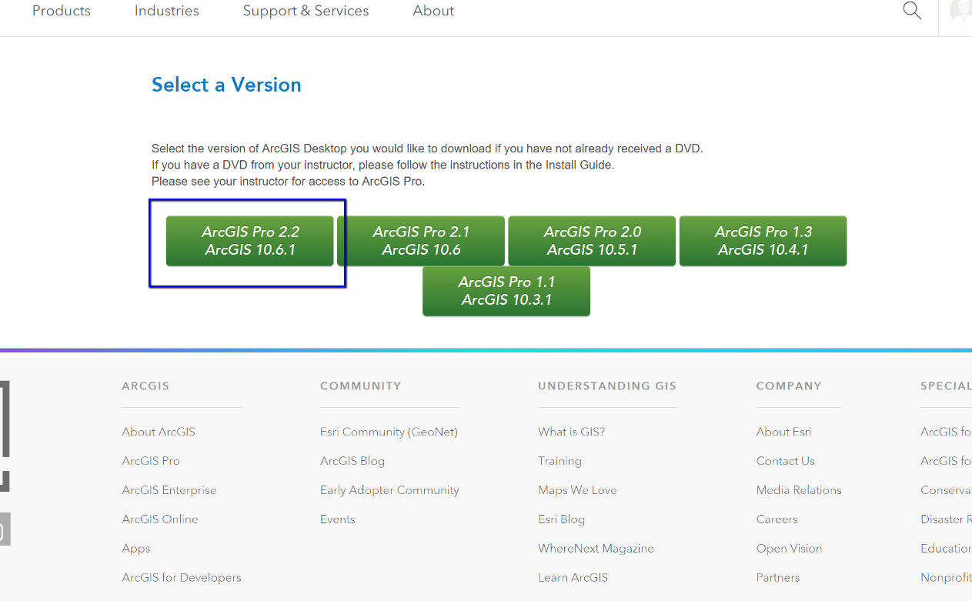

5. Read these instructions carefully. Most Windows 10 computers have Microsoft: NET 4.5 and Microsoft Internet Explorer v8 installed; they are required for ArcGIS Pro. Click on the link to download/install Microsoft: NET 4.5. If you receive a notice saying it is already installed, you’re good, otherwise it should install automatically.
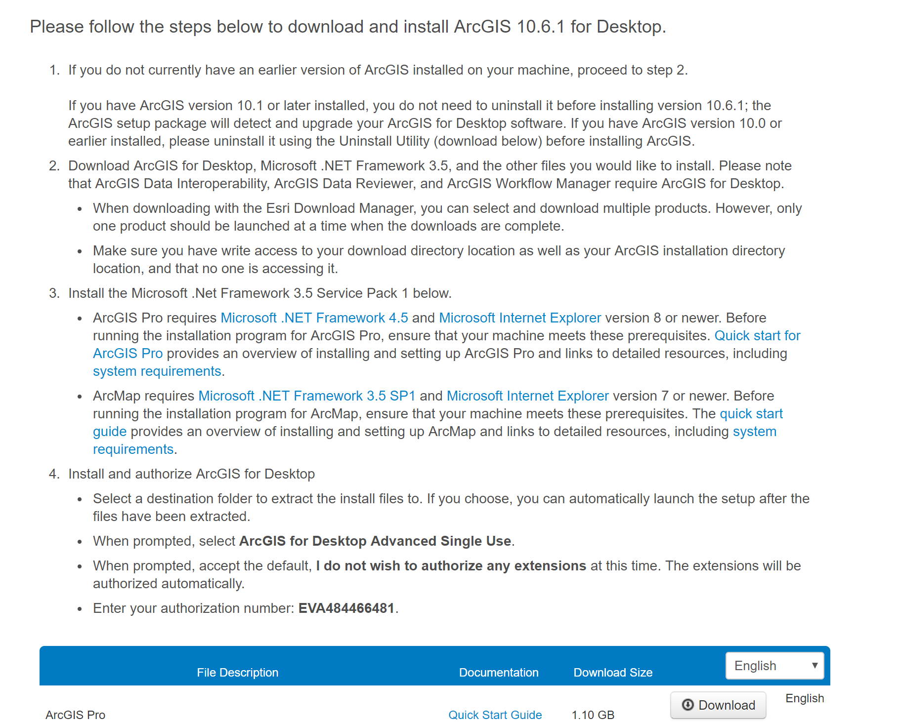

6. Click on DOWNLOAD for ArcGIS Pro. This will download the software to your computer.
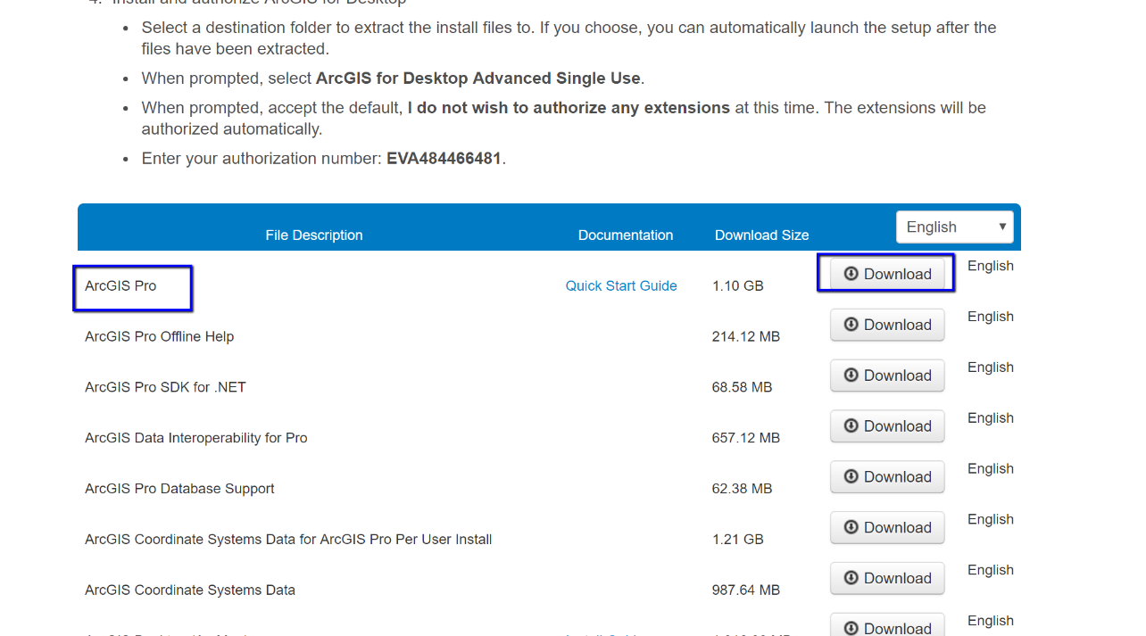
7. Click on CLICK TO DOWNLOAD YOUR FILE NOW button. ArcGIS Pro will now start downloading to your computer.
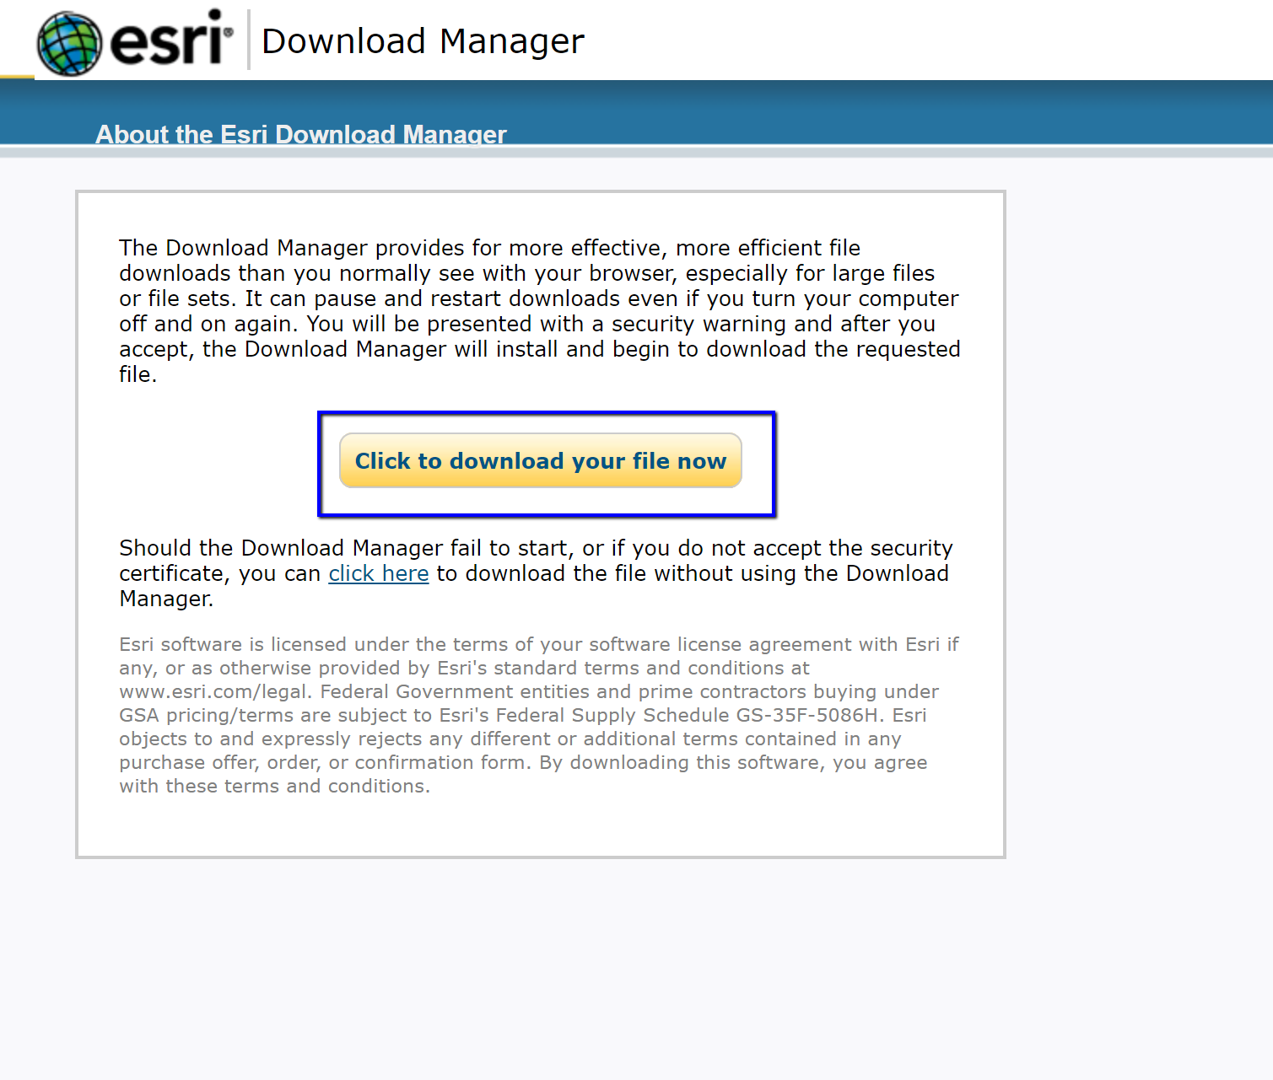
8. Download the install file to a location of your choice. Here it is downloading to the Downloads File.
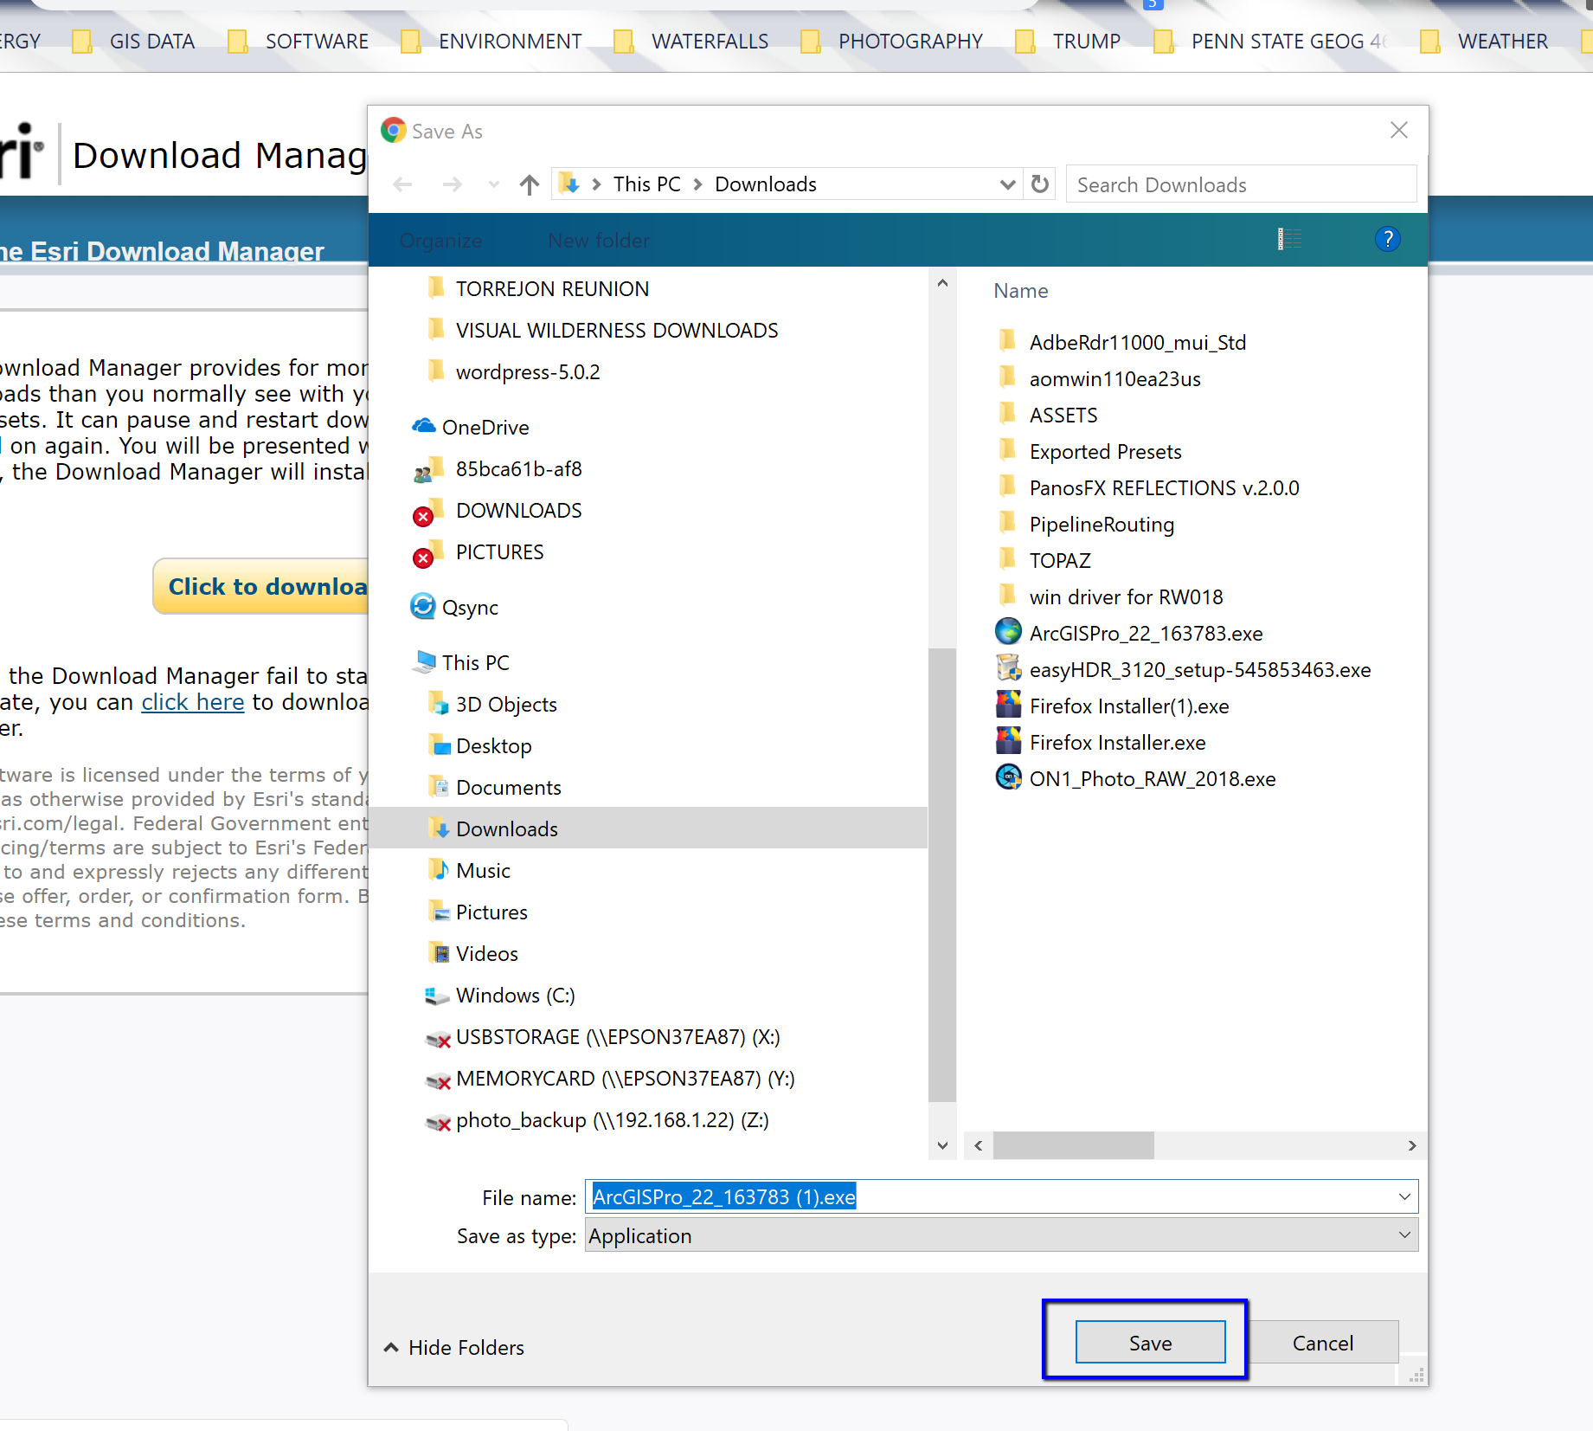

9. The progress of the download will show at the bottom left of your browser window as shown.
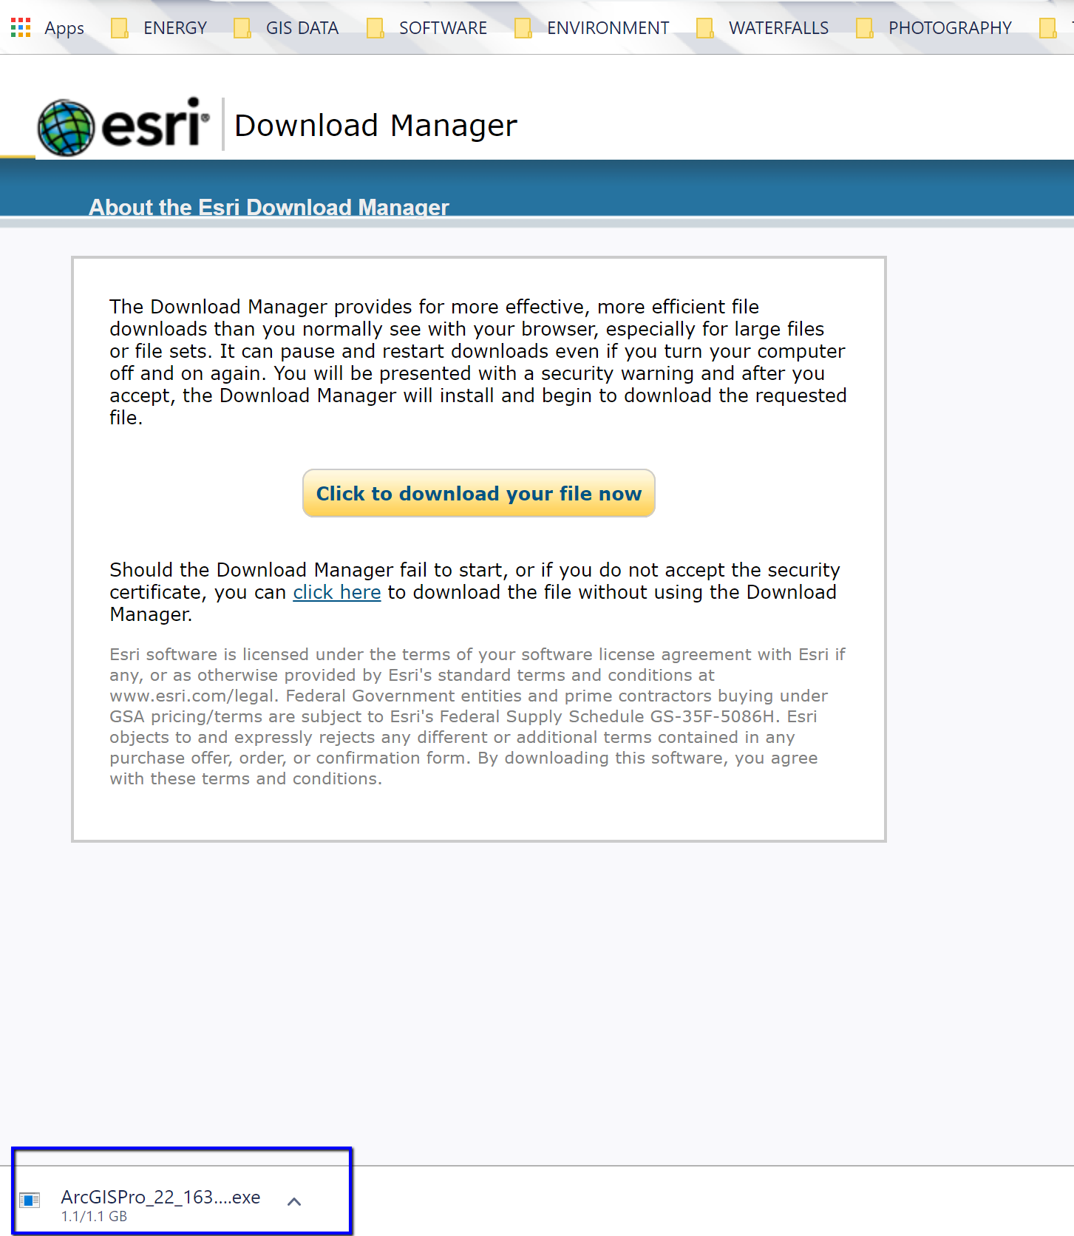

INSTALLING THE SOFTWARE
10. Once the download has completed, click on the up arrow on the download notification in the lower left corner of your browser window and select OPEN. This will extract the installation folders to your computer. You can leave the default location as shown on your screen.
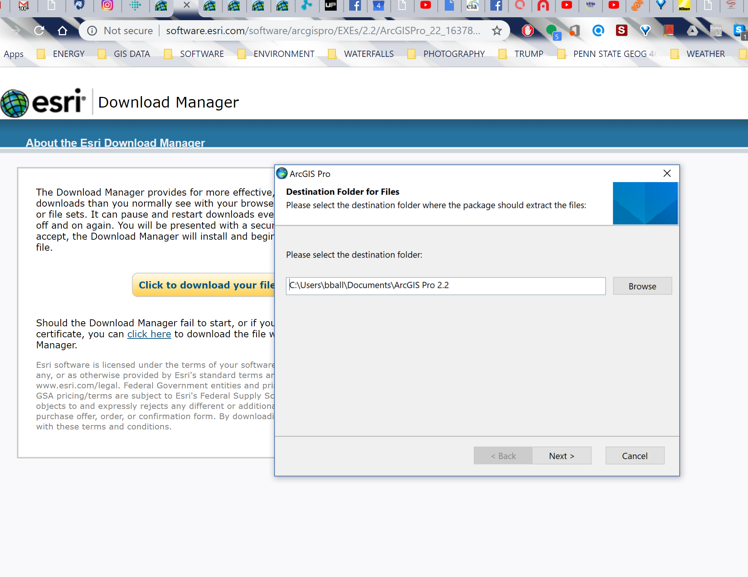

11. Once the files have been extracted to your computer, a notice will appear indicating the files have been extracted. Make sure the LAUNCH THE SETUP PROGRAM box is checked and press CLOSE.
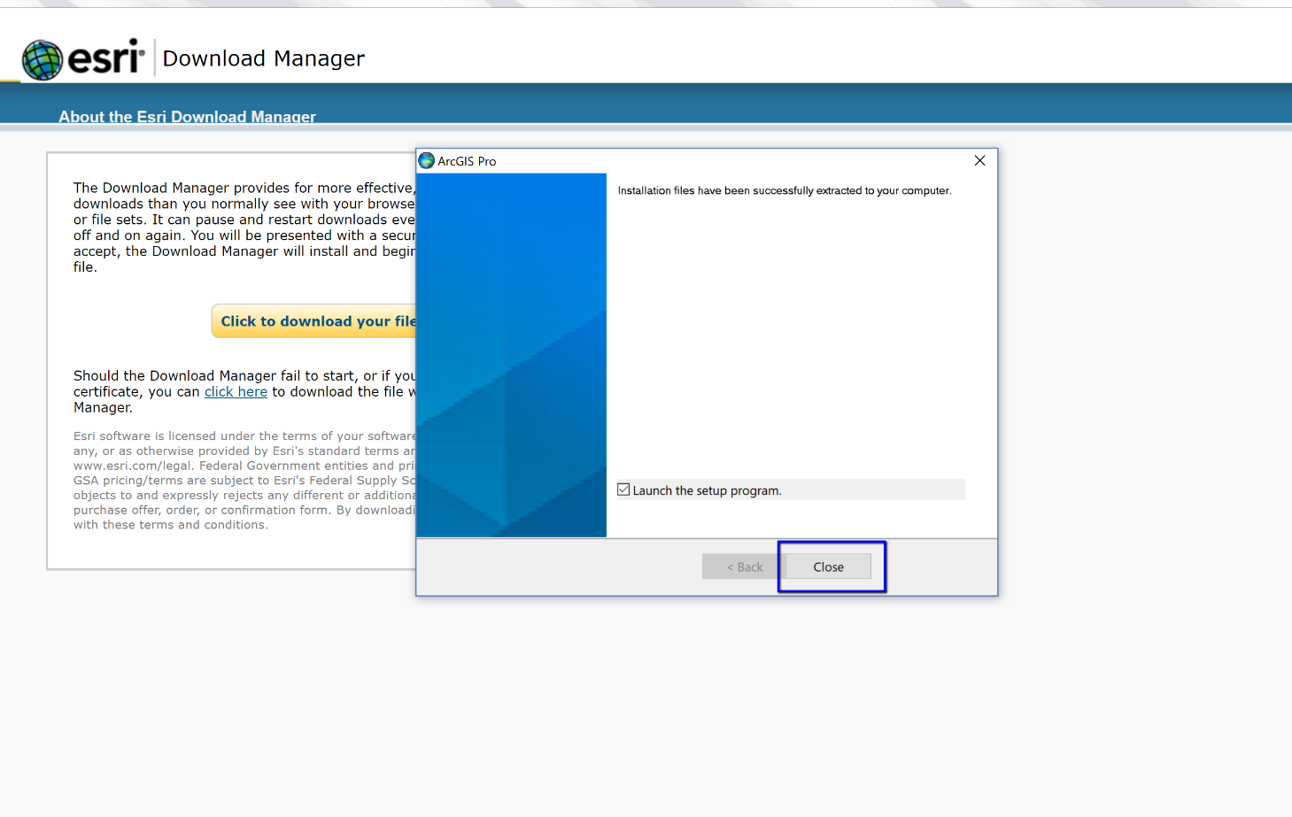

12. Click NEXT on the Welcome to the ArcGIS Pro Setup Program to start the installation.
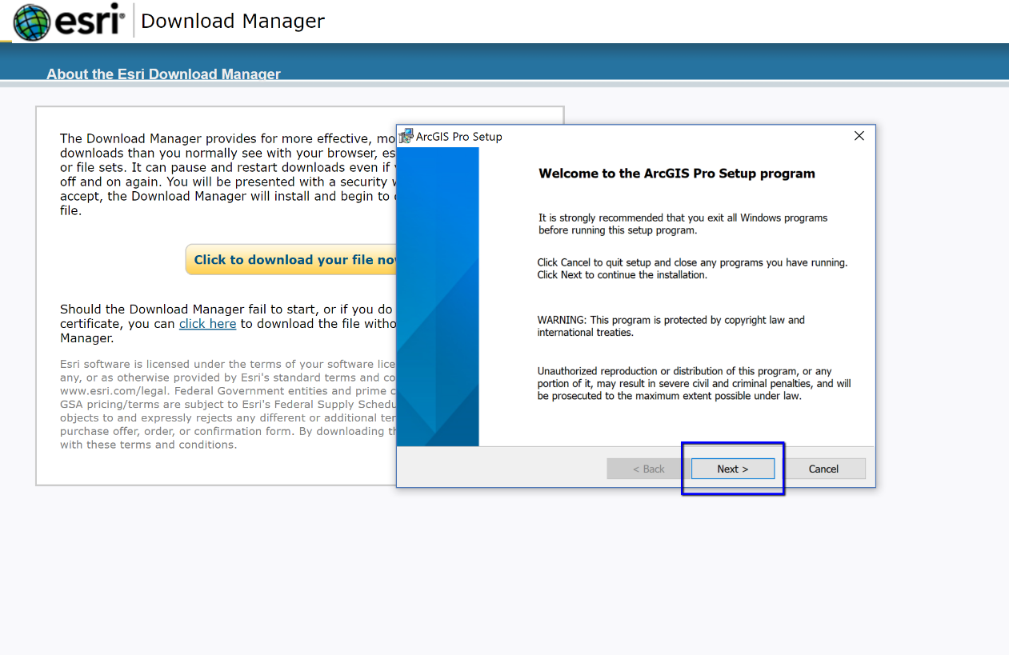

13. Click I ACCEPT…., and then NEXT.
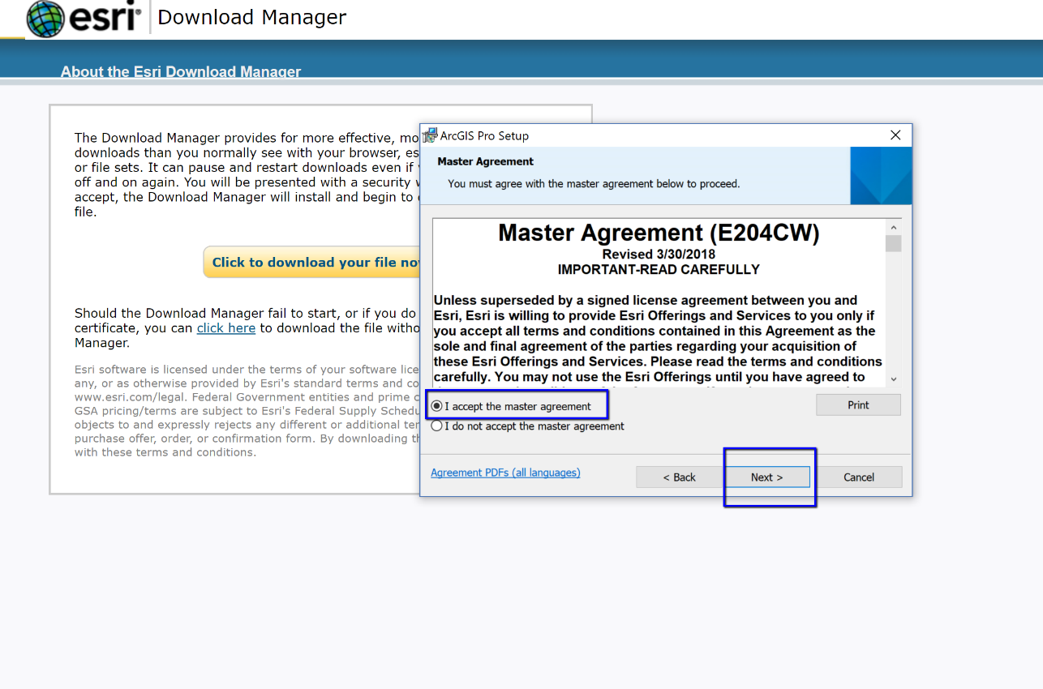
14. Select: ANYONE WHO USES THE COMPUTER (ALL USERS). Then Click NEXT.
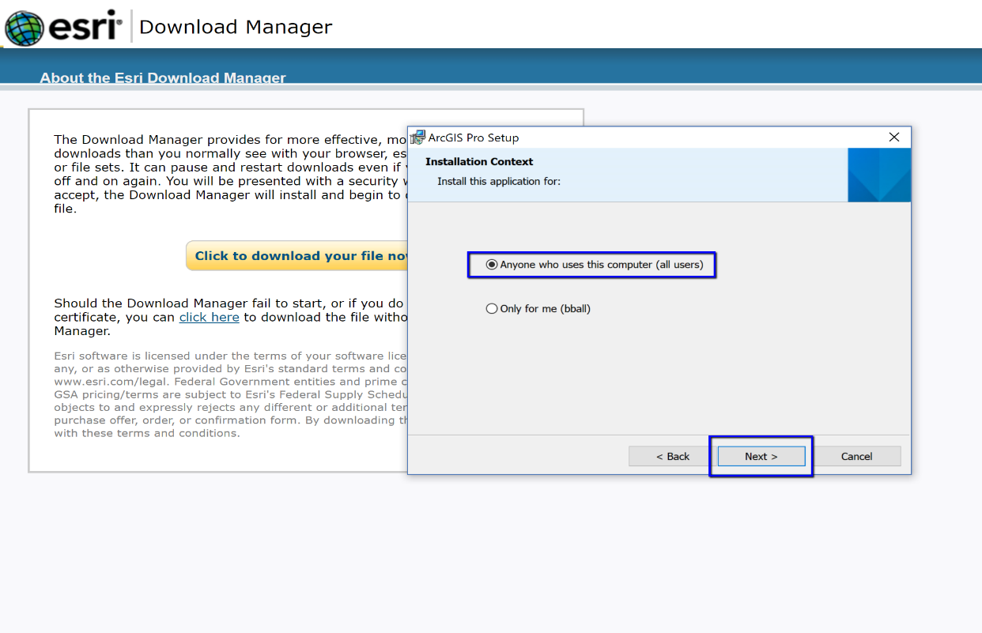

15. Leave the Destination Folder as is and then click NEXT.
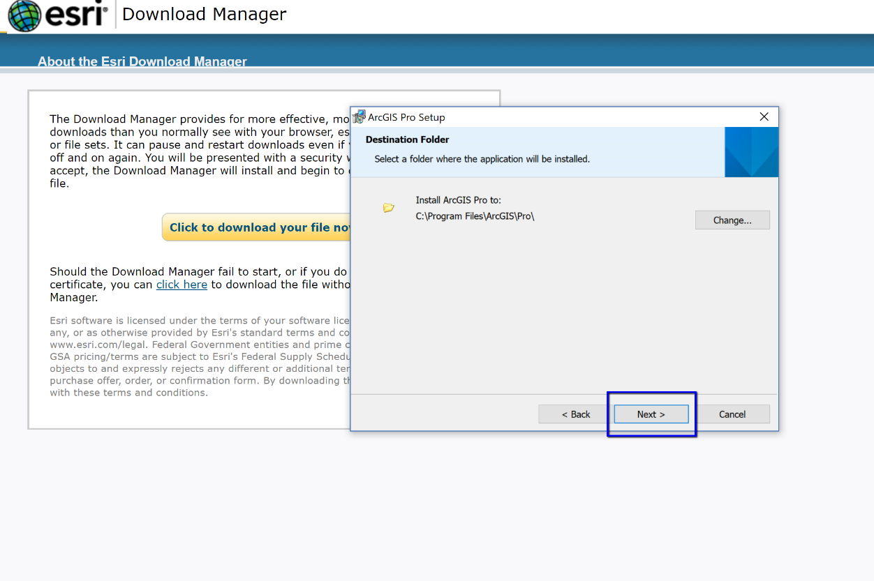

16. Click the INSTALL button.
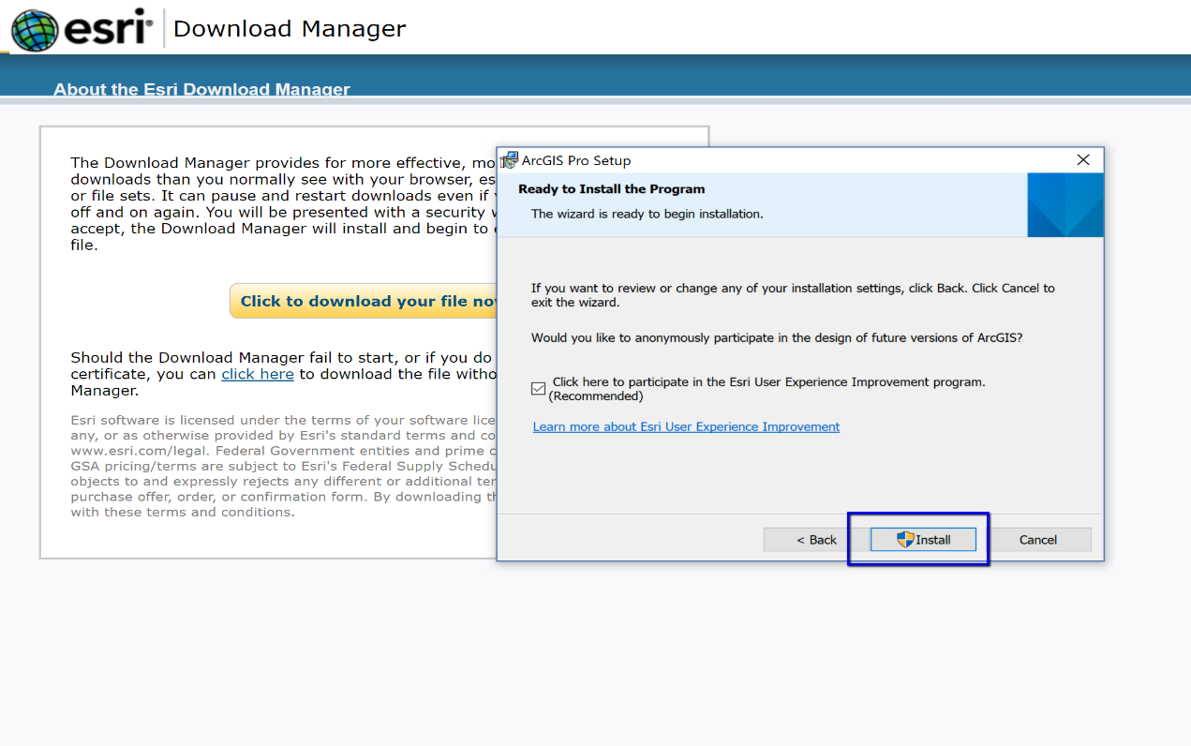
17. A notice will appear when ArcGIS Pro has been successfully installed. Make sure the RUN ARCGIS PRO box is checked and then click FINISH.
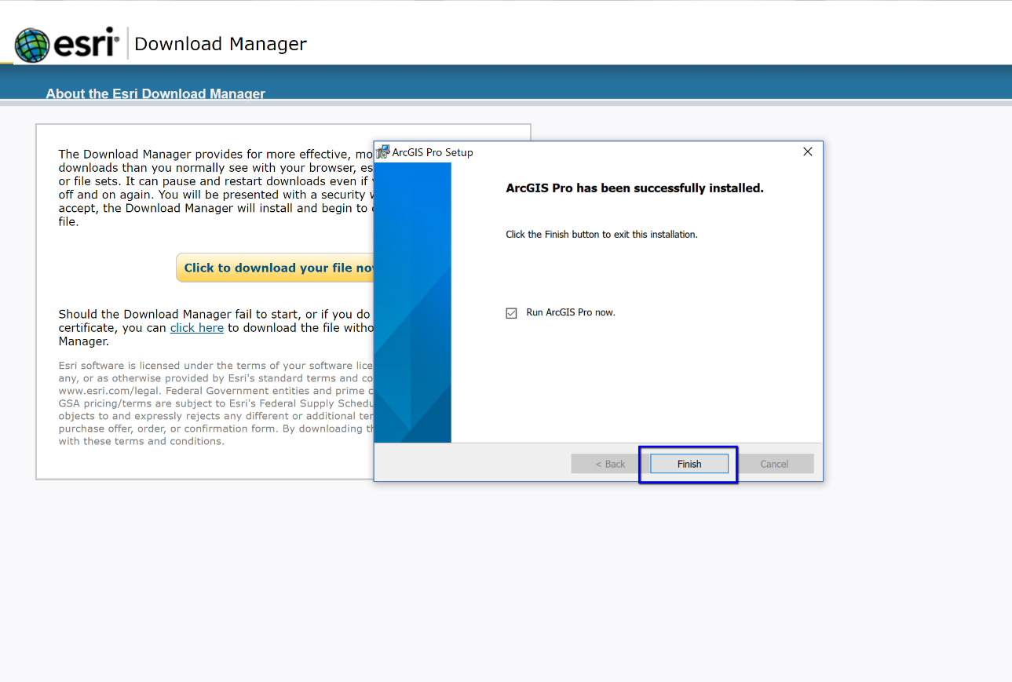

AUTHORIZING THE SOFTWARE
18. Log into ArcGIS Online with your PSU user ID and password. https://pennstate.maps.arcgis.com/home/index.html

You can close ArcGIS Online after you log-in.

OPENING THE SOFTWARE

19. To open ArcGIS Pro, open the Windows Menu by clicking on the Microsoft Windows icon in the lower left corner of the screen. Navigate to your ArcGIS Pro App and click on it to open. ArcGIS Pro should now open.

This is the opening screen of ArcGIS Pro. Click Sign-in in the upper right-hand corner.

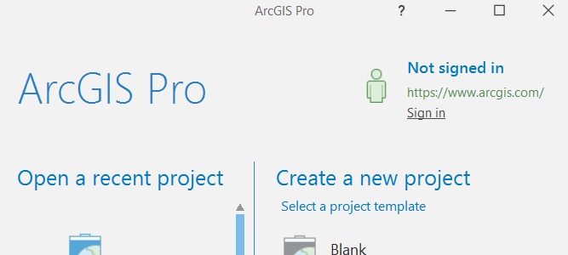

A. Click: Sign in with ENTERPRISE LOGIN

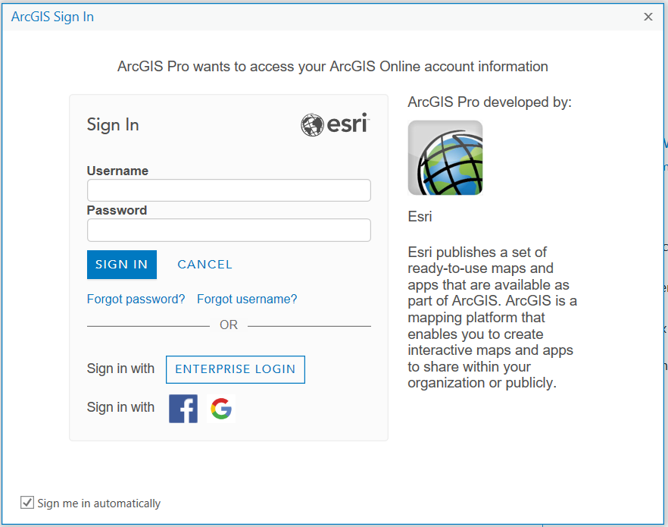

B. ENTER: Lower case pennstate in the ArcGIS organizations URL box.
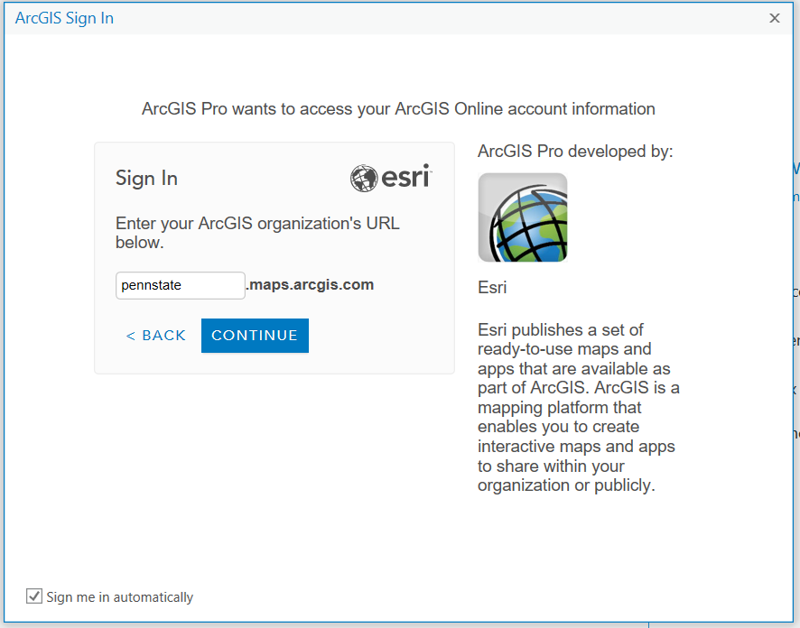

C. Click the blue PENN STATE WEBACCESS button. Log in with your PSU id and password.
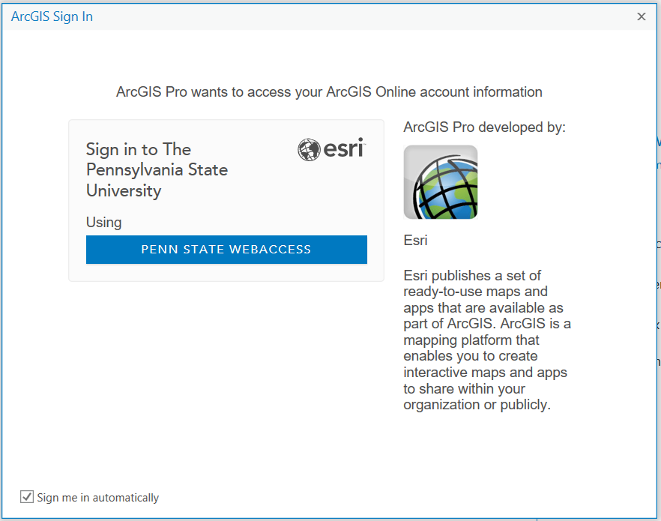

D. Click on Blank, if this is the first time you are opening ArcGIS Pro; otherwise select your project from the project icons listed.

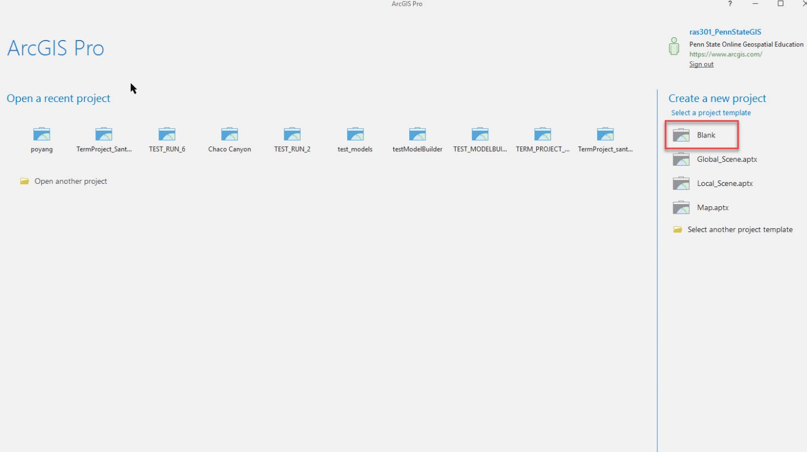

E. If you are opening ArcGIS Pro for the first time or are starting a new project, complete the Create A New Project window by giving your project a name and identifying the location where you want to store project folders.

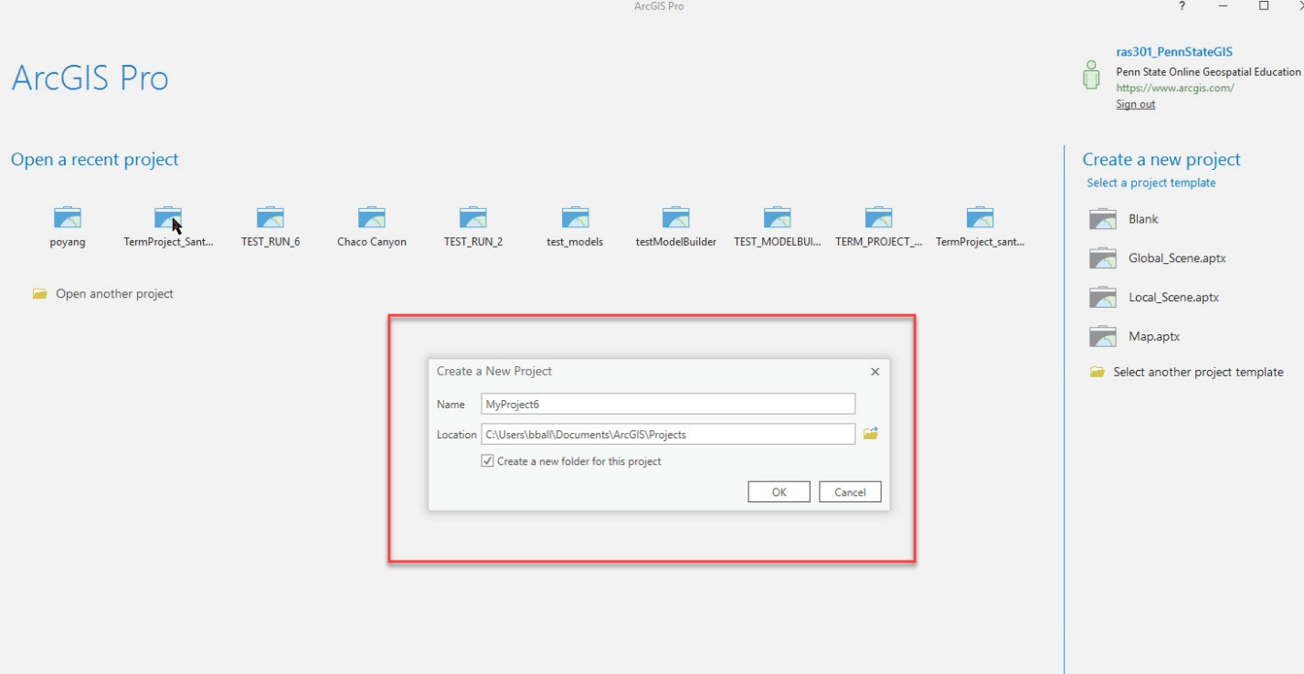

F. This is the opening screen of ArcGIS Pro if using it for the first time.

