Determining Surface Wind Direction
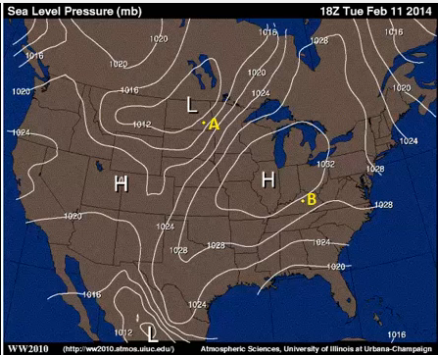
One of the objectives from the lesson, and a really useful skill, is to be able to look at a map of isobars and estimate the wind direction at any given point. And using the concepts from the lesson, we can do that. So I'm going to walk you through, kind of, the recipe that I go through when I need to estimate wind direction at a given point.
The first thing we have to do is we have to pretend that we're dealing with geostrophic winds. Now, with the geostrophic wind, we know that the pressure gradient force is exactly balanced by the Coriolis force. But in practical terms, the important thing about geostrophic winds is that they blow parallel to local isobars.
So at point A here, if we have winds blowing parallel to local isobars, they're either going to be from the southwest, or from the northeast. There's only two choices. So we have to determine which way they'd be blowing from.
And to do that, we have to remember our circulations around areas of high and low pressure. In the northern hemisphere, we have counter-clockwise circulation around areas of low pressure, so that's going to give us a general sense of the wind flow that's like this. And that means that we have geostrophic winds that would be blowing from the southwest at point A.
Another way to think about it is that if you're standing with the wind at your back, lower pressures are going to be on your left. So if we stood with our wind at our backs at point A, and we were looking off toward the northeast, the only thing that makes sense is a southwesterly wind, because that gives us lower pressures on our left. So geostrophic winds would be from the southwest, blowing parallel to local isobars at point A.
But we have to account for friction. The wind actually isn't geostrophic. Friction throws off the balance between the pressure gradient force and the Coriolis force, and it slows the wind down. But it also changes its direction and causes it to cross local isobars in toward lower pressure at a 30-degree angle, on average.
So if we take that into account, that means that the winds are going to cross the local isobars in toward lower pressure, about a 30-degree angle. And that's going to give us a wind that's almost from due south. Something around 180 degrees, give or take a little bit. So that's going to be our approximate wind direction at point A when we've accounted for friction as well.
We can do a similar analysis at point B. If we first pretend that the winds are geostrophic at point B, they're parallel to local isobars. So they're either from the east-northeast or from the west-southwest. And to figure out which one it is, we remember that air circulates clockwise around areas of high pressure in the northern hemisphere. So our general flow is going to be clockwise like this, and our wind flow is going to be from the east-northeast, parallel to these isobars. The geostrophic winds are going to be parallel to those isobars from the east-northeast.
But we have to account for friction, too. And to do that, we have to cross isobars at about a 30-degree angle away from higher pressure. So our winds would look something more like this, and ours winds would be from the northeast, or even north-northeast, at probably something like 20 or 30 degrees when we've accounted for friction, because we don't actually have geostrophic winds.

