Interpreting Visible and Infrared Satellite Imagery
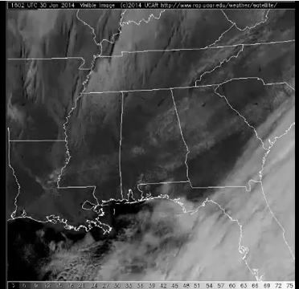
I'd like to take a few minutes to talk about the differences between visible satellite imagery and infrared satellite imagery and the types of information we can get from each type of image because that's a really big part of this lesson.
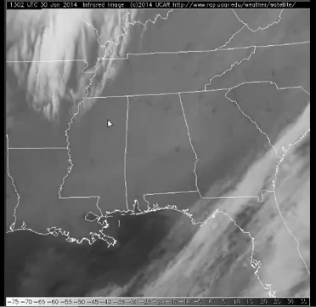
So I have a visible satellite loop and a corresponding infrared satellite loop. There's the infrared loop from January 30, 2014. We'll see what things we can tell from each particular type of image.
First, visible satellite imagery works off of reflected visible light. So the more light that an object reflects, the higher it's albedo and the brighter it will appear on visible imagery. The less light it reflects, the lower its albedo and it will appear darker.
That often helps us tell things about how thick an object is, how thick cloud cover is, in a particular area.
Infrared imagery though works differently. It works off of emissions of infrared radiation which is tied to temperature. The warmer an object is, it will appear dark on infrared imagery, at least traditional infrared imagery like this loop. And the colder an object is, the brighter white it will appear on traditional infrared imagery.
So getting back to our visible image here. As our loop goes on, we can see a stationary area of white shading across Alabama and Georgia. As the loop goes on, it doesn't move at all which means it's not cloud cover. The clouds are moving, as we can see here over Florida.
But this area of white across Alabama and Georgia is actually snow cover. Skies are clear in that area, and so we see the high albedo of snow cover across Alabama and Georgia.
We can also see little dark specks across northern Georgia. Those are unfrozen bodies of water that appear dark because they have much lower albedo than the surrounding snow cover.
We also note that the entire image is fairly dark at the beginning of the loop, and it brightens up as we go on and we can see the features better. That's because the loop starts at 13Z which is about 8 o'clock in the morning, and so the sun is still low in the sky. There's not a lot of reflected visible light off of anything at 13Z. But as the sun rises, we get more reflected visible light and everything brightens up on the image.
Because infrared satellite imagery doesn't require visible light, that progression of the day appears differently. We can notice it here though in an area of clear skies across Alabama and Georgia. It's not because of the reflected visible light, but it's because of changes in temperature that occur.
With skies being clear in this area, as the sun rose throughout the day, the ground warmed up. And we can tell that on this infrared image because at the beginning of the loop, it's fairly faint gray colored. But as the loop goes on, we go from that faint gray and it gets darker because the ground is actually warming up as the loop goes on, and we get that change in shading.
Also, on the infrared image, we can see some fairly bright looking clouds over in Arkansas toward the end of the loop. The fact that they're bright means that they're cold. And they must have fairly high tops because they're cold.
On visible satellite imagery though, those clouds look a bit differently toward the end of the loop. We can see some clouds here, but they're fairly faint gray which means that they're not reflecting a lot of visible light. They have a low albedo and so they must be relatively thin.
So we know from the visible image that they are thin clouds and from the infrared image, they're high clouds so we must be talking about cirrus clouds over Arkansas.
Now over the central Gulf of Mexico, we have a kind of a speckled appearance to the clouds. They must be reflecting a decent amount of visible light. They're brighter than those cirrus clouds we just looked at. But when we look at those clouds over the central Gulf on infrared imagery, they're actually pretty hard to see.
You can very faintly see those speckled clouds over the central Gulf, but they're very, very dark gray shaded on the infrared imagery. That means that they are warm which means they must have low tops. So we know that they're- they have low tops from the infrared imagery, but still at least somewhat thick from the visible imagery.
So we're looking at some sort of a low topped cumulus cloud across the central Gulf.
As we look at the clouds over Florida here, we can see they have bright shading on the infrared imagery. And that means that they have high tops, it's a cold cloud top.
And when we look at those same areas of clouds on the visible loop, we can see that those clouds are also quite bright. So they must be very thick. They have a high albedo. They're reflecting a lot of light.
So we know from the visible loop that they're thick. And we know from the infrared loop that they have high tops. So those are probably, at least some of those clouds over Florida are probably, cumulonimbus clouds.
So hopefully this gives you an idea to how to track things like snow cover in the progression of a day and how to tell cloud thickness from visible imagery and cloud height from infrared imagery.

