A "Tour" of a Low Pressure System
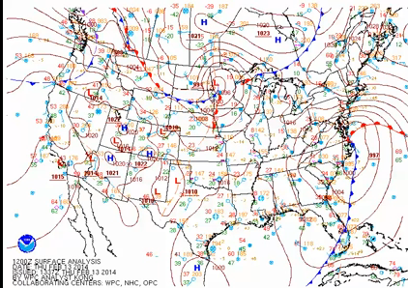
I want to take a tour of a surface low-pressure system and take a look at some of the different features so you can see how they fit together with a real weather system on real weather maps. We'll start at the surface. This is a surface analysis from 12Z on February 13, 2014. There was a 997 millibar low-pressure system along the East Coast, right along the North Carolina-Virginia border. This was a fairly significant storm, which dropped over two feet of snow in parts of the mid-Atlantic region. Heavy snow extended up into New England with localized blizzard conditions.
To the south of the surface low, we have this blue line with blue triangles. That's the cold front signaling the leading edge of advancing colder air. Out ahead of it, in the warm sector, we often have a maritime-Tropical air mass, which is warm and humid. Behind it, we have an advancing colder air mass, commonly continental polar, or even continental Arctic. And we can see some huge temperature contrasts here. To the east of Florida, temperatures are in the 70s on these station models. Behind the front in northern Florida we have temperatures in the 30s, so much colder air is arriving behind that cold front.
To the east of the low, the red line with red semicircles marks the warm front. That signals the boundary between retreating colder air to the north and advancing warmer air in the warm sector. It's the retreat of that cold air that actually allows the warm air to advance. So we have a maritime tropical air mass advancing northward while the colder, denser air north of the warm front, slowly retreats.
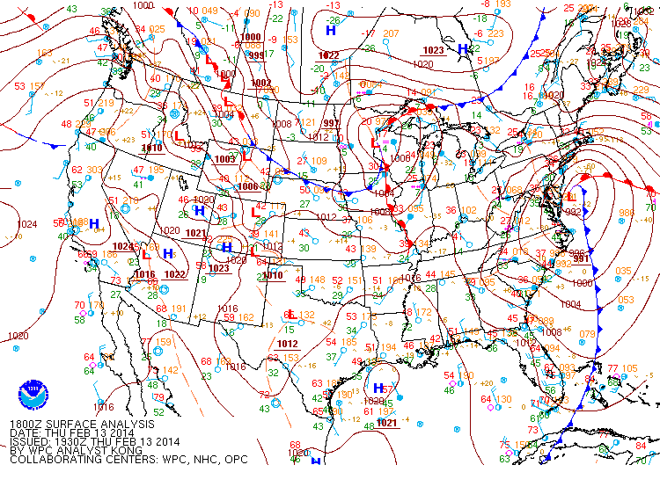
Now let's fast forward six hours to 18Z, and the low is even stronger now, around 991 millibars. The center of the low has moved northward off the Delaware Coast, and we just see the very beginning of an occluded front forming. It's hard to see, but the beginning of the occluded front signals that the low is starting to reach maturity. The cold front is trailing southward offshore, while the warm front extends toward the east.
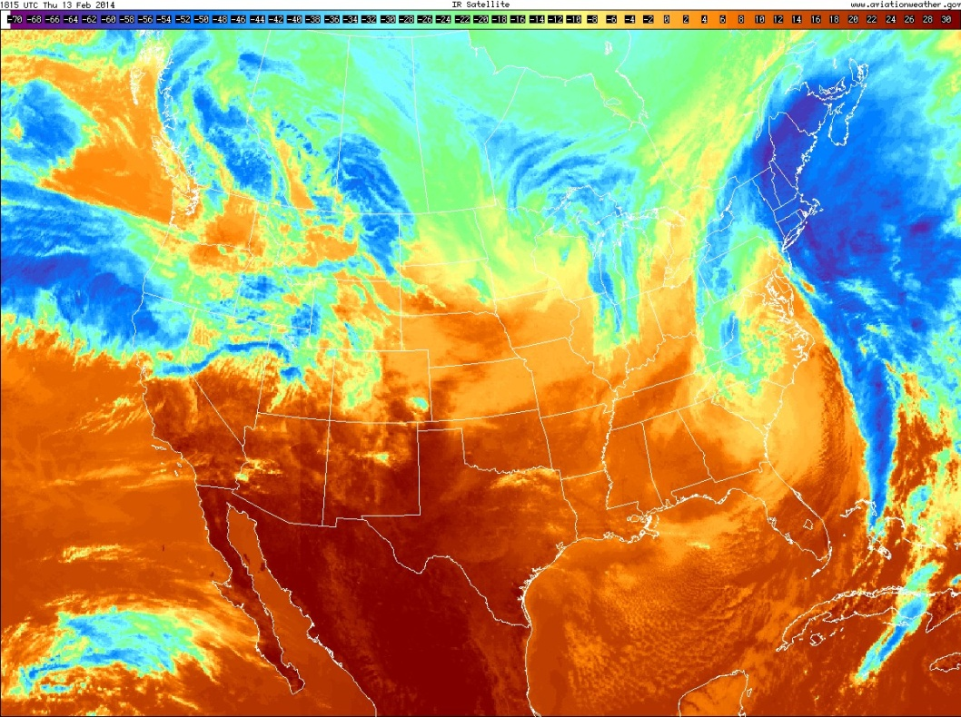
So, let's look at this mature low-pressure system on the corresponding enhanced infrared satellite image. To get your bearings, the greens, blues, and purples represent cold, high cloud tops. This cyclone has a classic comma signature to it, signaling that it's a mature mid-latitude cyclone. To the north of the warm front, we generally have upward motion from overrunning as the warm air glides over the dense cool air near the surface, which often results in a large area of layered clouds, which is what we see north of the warm front. These clouds near the northern edge of the cloud shield are quite high and cold.
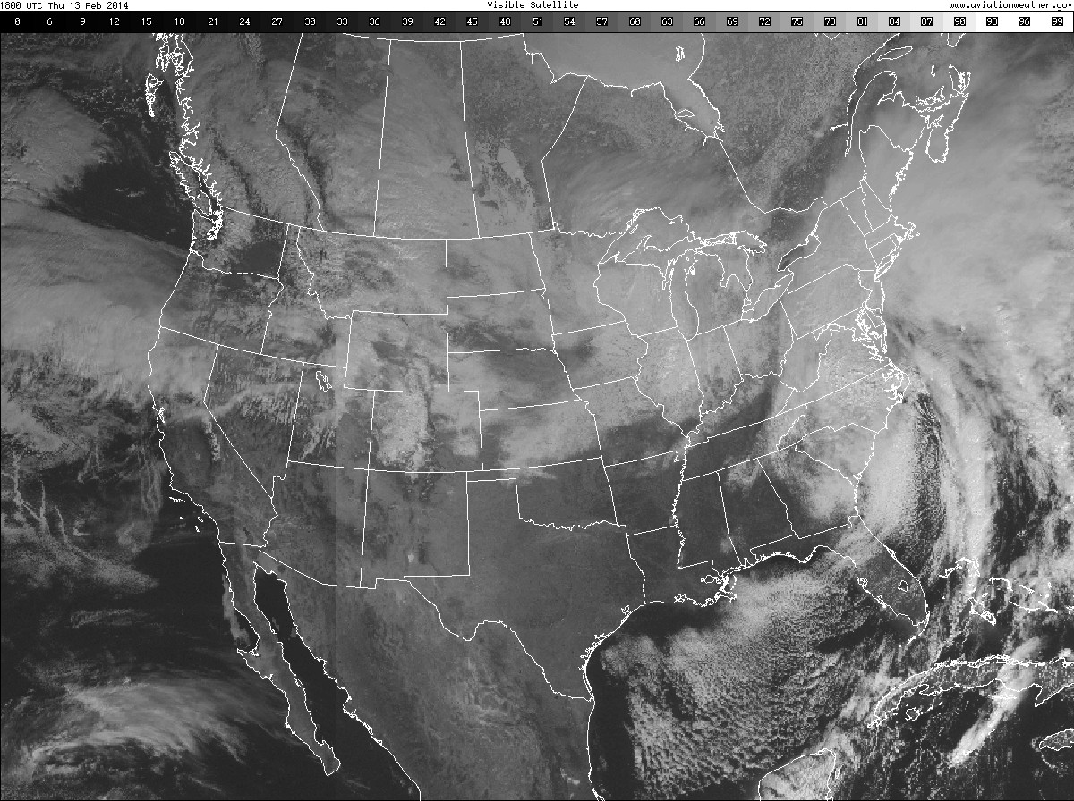
But, a look at the corresponding visible image shows that they seem to be relatively thin, which fits what we would expect. We often have thin, high cirrus and cirrostratus clouds well north of the warm front, thicker altostratus clouds as we get a little closer to the warm front, followed by thick stratus and nimbostratus clouds close to the warm front.
Switching back to the enhanced infrared, we can see that along and just ahead of the cold front, we have a thinner band of clouds, which is indicative of the showery weather that typically accompanies cold frontal passages. Satellite imagery also lets us get a handle on this low's conveyor belts, and for that we'll turn to water vapor imagery.
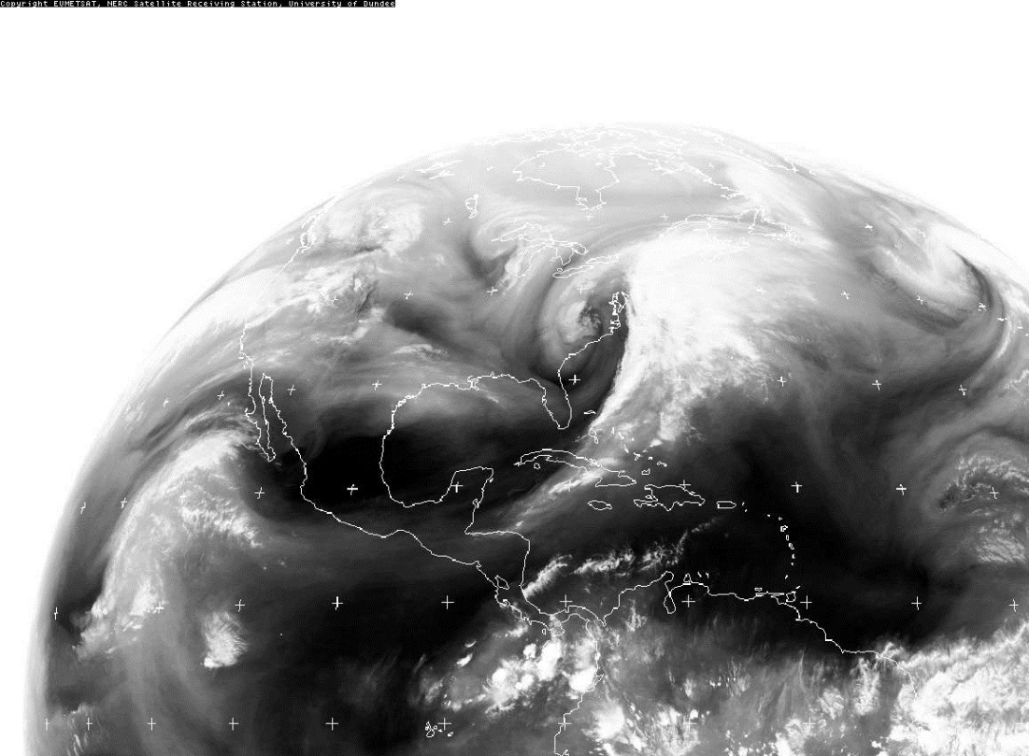

To get your bearings, here's the East Coast of the United States, and here's our cyclone. This stream of water vapor and clouds ushering moist air northward, which eventually overruns the colder air mass north of the warm front, is the warm conveyor belt. Meanwhile, the cold conveyor belt travels under the warm conveyor belt north of the warm front, and rises as it wraps around the cyclone, to create the clouds in the comma head. Finally, we can see evidence of the dry conveyor belt, too. It helps define the western edge of the comma head as dry air aloft, marked by the dark ribbon here, sinks from aloft around the western edge of the storm, and wraps around the storm to form the dry slot.
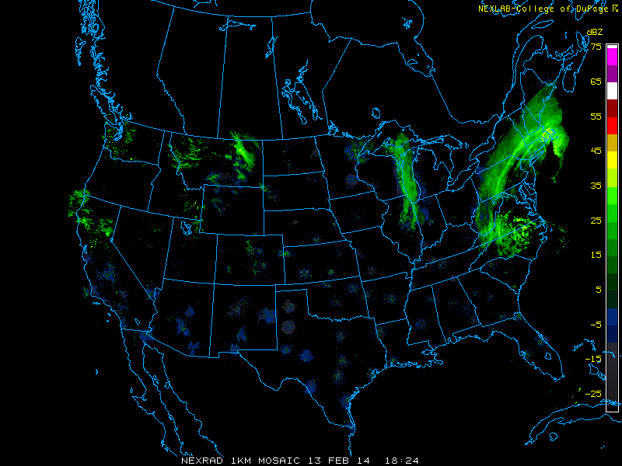
Finally, here's the corresponding radar image. Unfortunately, we can't see much of the precipitation with this mid-latitude cyclone because the showers and storms along the cold front, along with much of the stratiform overrunning precipitation north of the warm front was outside of the range of land-based radars, although you can see a bit of the overrunning precipitation off the New England Coast. But, we can get a good look at the wrap around precipitation associated with the cold conveyor belt, which was bringing snow from New England down through Pennsylvania, and even into Virginia and North Carolina, even though remember the surface low was off the Delaware Coast.

