Activity Part 2: Degassing Calculations

The idea here is to determine the mass of CO₂ you released into the atmosphere during the first part of your experiment. Be sure to show all your calculations. Watch your unit conversions!

First, a few assumptions:
- We shall assume that the physical properties of Diet Coke are the same as those of water (H₂O) at room temperature (20˚C)
- We shall assume that a typical soda contains ~0.5% CO₂ by weight prior to being opened (in reality this may vary by quite a bit)

We start by determining the total mass of CO₂ present at the beginning of the experiment (prior to opening the bottle). In order to do this, first you will need to determine the mass of Diet Coke. Use the graph below to determine the density of water at 20˚C; we will assume your Diet Coke has the same density. Note that 1 cm³ = 1 mL.

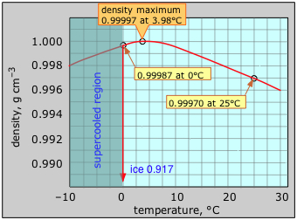
Image from UC Davis Chem Wiki, used under Creative Commons Share Alike 3.0 license

1. Approximately how many grams of Diet Coke (water) are in a 2 liter bottle? Begin by determining the number of milliliters in 2 liters, then convert to cm³. Then use the density of water at 20˚C (room temperature) to determine the mass in grams. Show all your work.

2. Given that the concentration of CO₂ is 0.5% by weight, how many grams of CO₂ are in the bottle? Recall that 1% is equivalent to a fraction of 1/100 or a multiplier of 0.01. What then is 0.5%? Multiply this by the mass of Diet Coke you determined in Question 1 above to get the mass of CO₂ in grams. Show all your work.

Solubility is the amount of a compound that will remain in solution under a given set of conditions. Use the graph below to estimate the solubility of CO₂ in water at 20˚C and atmospheric pressure.

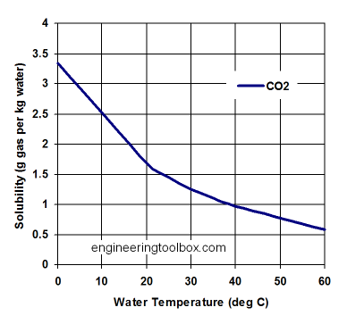

3. Estimate the solubility of CO₂ in water (Diet Coke) at 20˚C using the graph above. Convert your answer to grams of CO2 per gram of water by dividing by 1000. Show all your work.

4. How many grams of CO₂ will remain dissolved in our 2 liters of Diet Coke after the experiment is done? In order to calculate this, multiply the solubility you determined in Question 3 in grams of CO2 per grams of Diet Coke by the total grams of Diet Coke you determined in Question 1. Show all your work.

5. What was the mass of CO₂ released during the experiment? The amount of CO₂ released is found by subtracting the amount retained after the degassing experiment (Question 4) from the total amount present prior to opening the bottle (Question 2). Show all your work.

We can use the same approach to calculate the mass of SO₂ released from the lava during the Lakagígar eruption. First, we need to estimate the mass of SO₂ dissolved in the magma prior to eruption. But how does one determine the concentration of a volatile component prior to degassing, when all the lava and tephra samples we have are already degassed? The answer lies in tiny bits of glass trapped inside of crystals. We call these bits of glass melt inclusions, because they represent the magma that was present at the time the crystals formed. Once a melt inclusion has been overgrown by a crystal, the volatiles are trapped inside and cannot escape*.

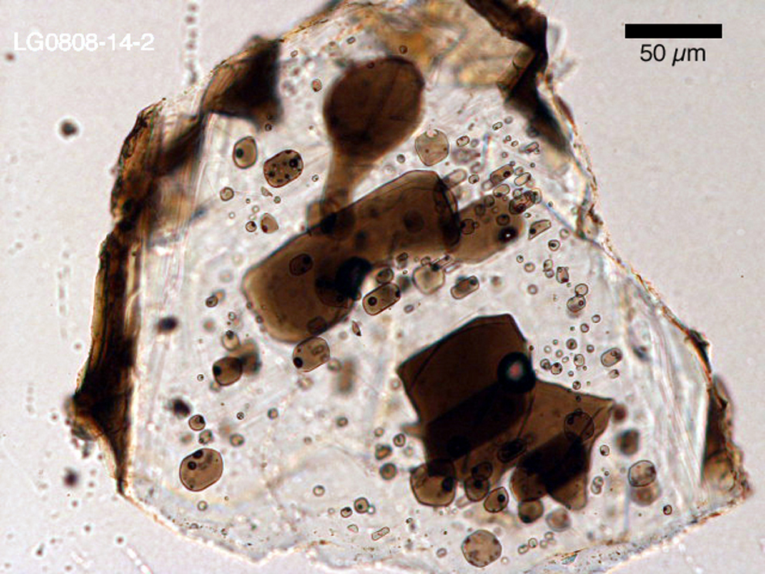
Melt inclusions in a plagioclase crystal from a phreatomagmatic event at Lakagígar. Volatile elements, including sulfur, remain trapped inside the crystal even after eruption and cooling, allowing us to determine the pre-eruptive volatile content of the magma. Photomicrograph by M. Feineman.

The concentration of sulfur measured in melt inclusions from Lakagígar ranges from ~1200 to 1800 parts per million (ppm). We can use the best estimate of 1675 ppm from Thordarson et al., 1996. In order to convert this concentration into an equivalent mass of S, we need to multiply by the total mass of lava erupted.

*In detail this is not entirely true – volatiles can still diffuse out through the solid crystals at high temperatures – but for the purposes of our calculations we can assume that they remain perfectly entrapped.

6. The estimated volume of the Lakagígar eruption is 15.1 km³ of lava erupted. Assuming an average basalt density of 2750 kg/m³, what is the total mass of lava erupted in megatons? Keep track of your units! Not only do you need to convert kilograms to megatons (1 mt = 10⁹ kg), but you also need to convert cubic kilometers to cubic meters (1 km³ = 10⁹ m³). Show all your work.

7. What is the total mass of sulfur in the magma before degassing? We know that the concentration of S in the magma was 1675 parts per million, so multiply the mass of lava you just calculated by 1675⋅10⁻⁶ to get the mass of sulfur prior to degassing. Give your answer in megatons. Show all your work.

8. Just as with the CO₂ in Coke experiment, you will need to estimate the mass of sulfur after degassing, which is determined by measuring the concentration of sulfur in the degassed tephra and lava. The best estimate given by Thordarson et al. (1996) is 205 ppm. Using the total mass of lava you calculated in Question 6, calculate the mass of sulfur remaining after degassing. Give your answer in megatons. Show all your work.

9. What is the total mass of sulfur released to the atmosphere? Determine this by subtracting the mass of sulfur remaining after degassing that you calculated in Question 8 from the initial mass of sulfur you calculated in Question 7. Give your answer in megatons. Show all your work.

One last thing. The sulfur released to the atmosphere is not pure elemental sulfur, it is mostly in the form of SO₂ gas. In order to convert the mass of S into the equivalent mass of SO₂, you will need to multiply by the mass ratio of SO₂ / S. You can use any periodic table (I like www.webelements.com) to calculate the molar mass of SO₂ (which is equivalent to the molar mass of sulfur plus 2 times the molar mass of oxygen). Then simply divide this by the molar mass of S, and you have the mass ratio. Multiply by the total mass of sulfur released, and you’re done!

10. What is the mass ratio of SO₂/S? Since this is a ratio, there are no units. Show all your work.

11. What is the total mass of SO₂ released to the atmosphere? Simply multiply the total mass of sulfur released (Question 9) by the mass ratio of SO₂/S (Question 10). Give your answer in megatons. Show all your work.

12. Thordarson et al. (1996) calculated 122.1 megatons of SO₂ released. How close did your calculation come to theirs?

